**Lab File**

**Operating System**

**(CSE202)**

**DEPARTMENT OF COMPUTER SCIENCE AND ENGINEERING**



**Submitted to: Submitted by:**

**Ms Seema Sharma Prerna Singh**

**Ast. Professor A2305219264**

**CSE Department, ASET B.tech. C.S.E.**

**4CSE-4Y**

**Amity School Of Engineering and technology**

**Amity University Uttar Pradesh**

**Noida -201301**

**INDEX**

|  |  |  |  |  |  |  |  |  |
| --- | --- | --- | --- | --- | --- | --- | --- | --- |
| **Exp No** | **Assignment**  **Category** | **Code** | **Name of Experiment** | **Date of Allotment** | **Date of Evaluation** | **Max**  **Marks** | **Marks**  **Obtained** | **Faculty**  **Sign** |
| **1** |  |  | To explore basic Linux commands. | 17/12/2020 |  |  |  |  |
| **2** |  | To explore basic files and directories related Linux commands. | 24/12/2020 |  |  |  |  |
| **3** |  | To explore file and directory related commands, and using VI Editor. | 07/01/2021 |  |  |  |  |
| **4** |  | To explore file and directory related commands in Linux. | 14/01/2021 |  |  |  |  |
| **5** |  | To explore Shell scripting using Vi editor. | 21/01/2021 |  |  |  |  |
| **6** |  | To explore Shell scripting using Vi editor. | 04/02/2021 |  |  |  |  |
| **7** |  | To explore Shell scripting using Vi editor (for loop and switch case). | 11/02/2021 |  |  |  |  |
| **8** |  | Write a program to simulate FCFS CPU Scheduling algorithm. | 18/02/2021 |  |  |  |  |
| **9** |  | Write a program to simulate Non preemptive and Preemptive SJF algorithm. | 04/03/2021 |  |  |  |  |
| **10** |  | Write a program to simulate Round robin. | 18/03/2021 |  |  |  |  |
| **11** |  | Write a program to simulate Banker’s algorithm | 25/03/2021 |  |  |  |  |
| **12** |  | Write a program for FCFS disk scheduling | 25/03/2021 |  |  |  |  |

**EXPERIMENT- 1**

**DATE- 17/12/2020**

**OBJECTIVE-** To explore basic Linux commands

**SOFTWARE USED-** Cygwin

**THEORY-**

1. **man**- man command provides the user with manual of other commands, type man with the name of the command.

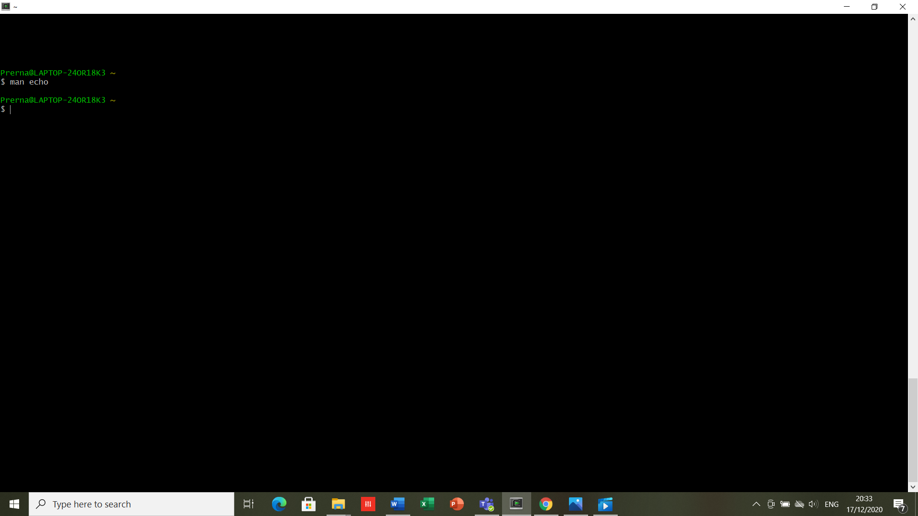

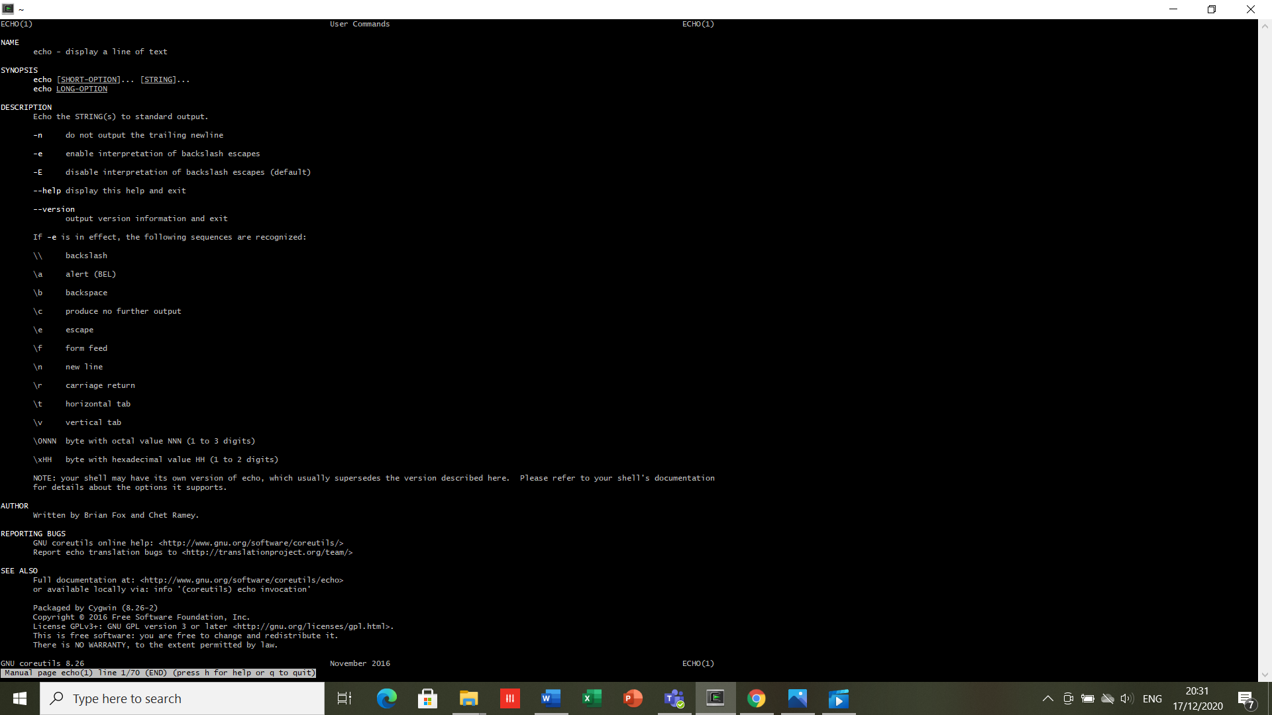

1. **echo-** echo display line of text/string that are passed as an argument.

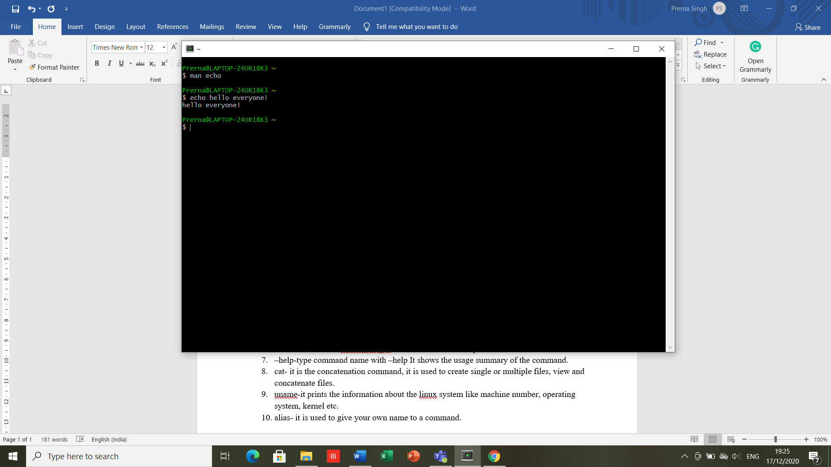

1. **clear-** clear commands clear the contents on screen.

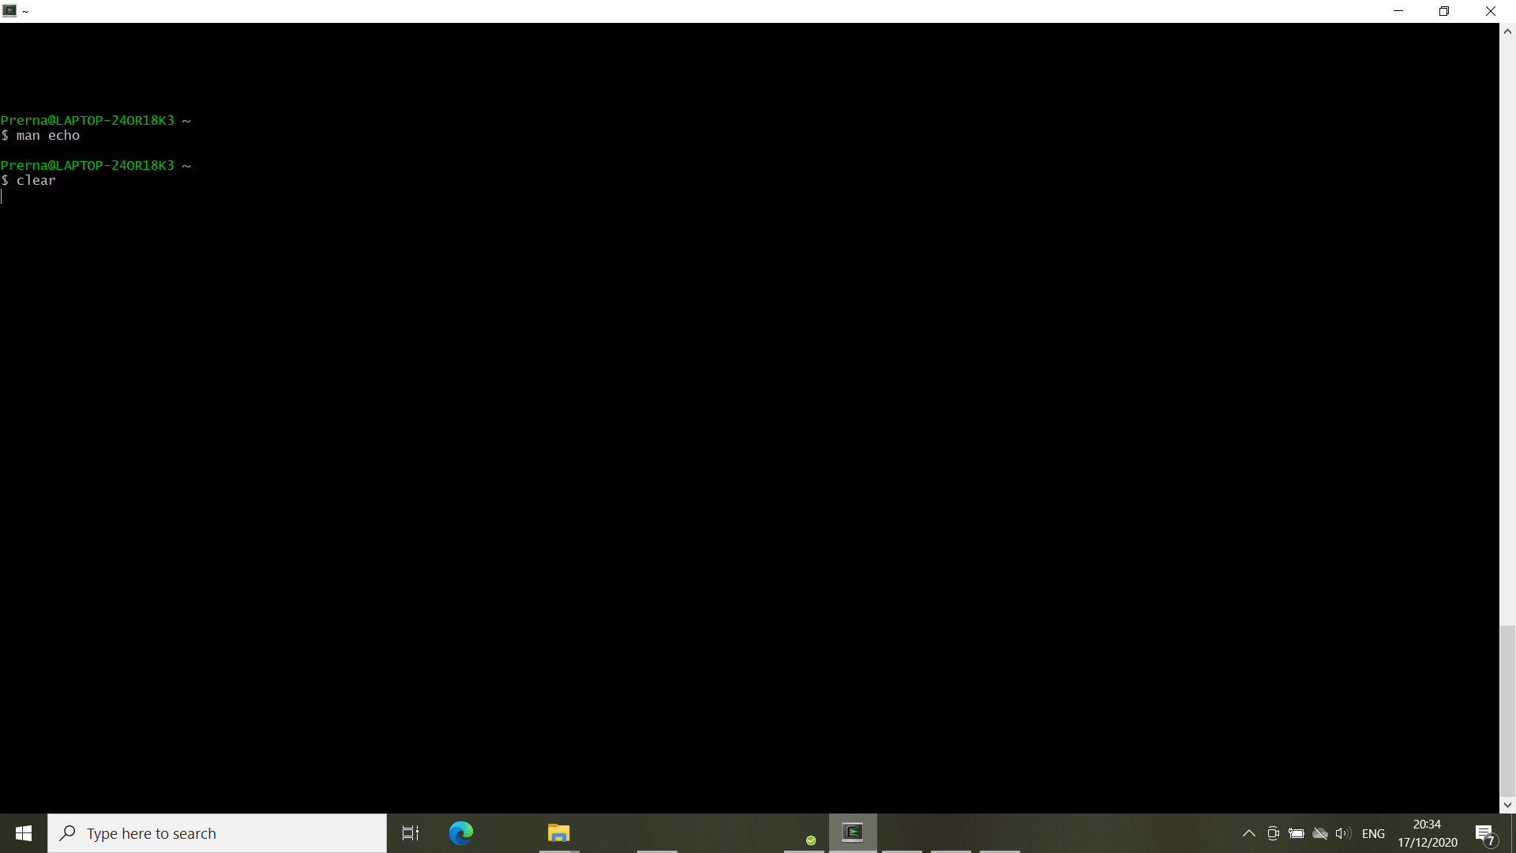

1. **history-** history command shows all the commands which were entered before by the user.

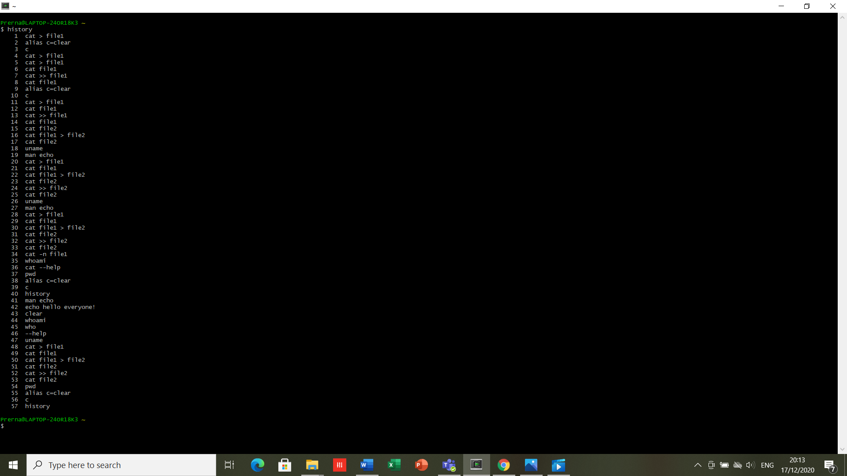

1. **whoami-**this command displays the username of the current user.

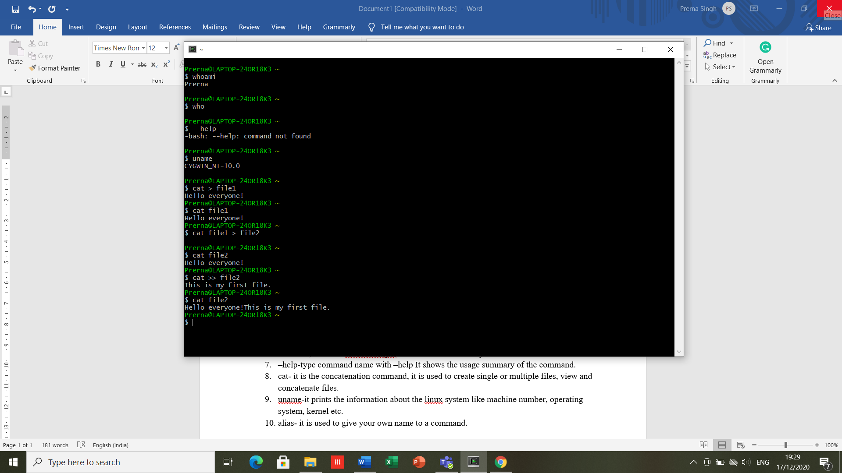

1. **who-** used to get information about currently logged in user on to system, login name of the users, terminal numbers, login time of the users in to system.



1. **–help**-type command name with –help It shows the usage summary of the command.

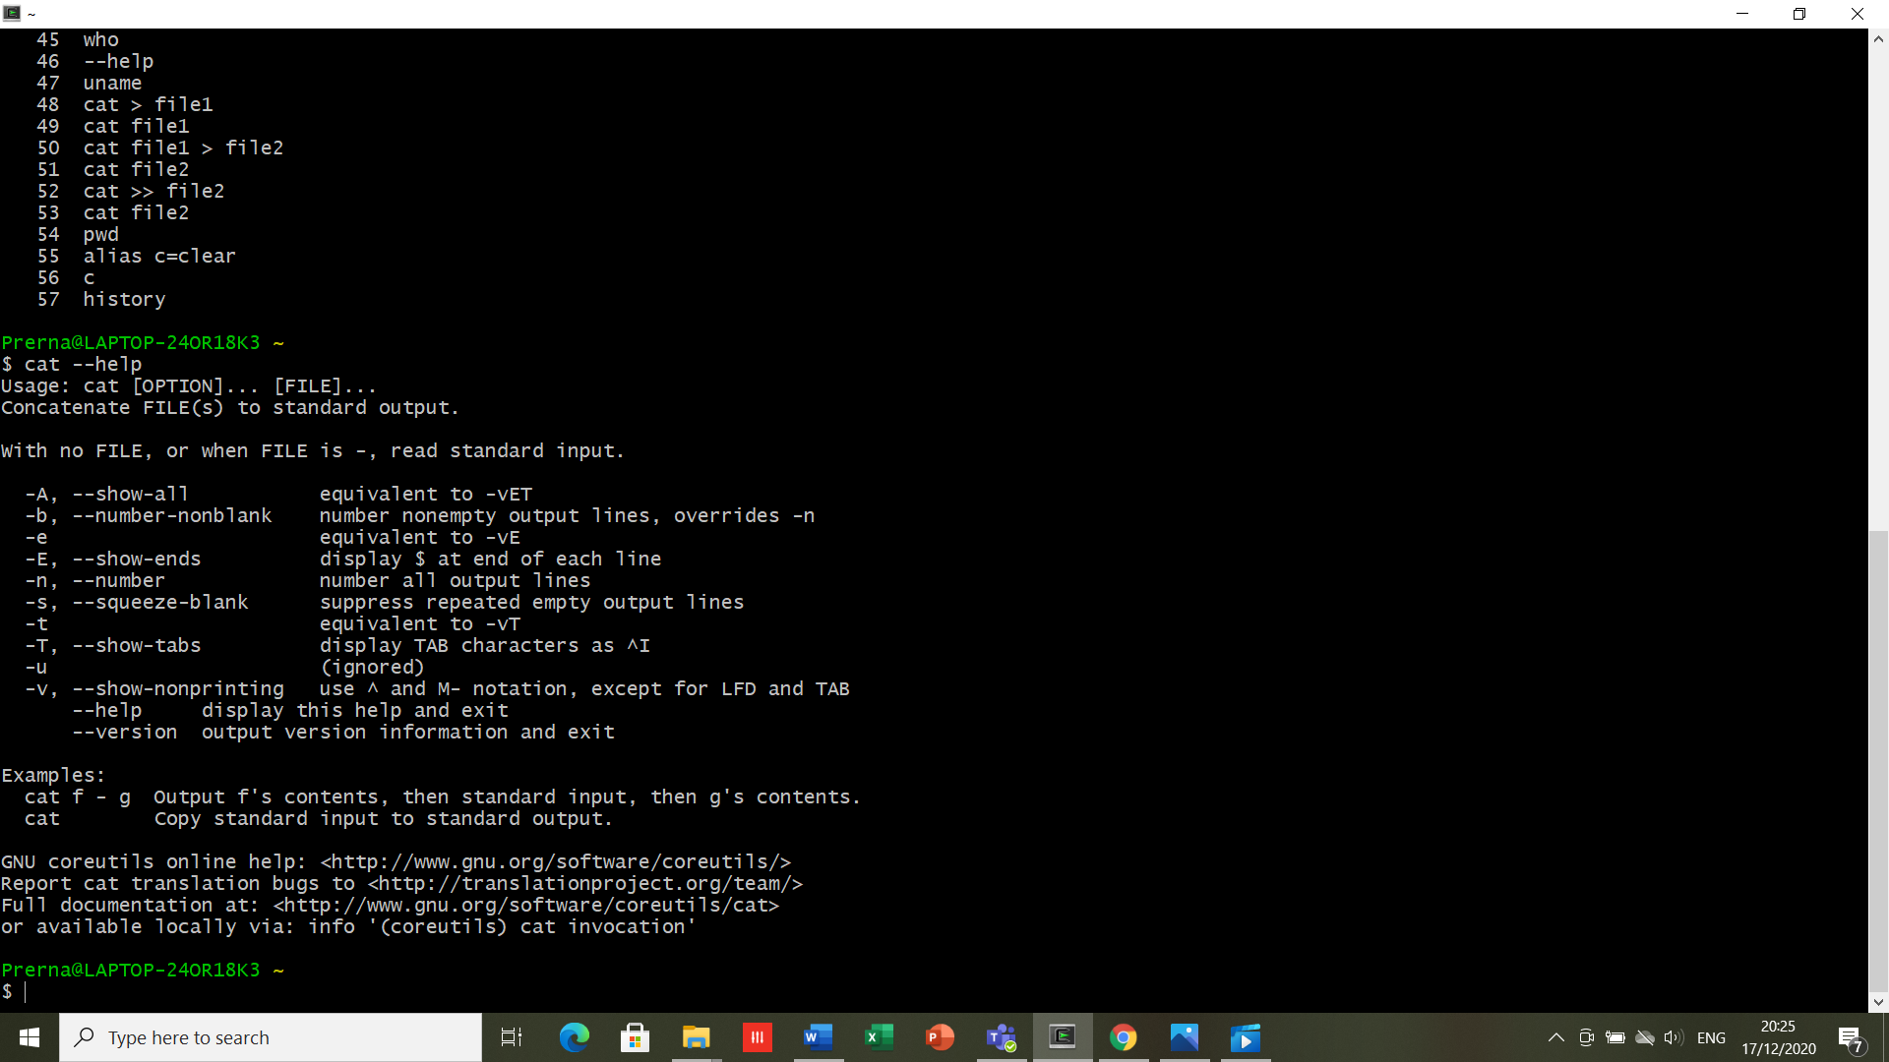

1. **cat-** it is the concatenation command, it is used to create single or multiple files, view and concatenate files.



1. **uname-**it prints the information about the linux system like machine number, operating system, kernel etc.



1. **alias-** it is used to give your own name to a command.

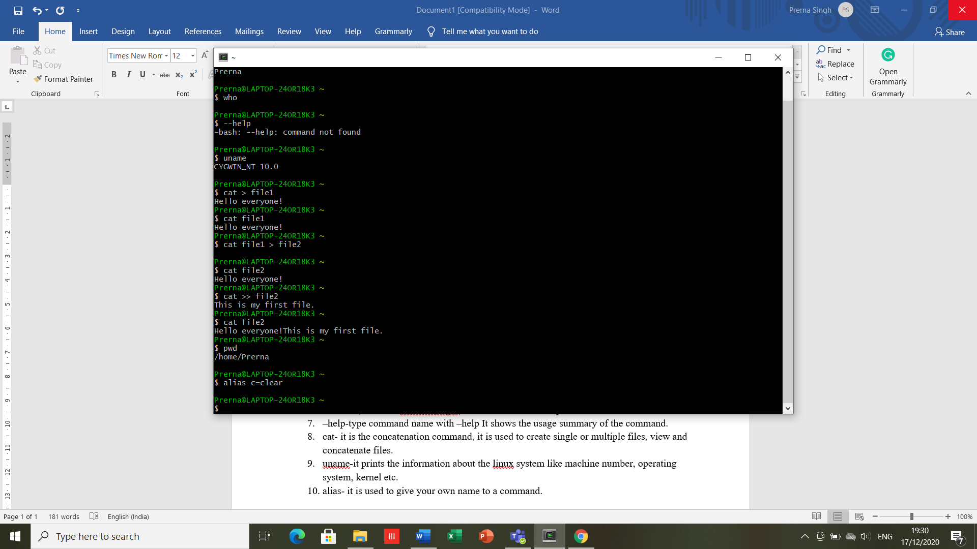

**RESULT-** Executed basic commands with some of their alternatives.

**EXPERIMENT- 2**

**DATE- 24/12/2020**

**OBJECTIVE-** To explore basic files and directories related Linux commands.

**SOFTWARE USED-** Cygwin

**THEORY-**

1. **mkdir-** use to make directories.

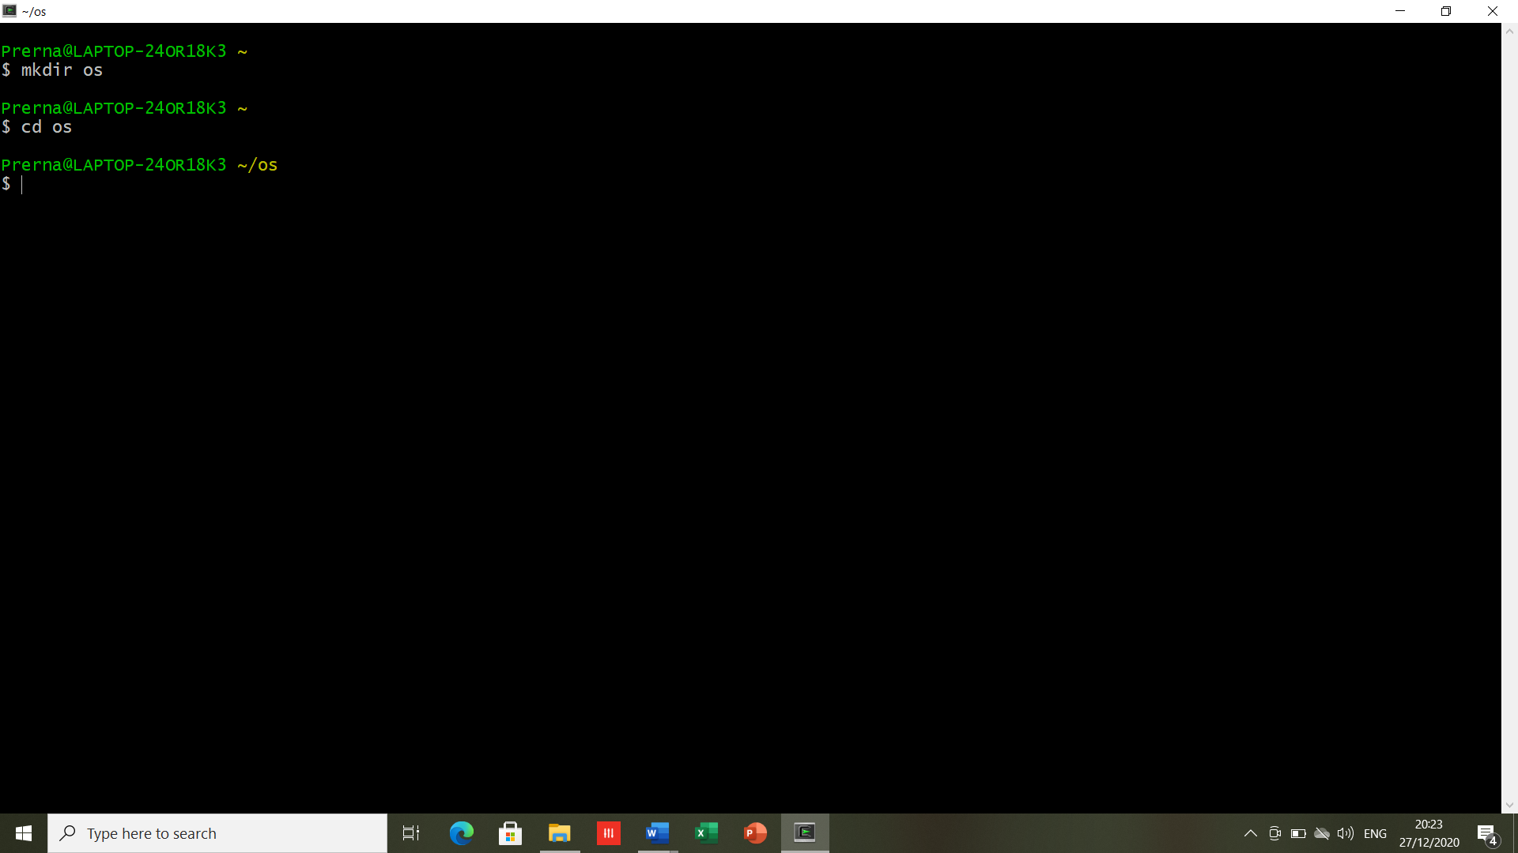

1. **cd-** stands for change directory. It is used to open the required directory. Switches between directories.



1. **ls-** It is used to list the directories contents.
   1. **ls -l:** long list (displays lots of information).
   2. **ls -t**: sorts the list by modification time.
   3. **ls -r:** reverse the order of list sorted by modification time.
   4. **ls-lt:** List the files by time in reverse order with long.

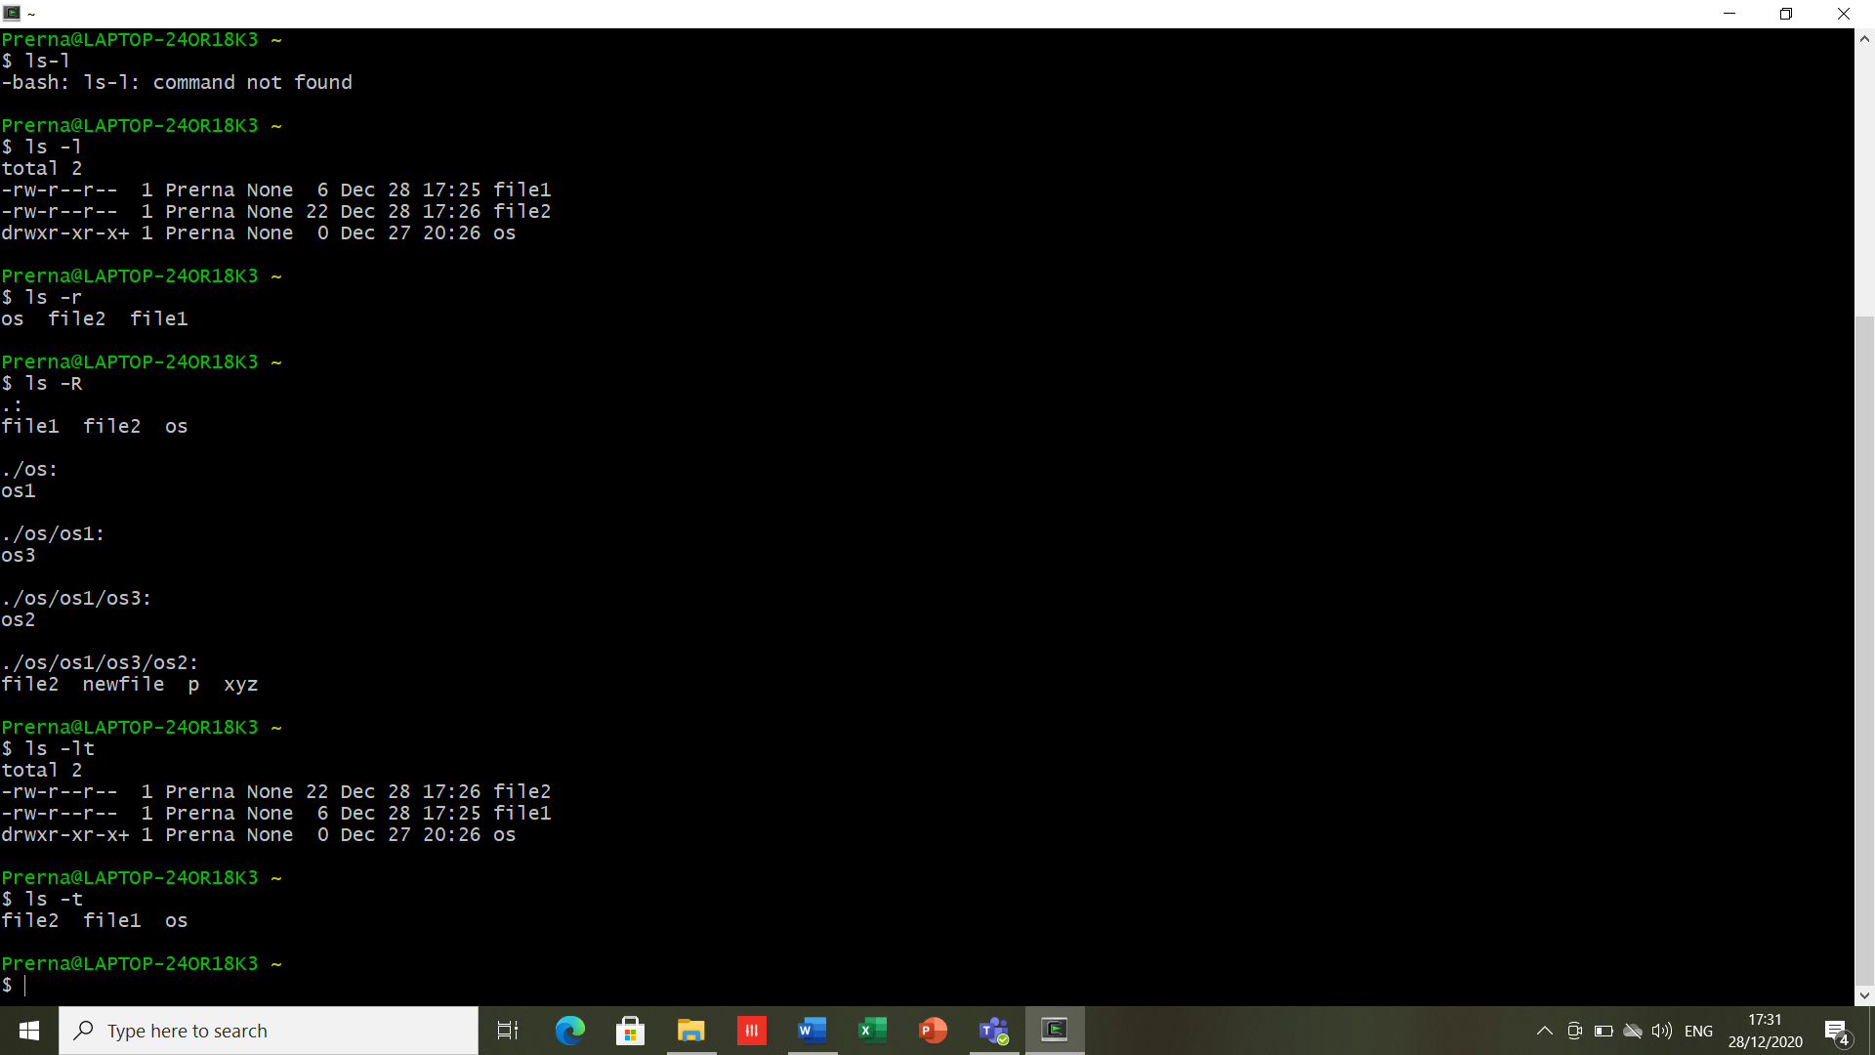



1. **mv-** moves files or directories from one place to another. Also, it is used to rename the files.

* Move:

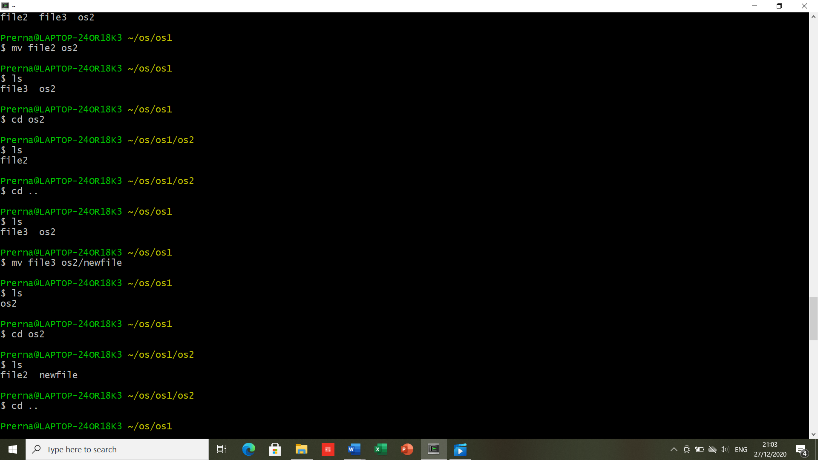

* Rename:

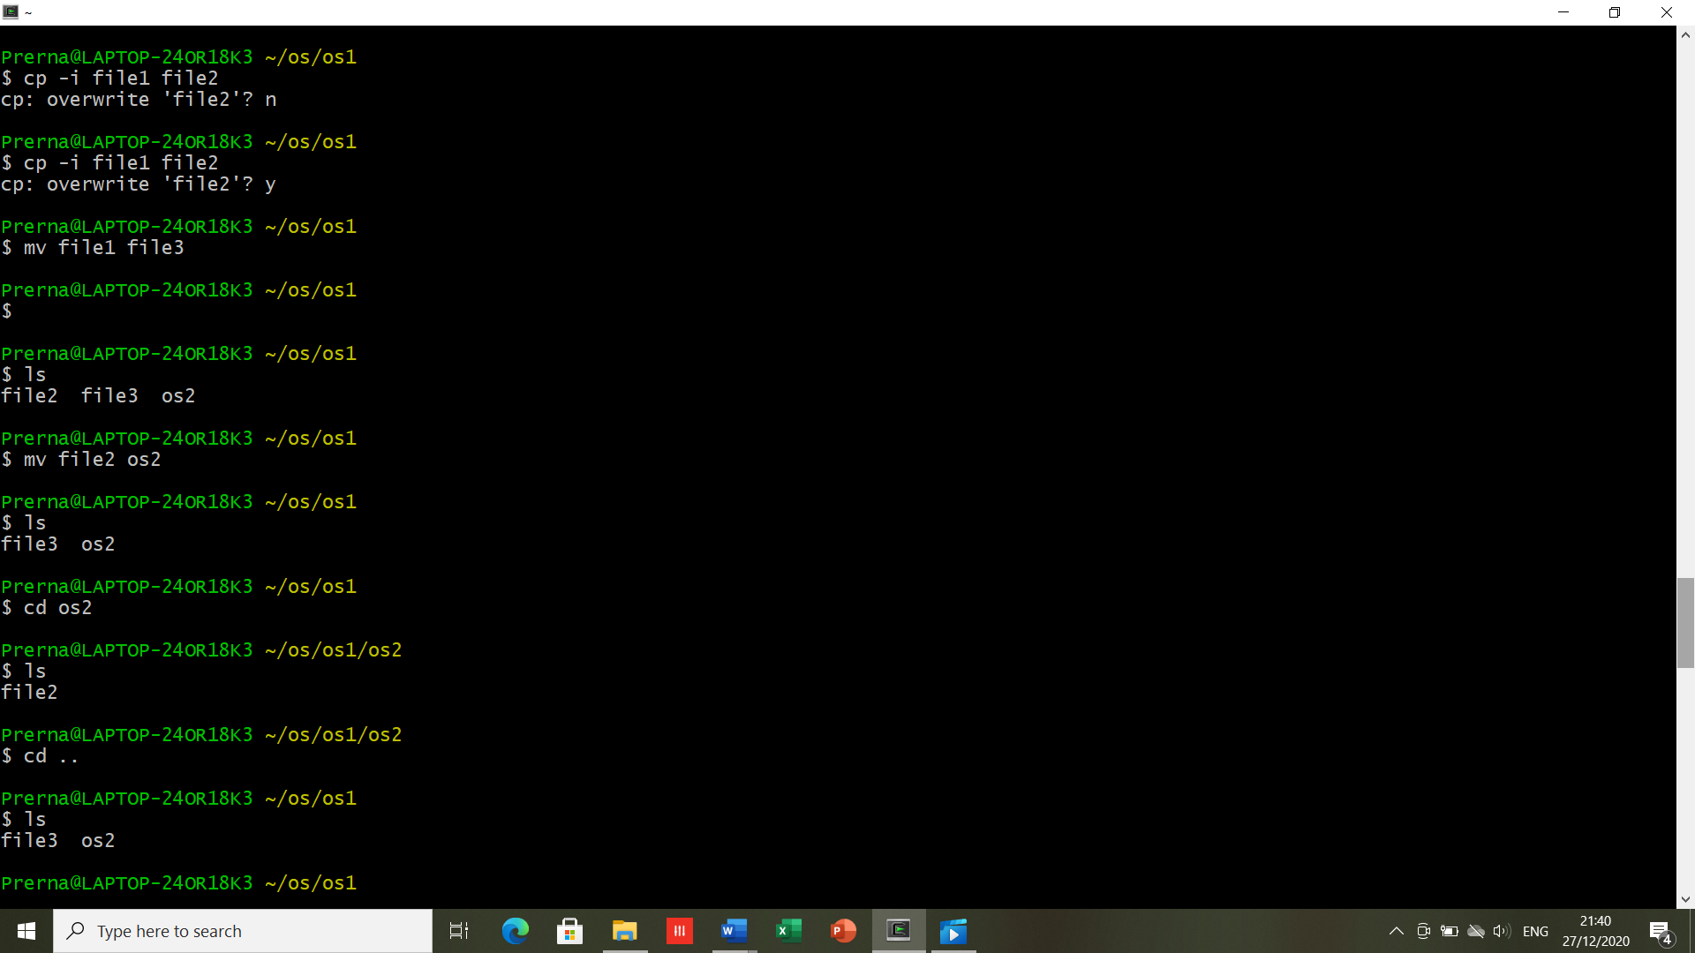

1. **cp-** it is used to copy the contents of a file or a directory.

* Copying file:

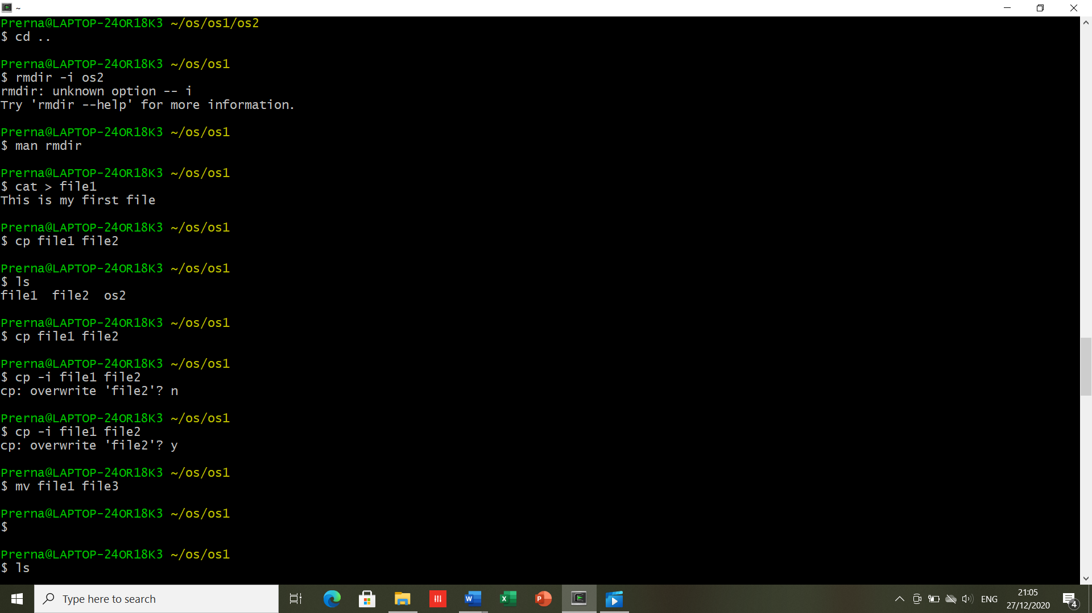

* Copying a directory:

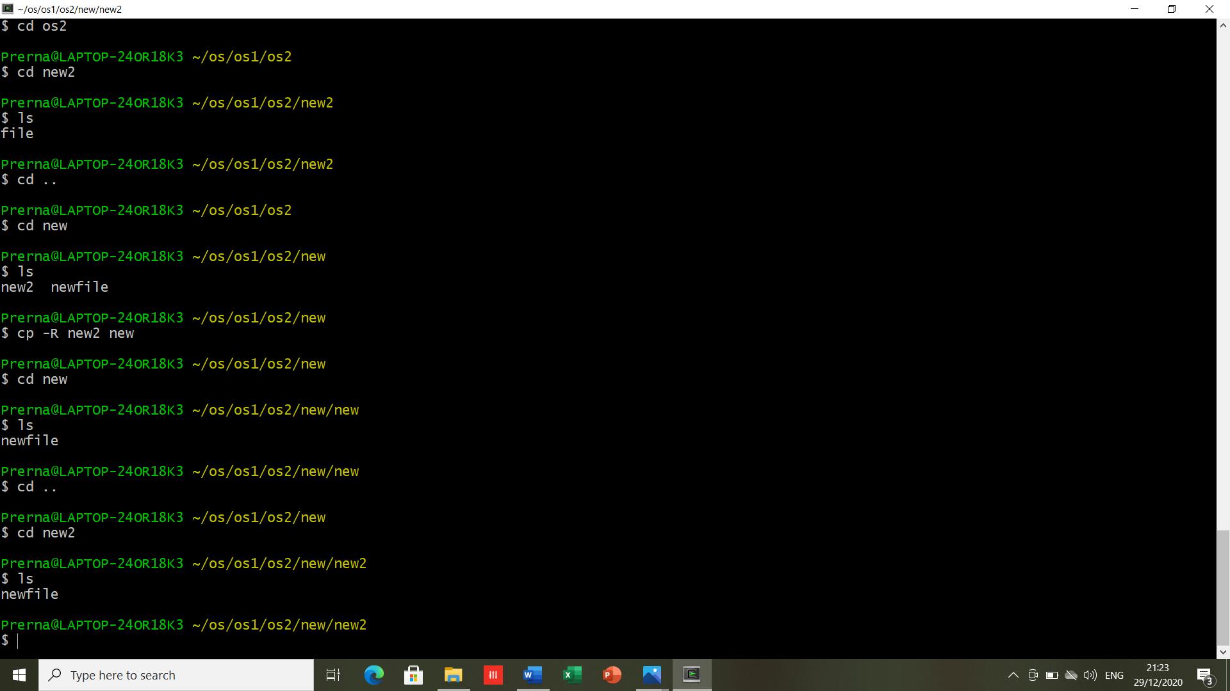



1. **rm-** It is used to remove a file or a directory.

* rm -r: is used to remove a file/ directory “recursively”.
* rmdir: is used to remove an empty directory.

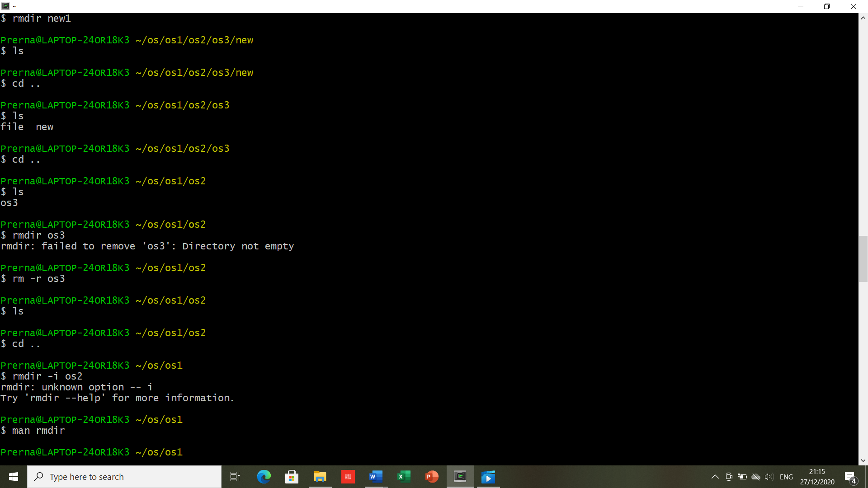

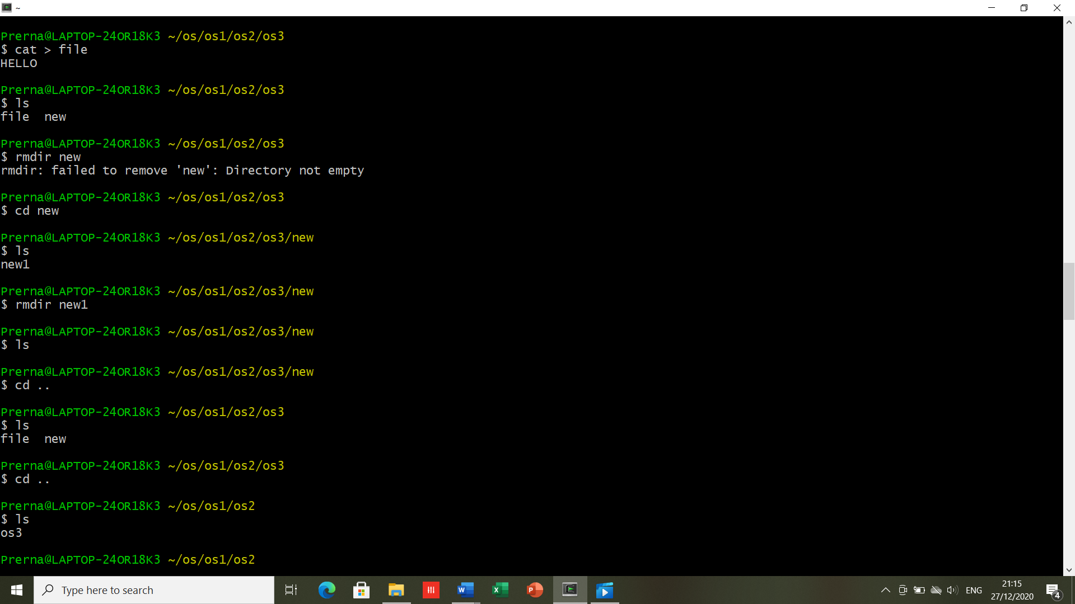

1. **link(ln)-** this keyword is used to create link between files.

A hard link is a mirror copy of the original file.

* **Hard link –> ln filename hard_link name​**

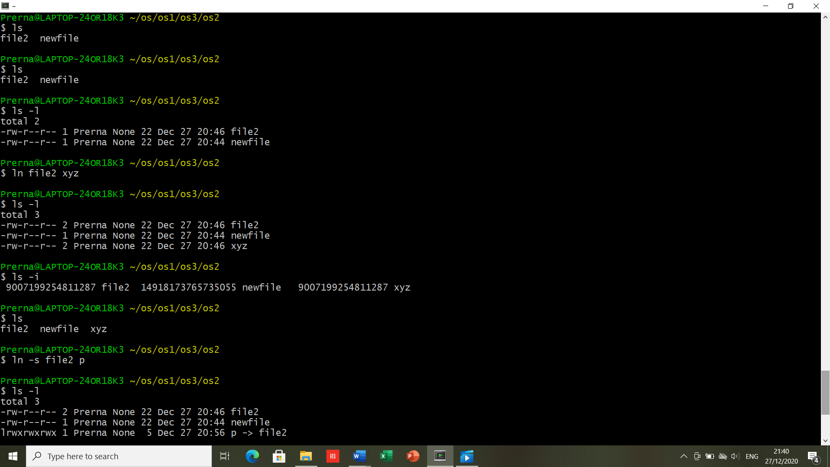

* **Soft Link –> ln –s filename soft_link name​**

**-** A soft link, is a special kind of file that points to another file, much like a shortcut in Windows. If you delete the original file, the soft link has no value, because it points to a non-existent file.

-s makes symbolic links instead of hard link.

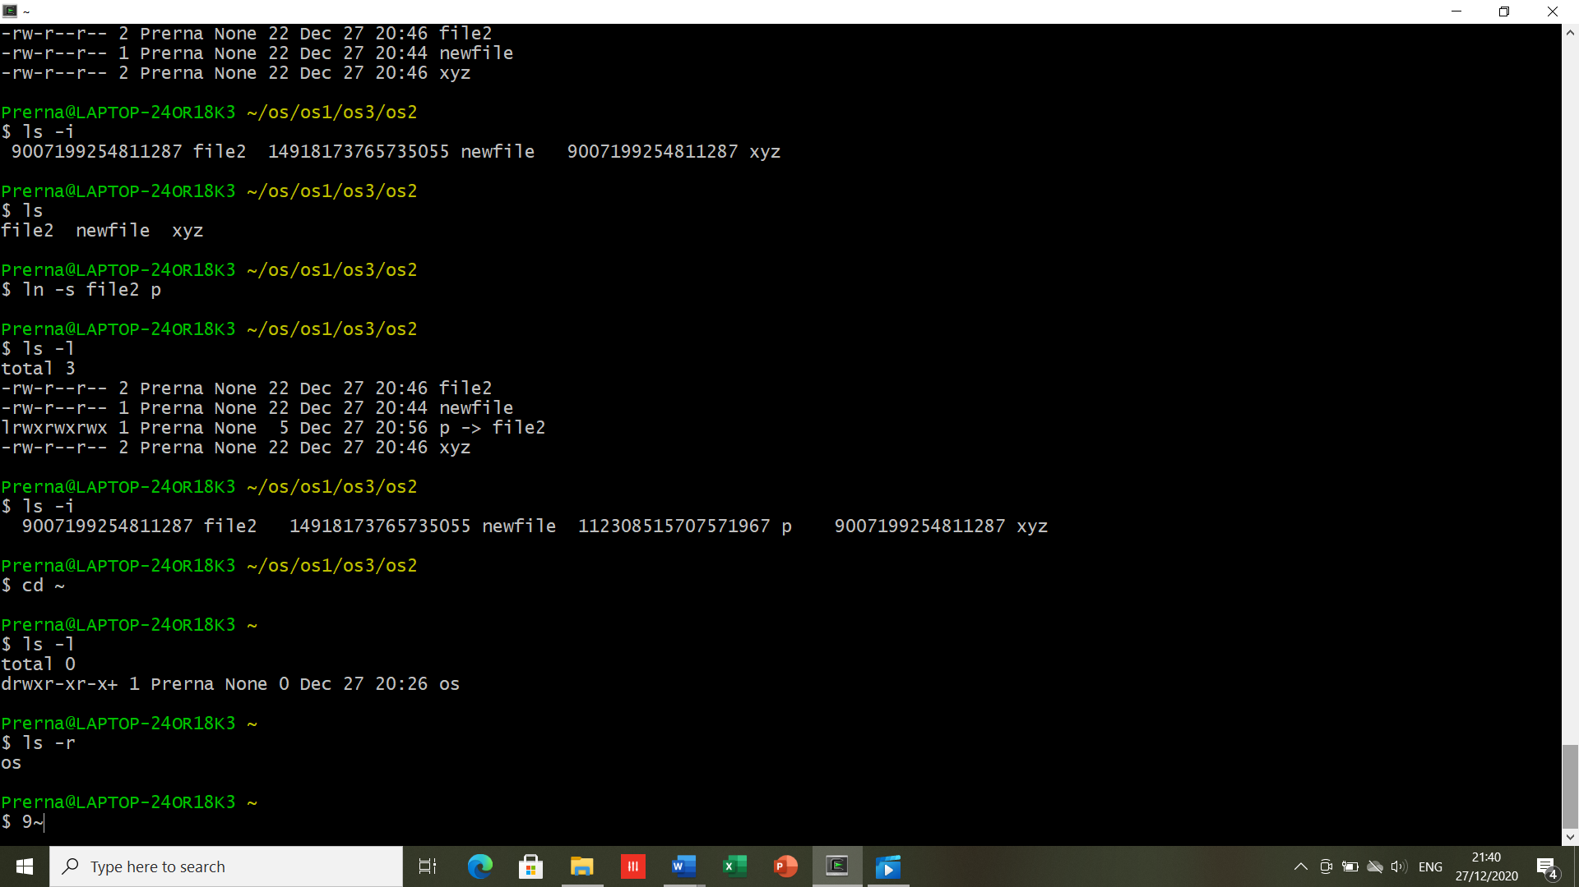

**RESULT-** Executed the basic files and directories related Linux commands successfully.

**DATE- 07/01/2021 EXPERIMENT -3**

**AIM**- To explore file and directory related commands, and using VI Editor.

**SOFTWARE USED**- Cygwin.

**THEORY-**

1. **wc**- It can return the number of lines in a file, the number of characters in a file and the number of words in a file. ​The output is number of lines, number of words, number of bytes, filename.

* -l: To print the number of lines in a file. ​
* -m: To print the number of characters in a file. ​
* -w: To print the number of words in a file.​

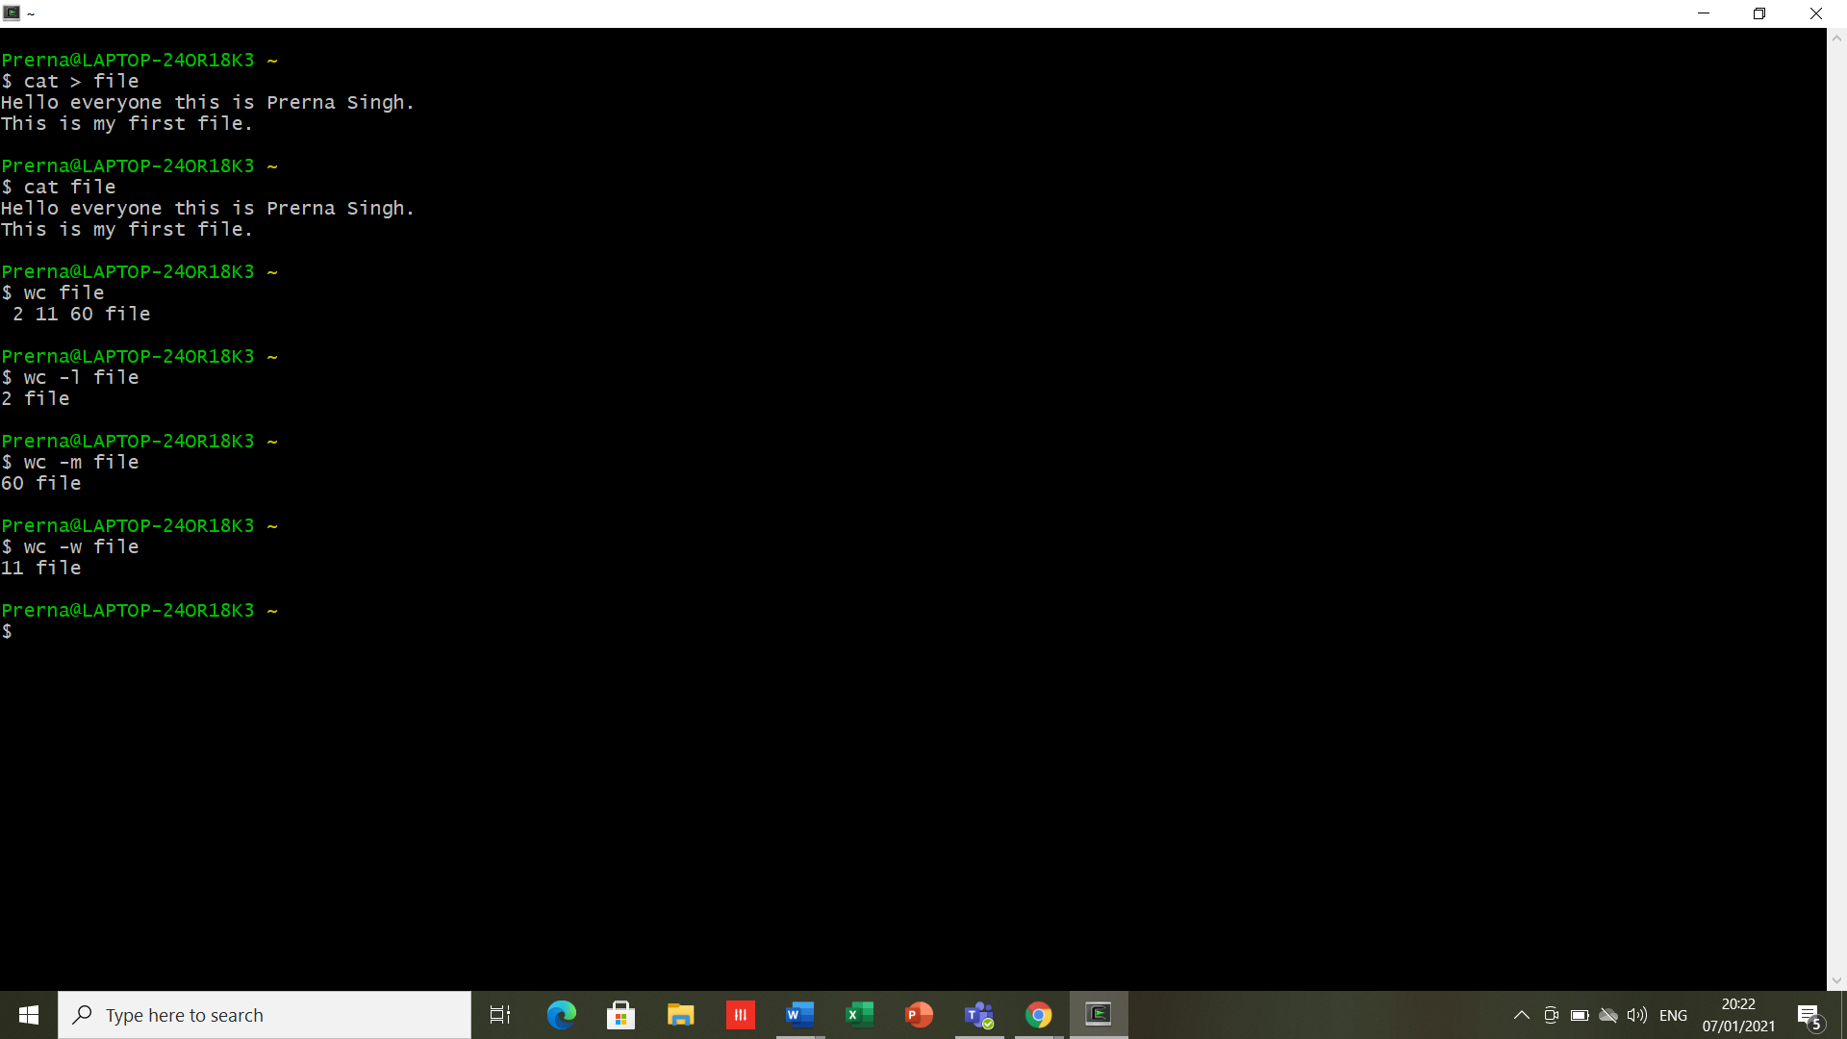

1. **cmp-** used to compare the two files byte by byte .​ It display the differing bytes in its output.

* **-b**: gives the detailed difference between the two files.
* **-I [bytes to be skipped from first file]**: this option, when used with cmp command, helps to skip a particular number of initial bytes from both the files and then after skipping it compares the files. ​
* **-i [bytes to be skipped from first file] : [bytes to be skipped from second file]** :This option is very much similar to the above -i [bytes to be skipped] option but with the difference that now it allows us to input the number of bytes we want to skip from both the files separately.​
* **-n [number of bytes to be compared]**: This option allows you to limit the number of bytes you want to compare, like if there is only need to compare at most 25 or 50 bytes.​

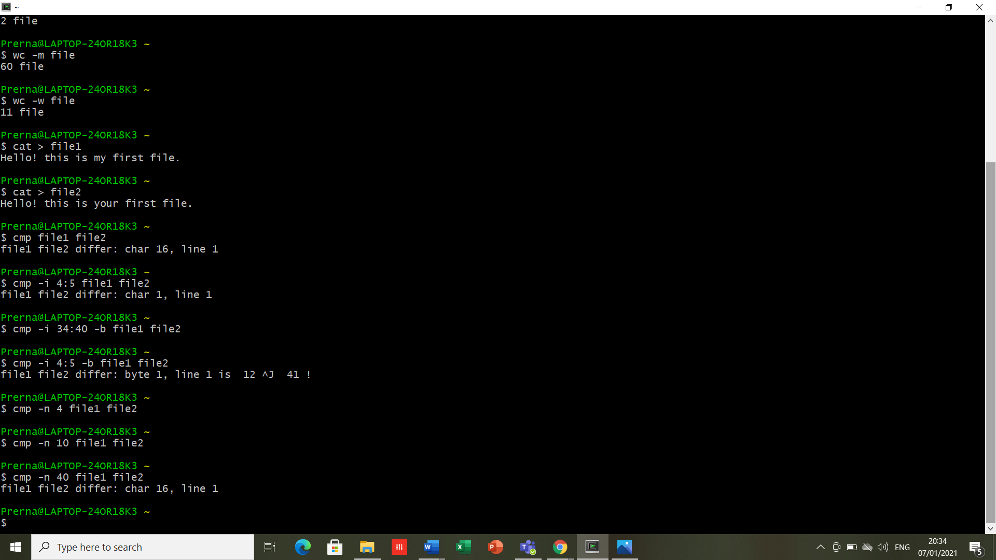





​

1. **comm-** It requires two sorted files, and lists the differing entries in different columns. It displays three-columnar output.

* The first column displays the lines unique to first file. The second column displays the lines unique to the second file. The third column displays the lines common to both the files.
* To drop a particular column, simply use its column number as an option prefix.

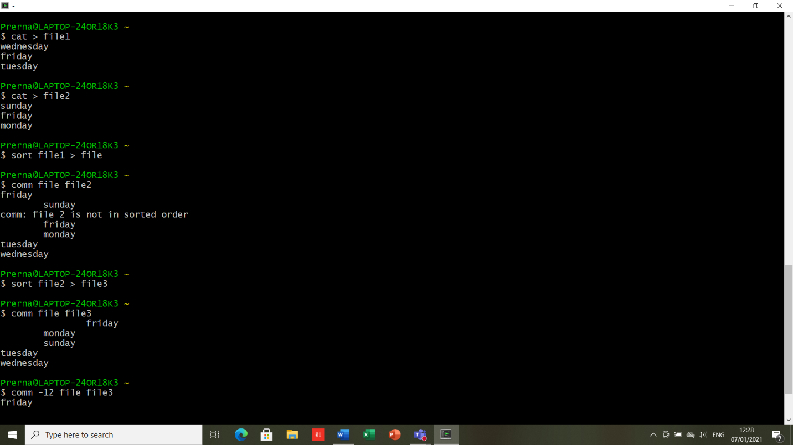

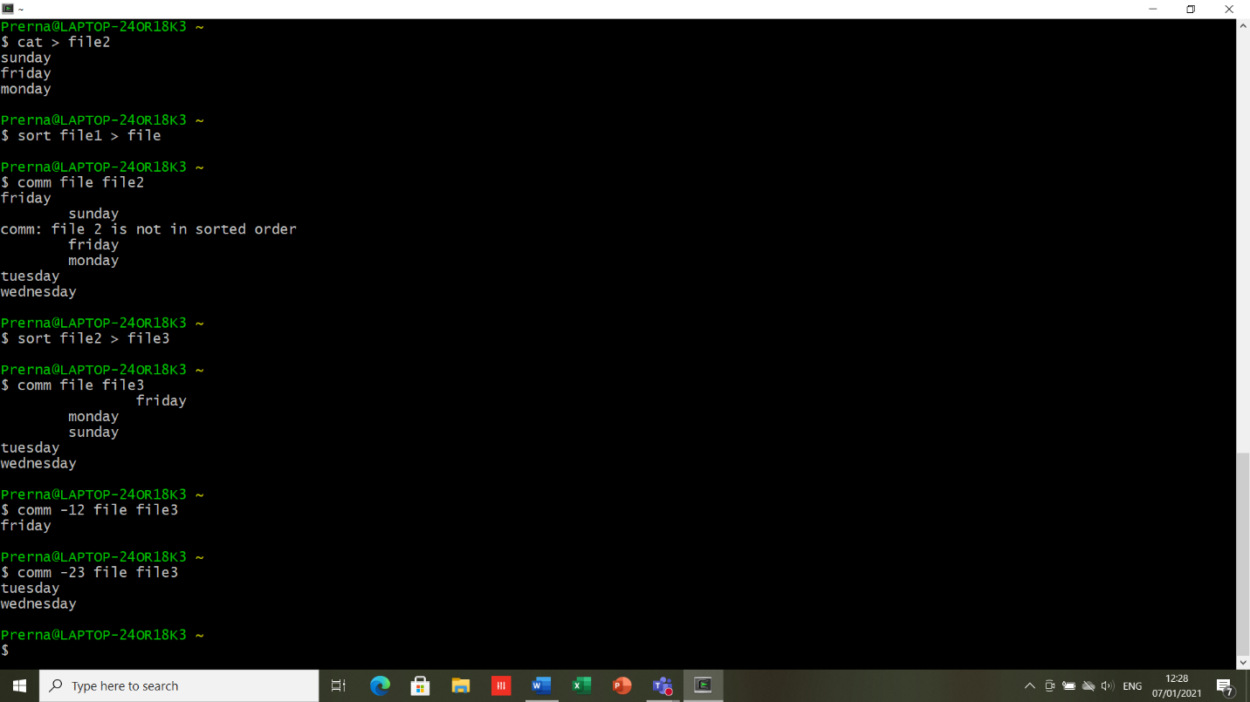

1. **sort-** It sort lines alphabetically by default.

Running sort filename writes the contents of the filename in alphabetical order to standard output. ​

* -r: It sorts in reverse order and write the result to standard output.​
* -n: This will sort from lowest number to highest number and write the result to standard output.​
* -u: To sort and remove duplicates pass the -u option to sort. This will write a sorted list to standard output and remove duplicates.

​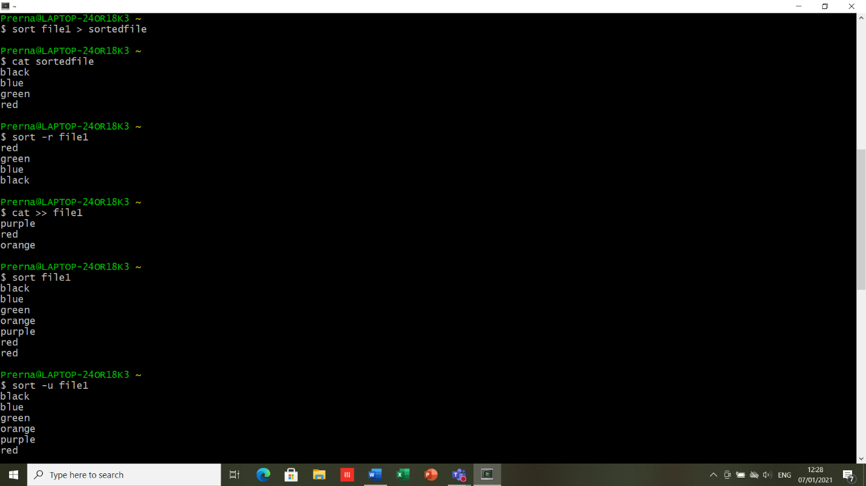

* -M : To sort by month pass the -M option to sort​. -m does not work. -M is to be used to sort a file by month.

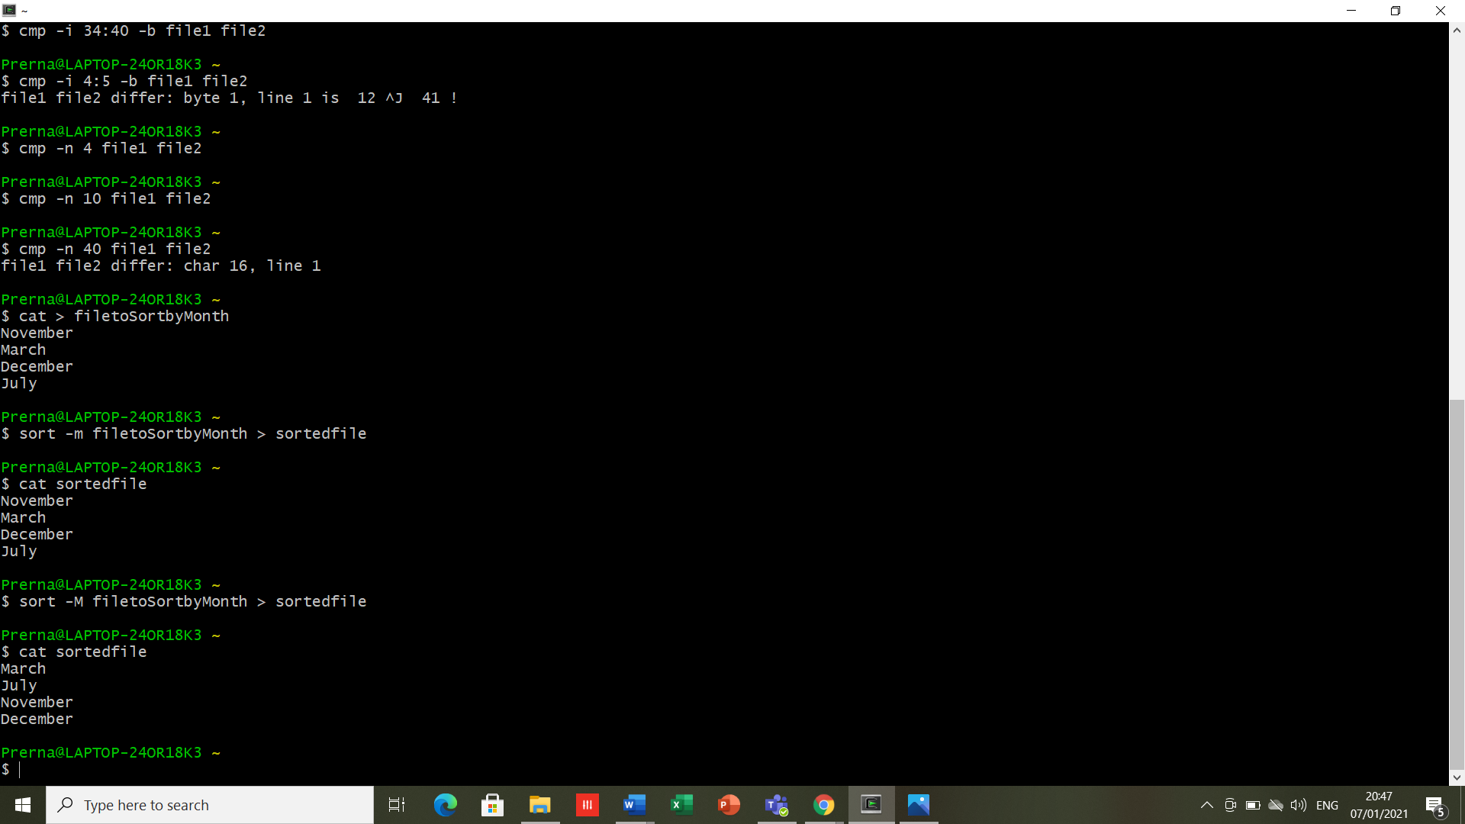





1. **VI-Editor**

The VI editor is the most popular and classic text editor in the Linux family.​

Below, are some reasons which make it a widely used editor –​

* 1. available in almost all Linux Distributions​
  2. works the same across different platforms and Distributions​
  3. user-friendly.

Modes of VI editor:

* Command Mode​
* Insert Mode​
* Escape Mode​

**Command Mode: (VI starts  in Command Mode.) ​**

VI interprets any characters we type as commands and  does not display them in the window. This mode allows us to move through a file, and to delete, copy, or paste a piece of text.​ To enter into Command Mode from any other mode, it requires pressing the [Esc] key. If we press [Esc] when we are already in Command Mode, then vi will beep or flash the screen.​

**Insert Mode: enables you to insert text into the file.**

Everything that’s typed in this mode is interpreted as input and finally, it is put in the file. The VI always starts in command mode. To enter text, you must be in insert mode. To come in insert mode you simply type ‘i’. To get out of insert mode, press the Esc key, which will put you back into command mode.​

**Escape Mode:**

Enables us to perform tasks such as saving files, executing commands.​ It is invoked by typing a colon [:], while VI is in Command Mode. The cursor will jump to the last line of the screen and VI will wait for a command. ​

VI Editing Commands:

* i - Insert at cursor (goes into insert mode)​
* a - Write after cursor (goes into insert mode)​
* A - Write at the end of line (goes into insert mode)​
* ESC - Terminate insert mode​
* U - Undo all changes to the entire line​
* o - Open a new line (goes into insert mode)​
* dd - Delete line​
* 3dd - Delete 3 lines.​
* D - Delete contents of line after the cursor​
* dw - Delete word​
* 4dw - Delete 4 words​
* cw - Change word​
* x - Delete character at the cursor​
* r - Replace character​
* R - Overwrite characters from cursor onward​
* s - Substitute one character under cursor continue to insert​
* S - Substitute entire line and begin to insert at the beginning of the line​
* Make sure you press the right command otherwise you will end up making undesirable changes to the file. ​
* You can also enter the insert mode by pressing a, A, o,  ​

Moving within a file:

* k - Move cursor up​
* j - Move cursor down​
* h - Move cursor left​
* l - Move cursor right​

Saving and closing file:

​

* :w - Save the file but keep it open​
* :q - Quit without saving​
* :wq - Save the file and quit​

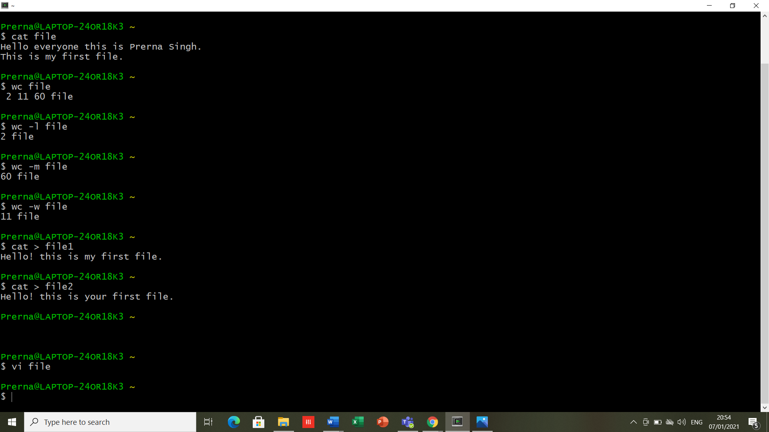

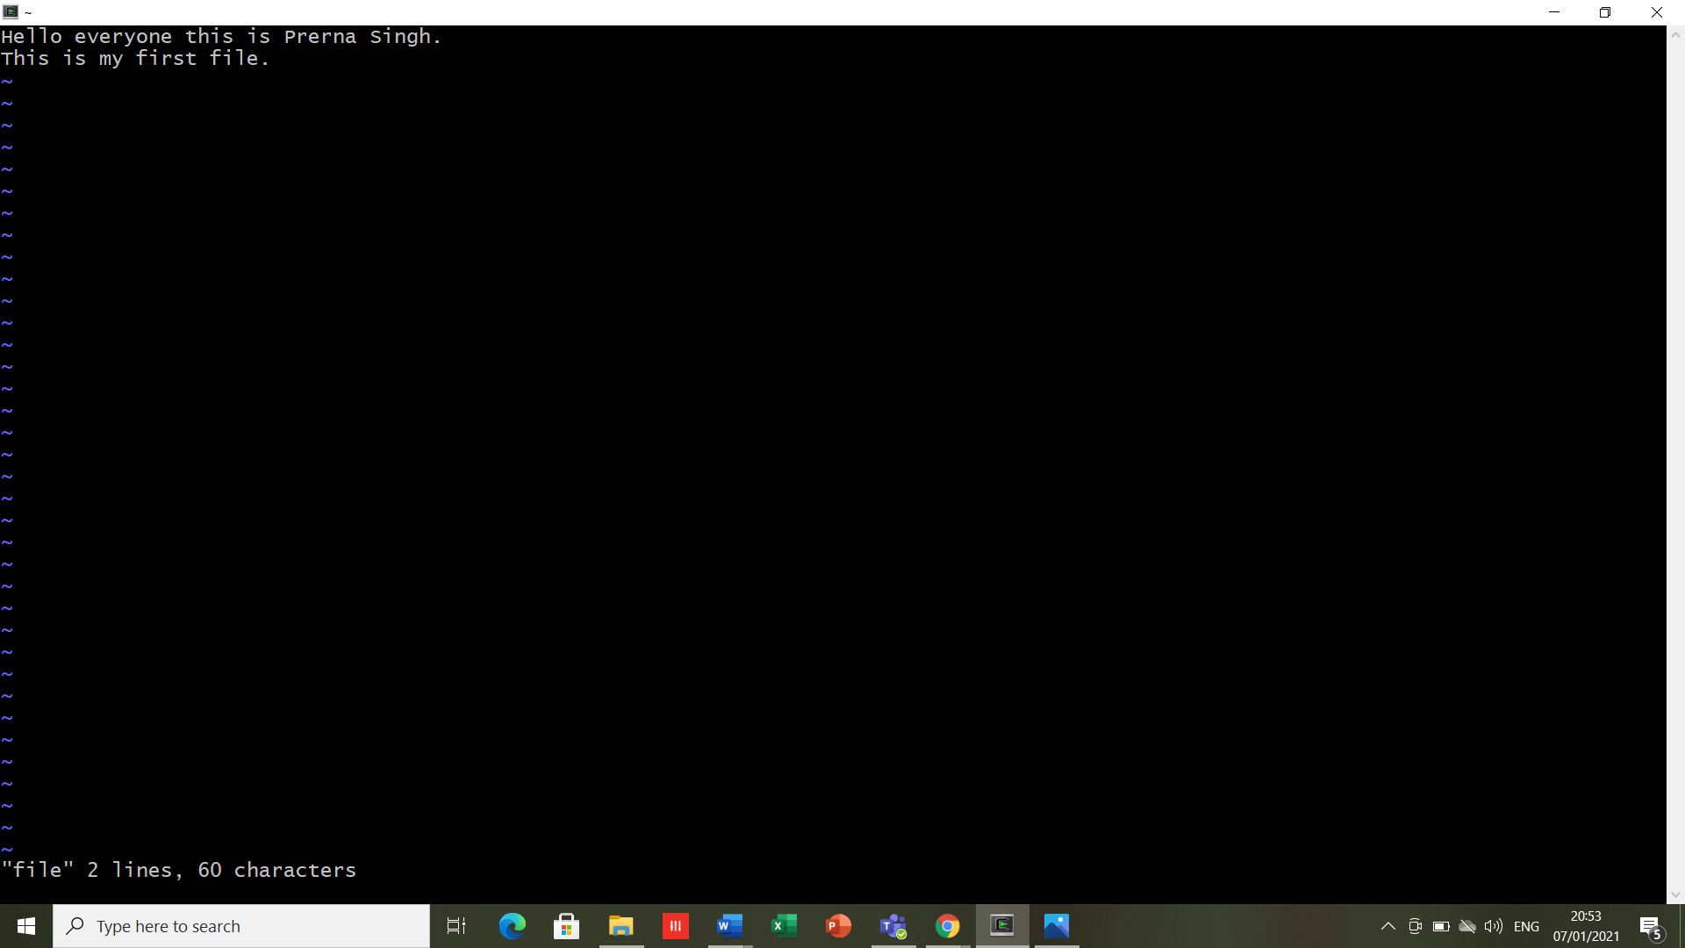

**RESULT-** Worked in VI Editor, and executed the file/directory related commands.

**DATE- 14/01/2021 EXPERIMENT -4**

**AIM**- To explore file and directory related commands in Linux.

**SOFTWARE USED**- Cygwin.

**THEORY-**

1. **chmod:** The chmod command allows you to change the permissions on a file using either a symbolic or numeric mode or a reference file.

There are three types of permissions: read (**r**), write (**w**), and execute (**x**).

* To **read** a file is to view its contents. For example, a text file must have **read** permission for someone to read the text within.
* If the user wants to add a sentence to that file, it needs **write** permission.
* The **execute** permission enables someone to run a file, such as a shell script or a binary program file.

Numeric value for the above permissions:

* r (read) = 4
* w (write) = 2
* x (execute) = 1

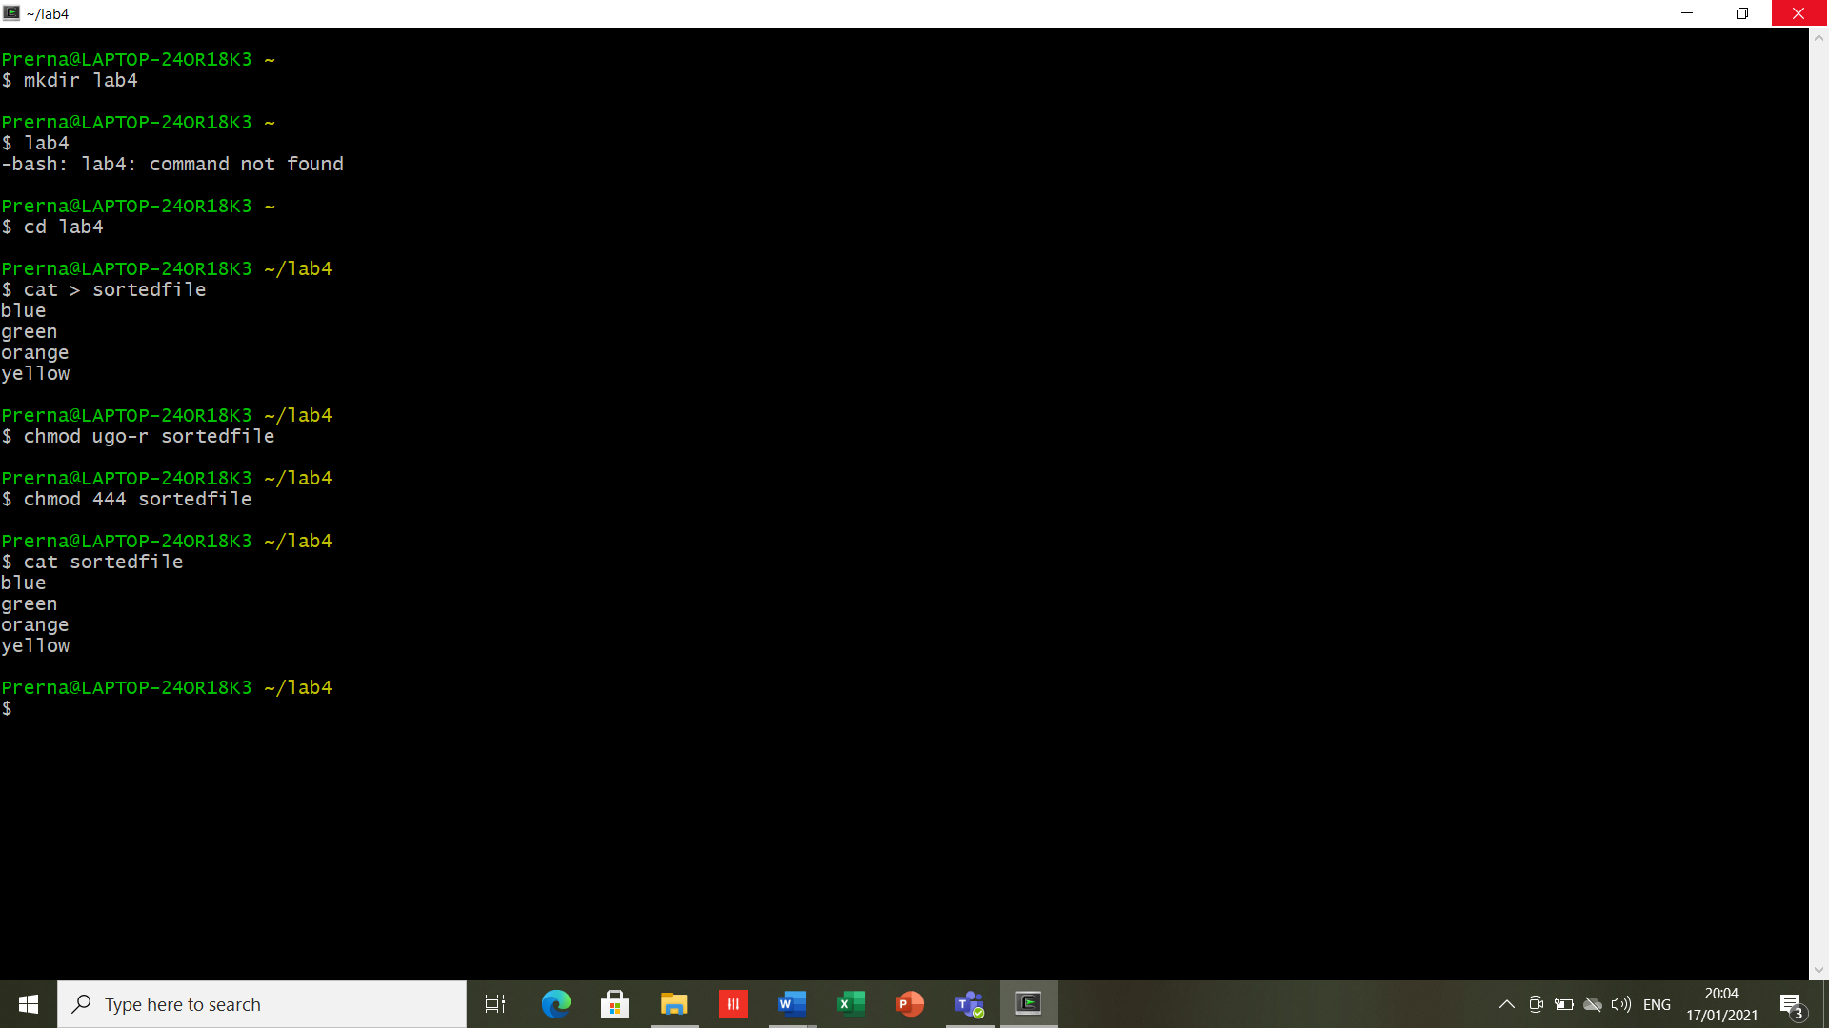

*Similarly is the case with w (write) and x (execute).*

Also, there are some operations associated with this command.

* **-** Removes the specified permissions.
* **+** Adds specified permissions.
* **=** Changes the current permissions to the specified permissions. If no permissions are specified after the = symbol, all permissions from the specified user class are removed.

**chmod** command can also work on *directories* as it works for the files of Linux.

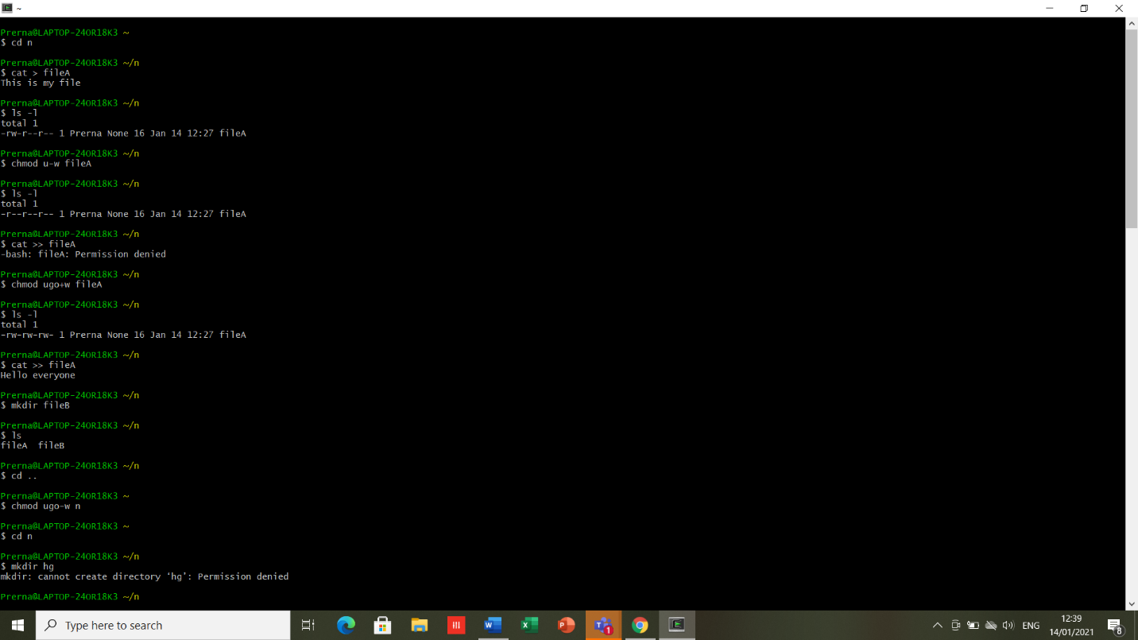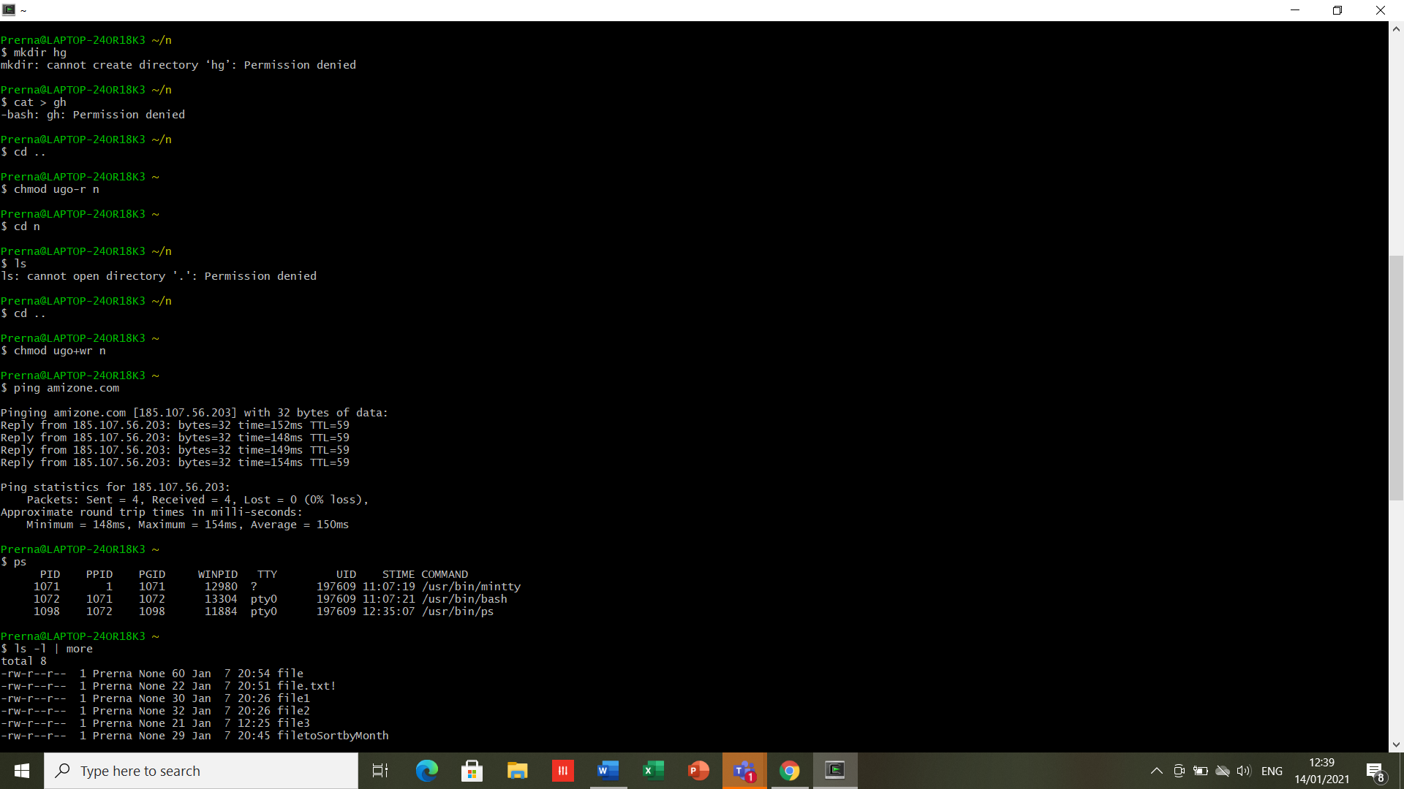

1. **ping:** The ping command lets you verify that you have network connectivity with another network device. It is commonly used to help troubleshoot networking issues. To use ping, provide the IP address or machine name of the other device.



1. **grep:** This command searches the named input *FILE*s, for lines containing a match to the given *PATTERN*. We use a grep command to search for a particular string/word in a text file.

* *grep options file1.txt* //Returns results for matching string “options”.
* *grep -I options file1.txt* //Returns results for case insensitive strings.
* *grep -n options file1.txt* //Returns the matching strings along with their line number.
* *grep -v options file1.txt* //Returns result of lines not matching the search string.
* *grep -c options file1.txt* //Returns results for matching string “options”.
* *grep -e options -e options1 file.txt //*Returns results for matching string “options” and “options1”

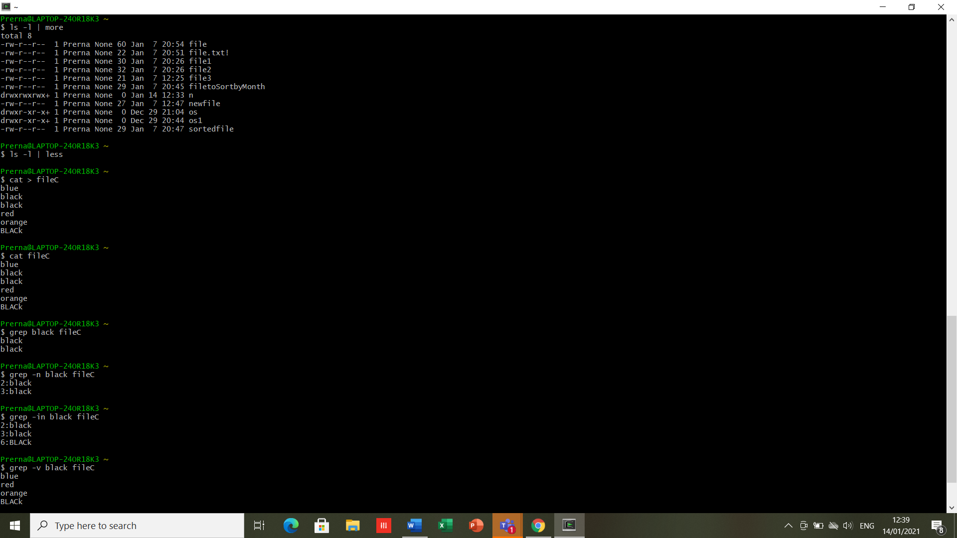

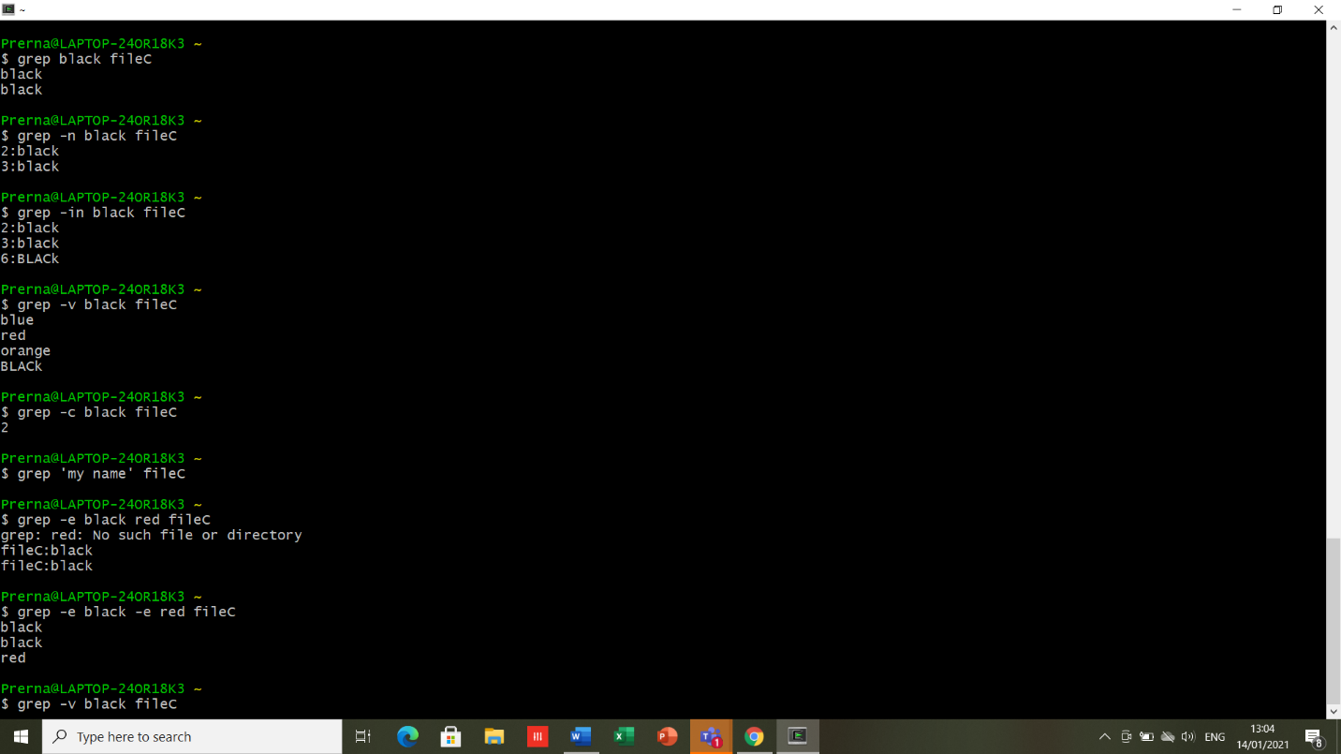



1. **Pipes:** A pipe is nothing but a temporary storage place, where the output of first command is stored and then passed as an input to the second command. It is used to run more than one command in a single command line.

* A pipe is a form of redirection (transfer of standard output to some other destination) that is used in Linux and other Unix-like operating systems to send the output of one command/program/process to another command/program/process for further processing.
* You can make it do so by using the pipe character ‘|’.
* It can also be visualized as a temporary connection between two or more commands/ programs/ processes.
* Pipes are unidirectional **i.e. data flows from left to right through the pipeline.**
* The pipe acts as a container which takes the output of ls -l and gives it to more as input. This command does not use a disk to connect standard output of ls -l to the standard input of more because pipe is implemented in the main memory.

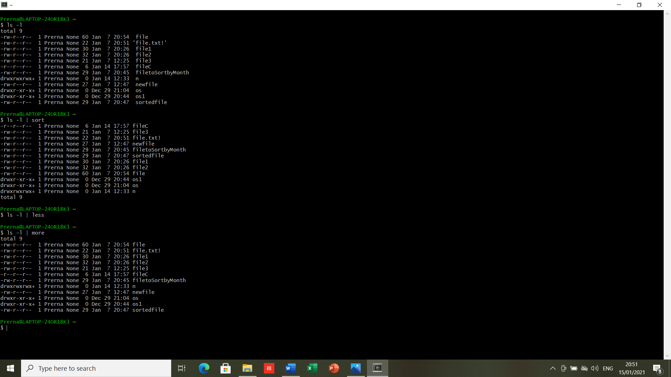

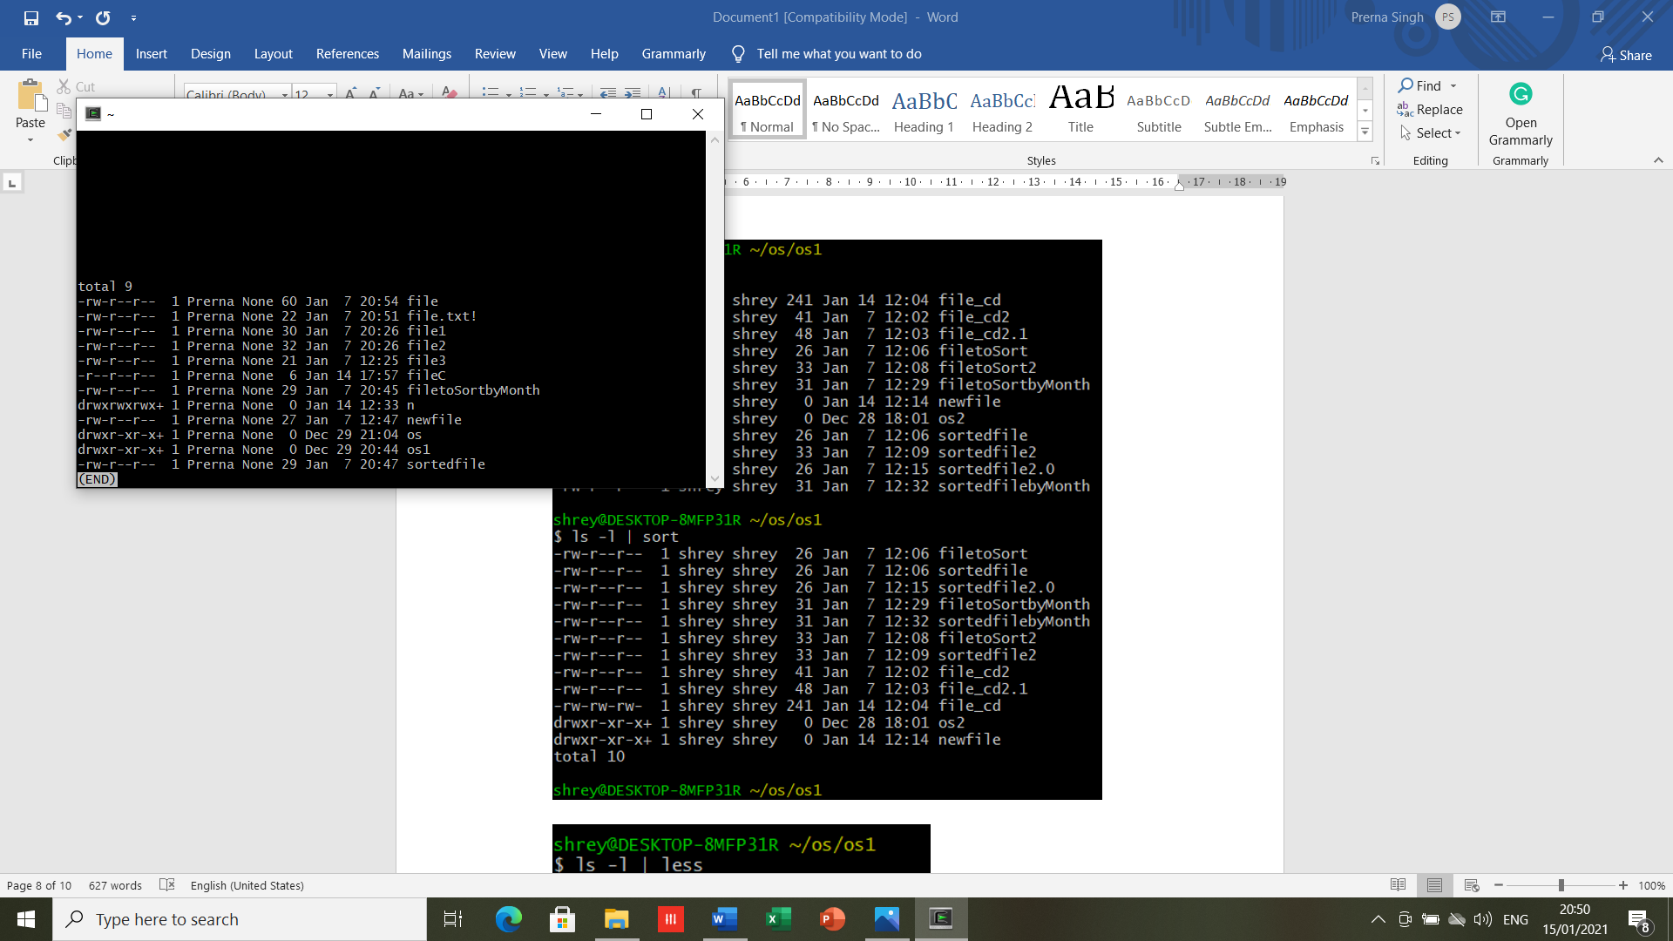



1. **TTY-** TTY is a command in Unix and Unix-like operating systems to print the file name of the terminal connected to standard input. TTY stands for *TeleTYpewriter*.

The TTY command basically prints the file name of the terminal connected to standard input.

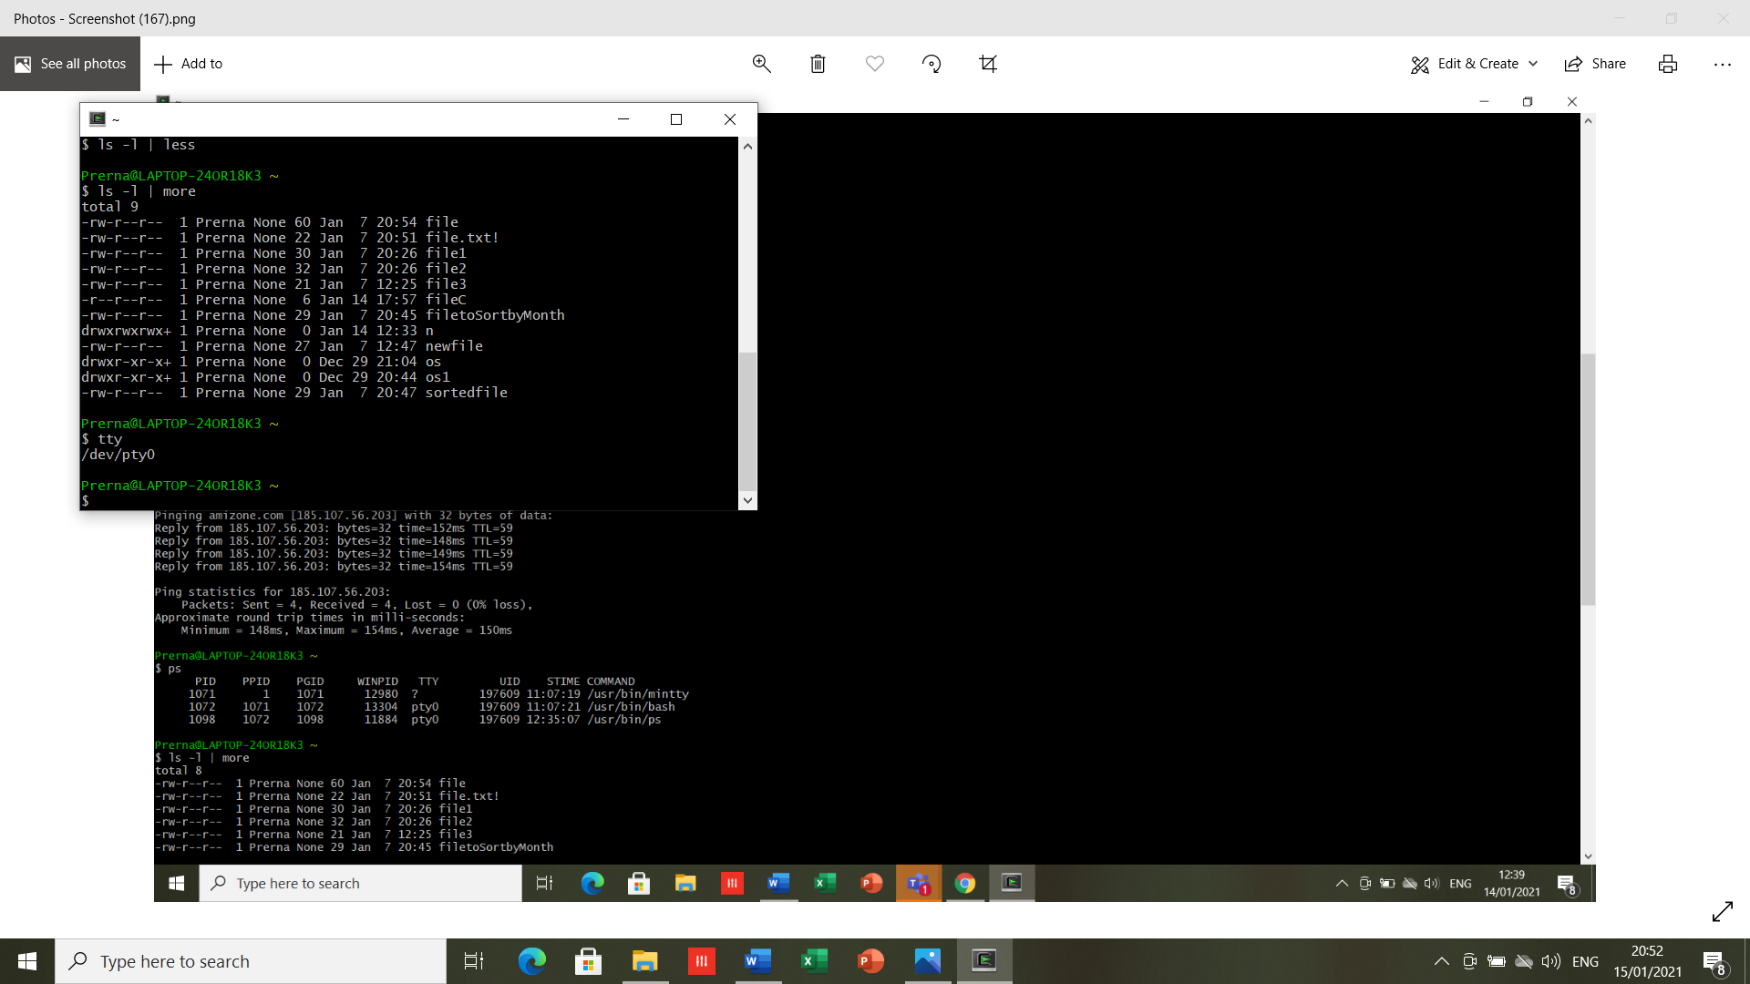

1. **ps-** The ps command lists running processes. Using ps without any options causes it to list the processes running in the current shell.

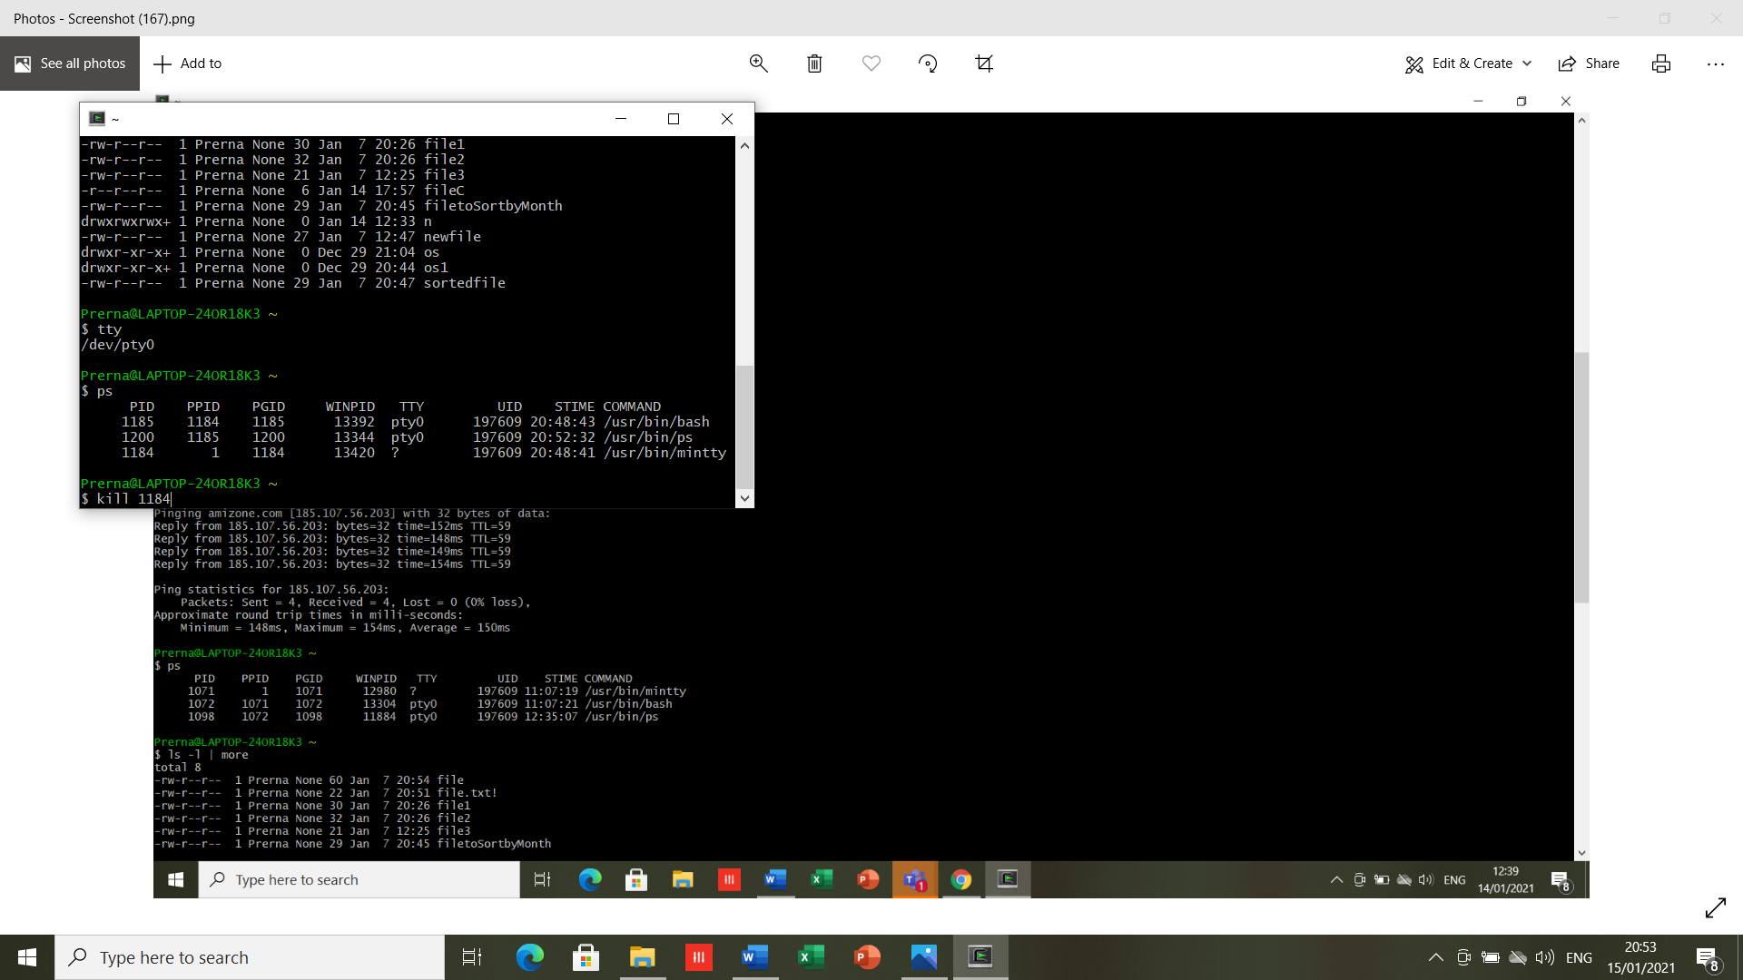

1. **kill:** It is used to terminate processes manually. *kill* command sends a signal to a process which terminates the process. If the user doesn’t specify any signal which is to be sent along with kill command then default *TERM*signal is sent that terminates the process.



* terminates the Cygwin terminal.

**RESULT-** Executed the file/directory related programs.

**EXPERIMENT -5**

**DATE-21/01/2021**

**AIM-** To explore Shell scripting using Vi editor

**SOFTWARE USED-** Cygwin

**THEORY-** Shell is the user interface to the operating system. It accepts human readable commands from user and convert them into something understandable by the kernel. Shell is after all, a real programming language, complete with variables, control structures, and so forth. Shell scripts are needed to avoid repetitive work and automation, System monitoring and adding new functionality to the shell etc. each shell script is saved with the .sh extension.

1. A shell script is a regular text file that contains shell or commands​

* Before running it, it must have execute permission:​ **chmod** **+x *filename***​
* A script can be invoked as:​

**./filename.sh**​

* When a script is run, the **kernel** determines which shell it is written for by examining the first line of the script​
* If 1st line starts with **#!*pathname-of-shell***, then it invokes *pathname* and sends the script as an argument to be interpreted​
* If **#!** is not specified, uses default shell​
* If a shebang is not specified the script will be parsed by whatever the default interpreter is used by that Shell. For example, the default interpreter for bash is bash and for zsh is sh.​
* The sequence of characters (#!) is called shebang and is used to tell the operating system which interpreter to use to parse the rest of the file.​

1. echo prints the rest of the line to the screen (standard output).​
2. Variable Names​

* The name of a variable can contain only letters (a to z or A to Z), numbers ( 0 to 9) or the underscore character ( _).​
* To access the value stored in a variable, prefix its name with the dollar sign ($) ​

*To set:*​

***name=value***​

*To Read:****$var***​

1. Arithmetic operator

* shell didn't originally have any mechanism to perform simple arithmetic operations but it uses external programs​.
* Use external command **/bin/expr**​
* **expr** **expression** ​

Evaluates expression and sends the result to standard output.​

* There must be spaces between operators and expressions.
* The complete expression should be enclosed between **‘ ‘**, called the backquote​.

1. **Write a program to swap 2 numbers.**

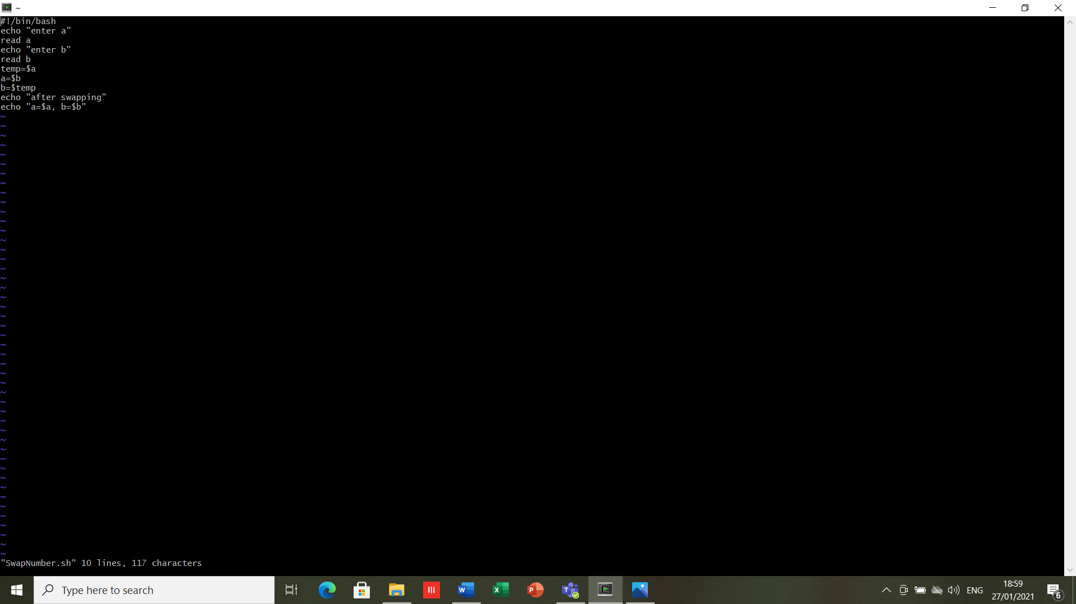

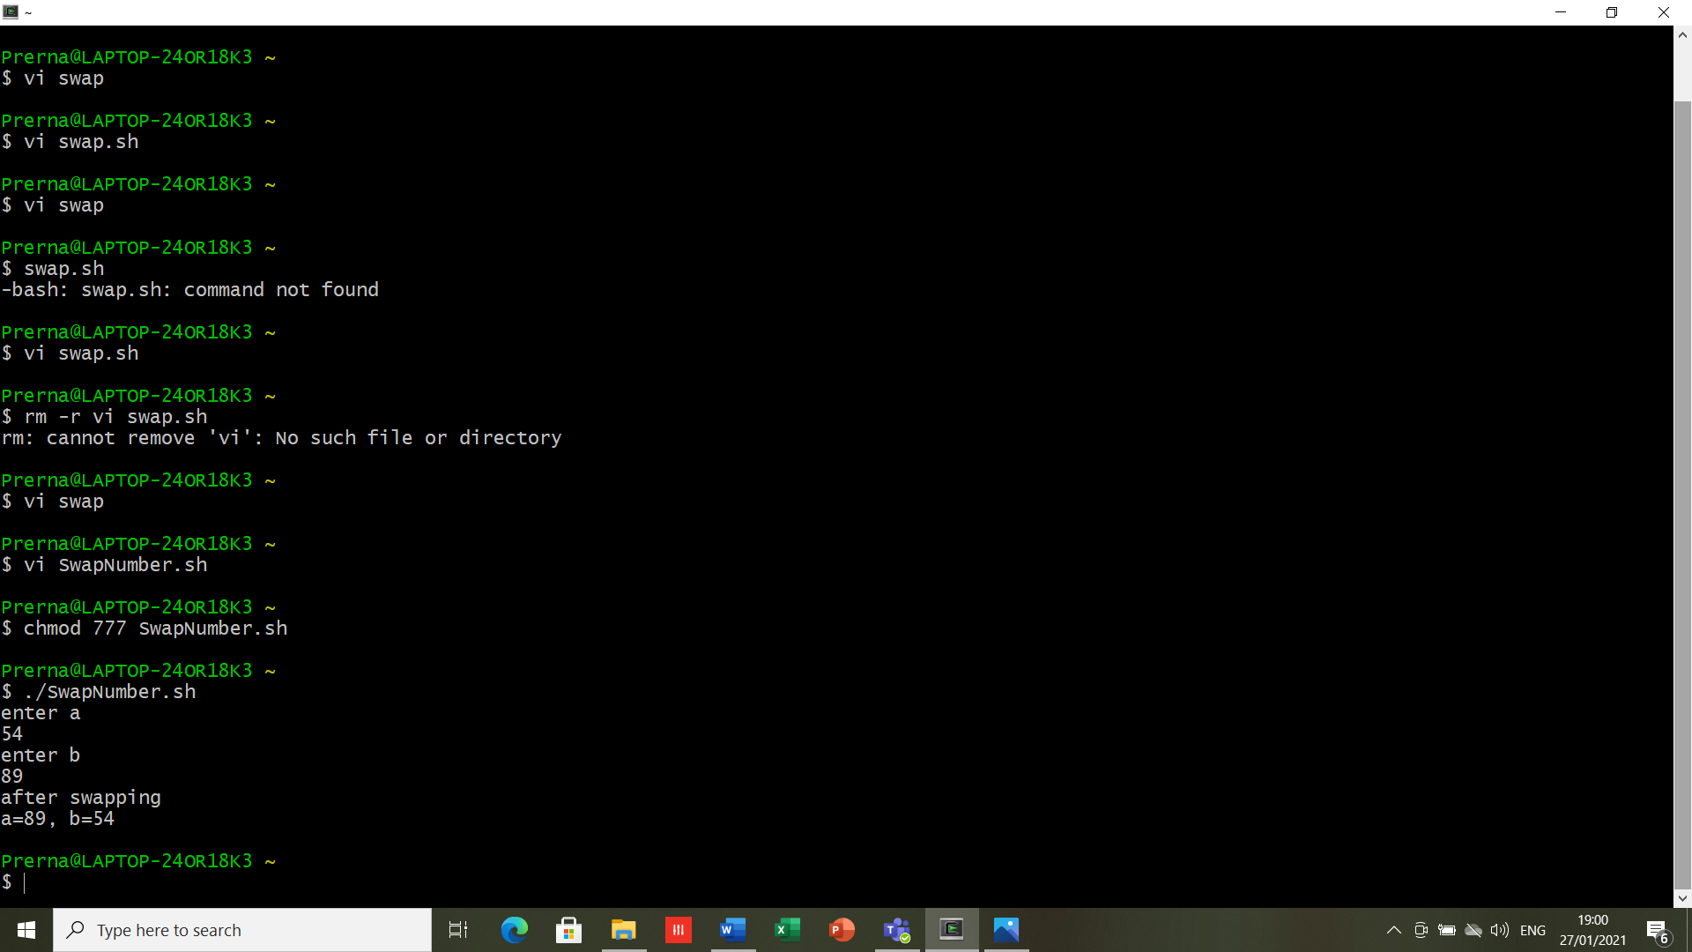

1. **Write a script to delete file.**

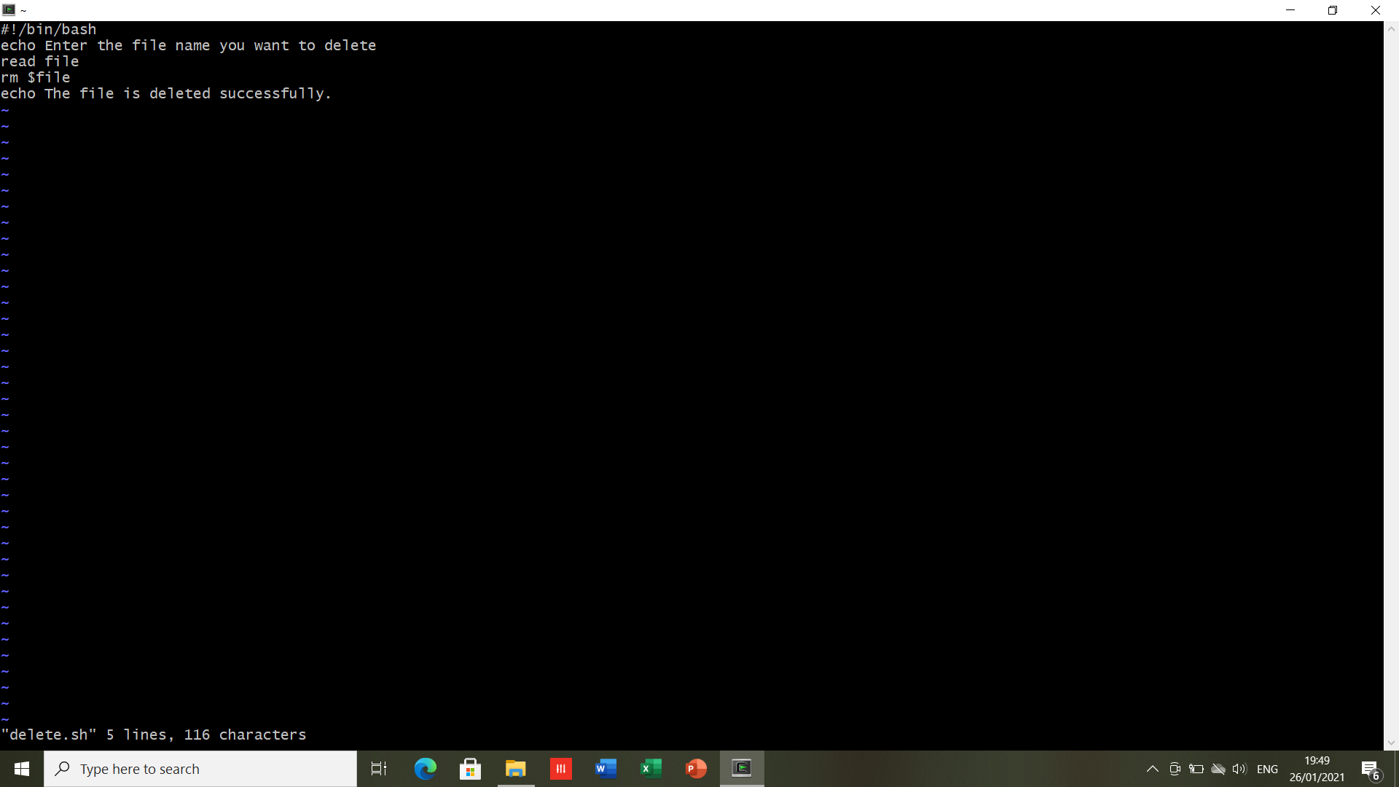

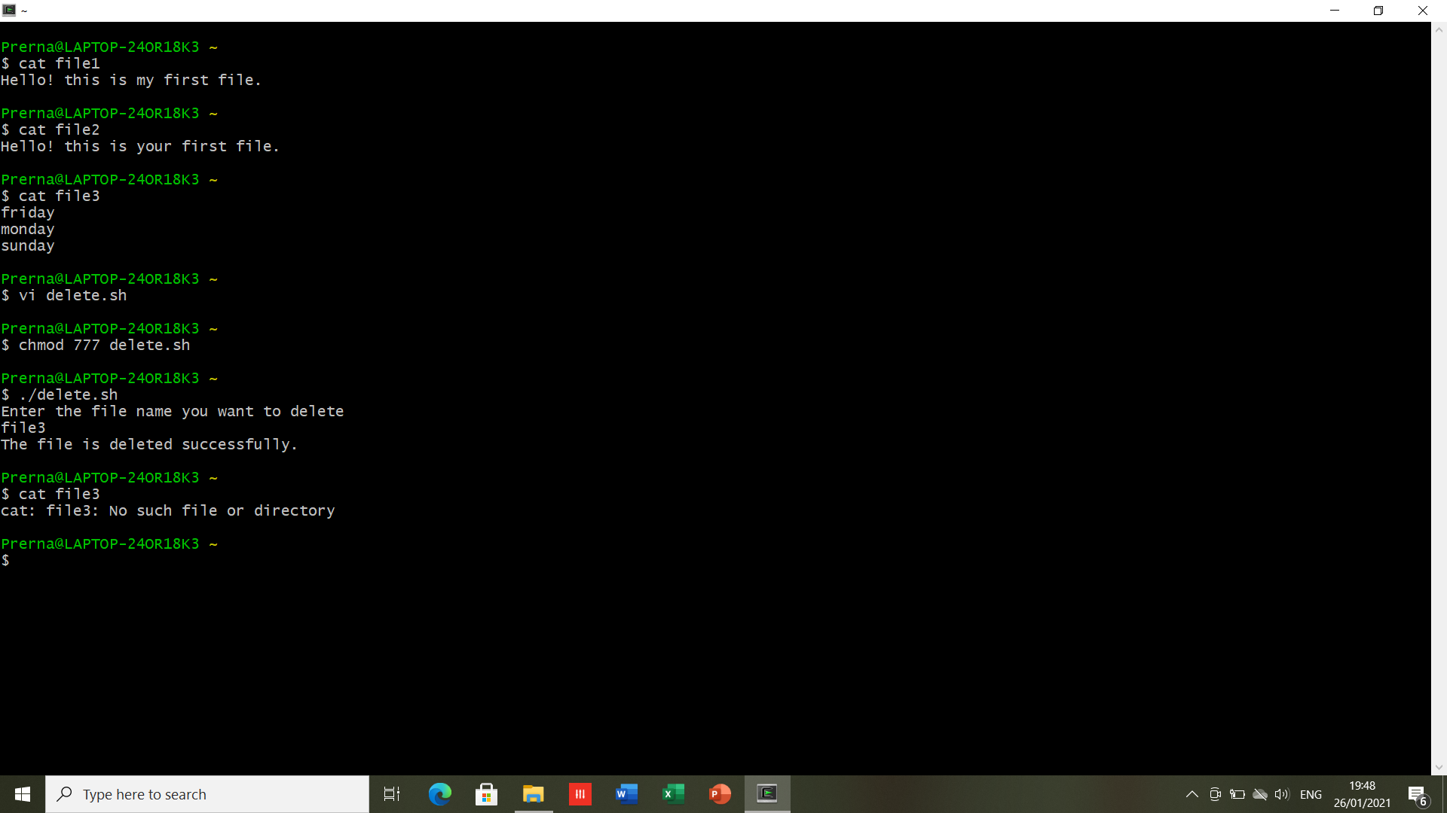

1. **Write a script to add some text in already existing file.**

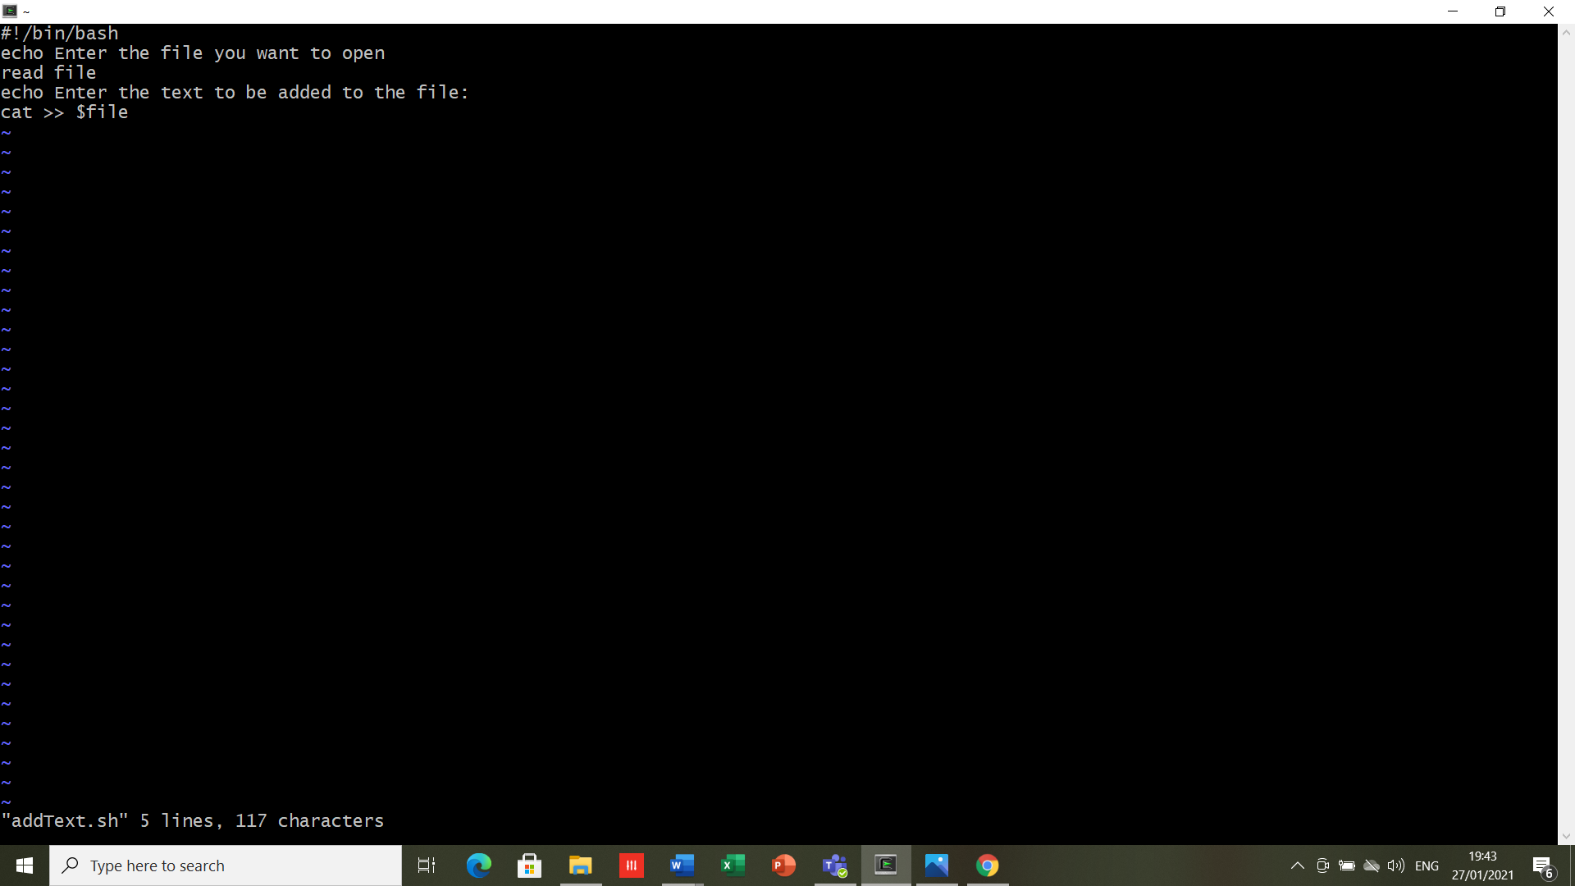

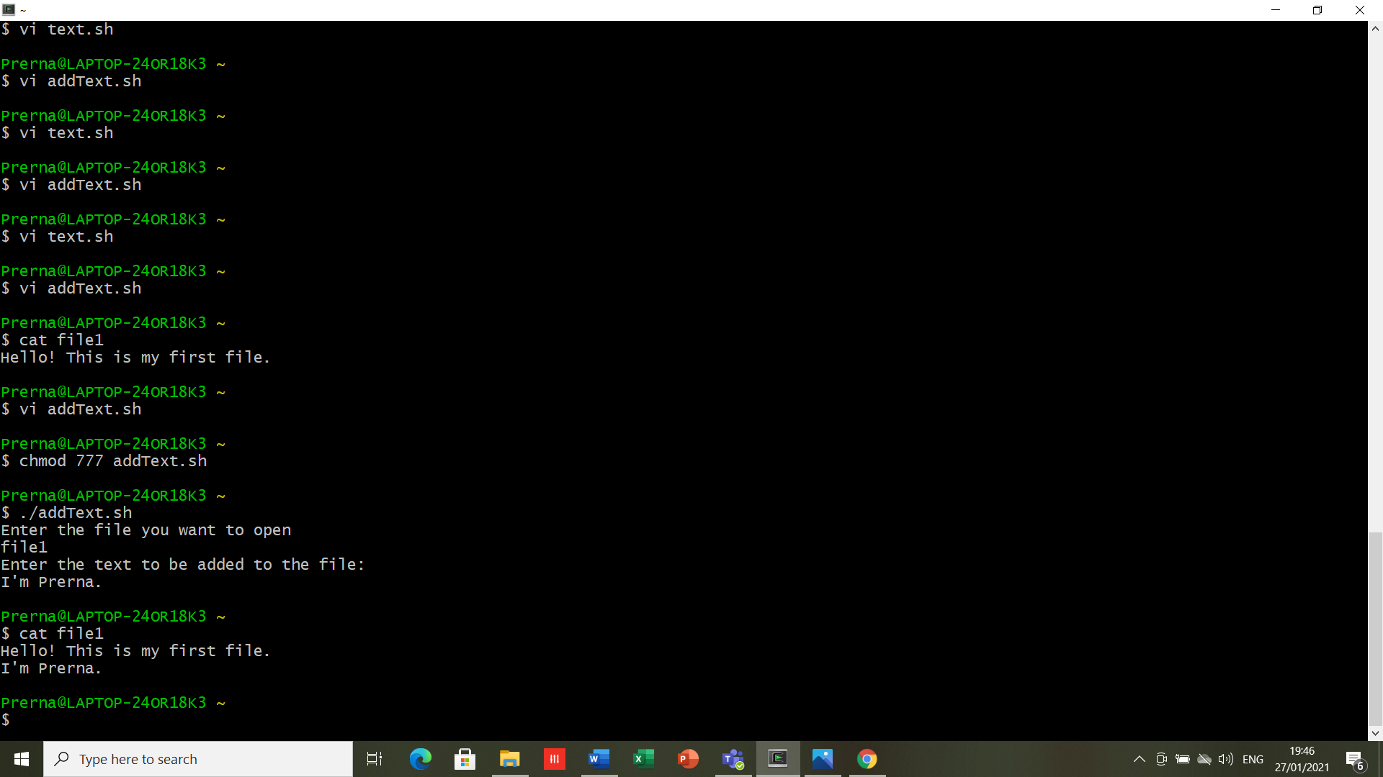

1. **Write a script to demonstrate use of arithmetic operator**

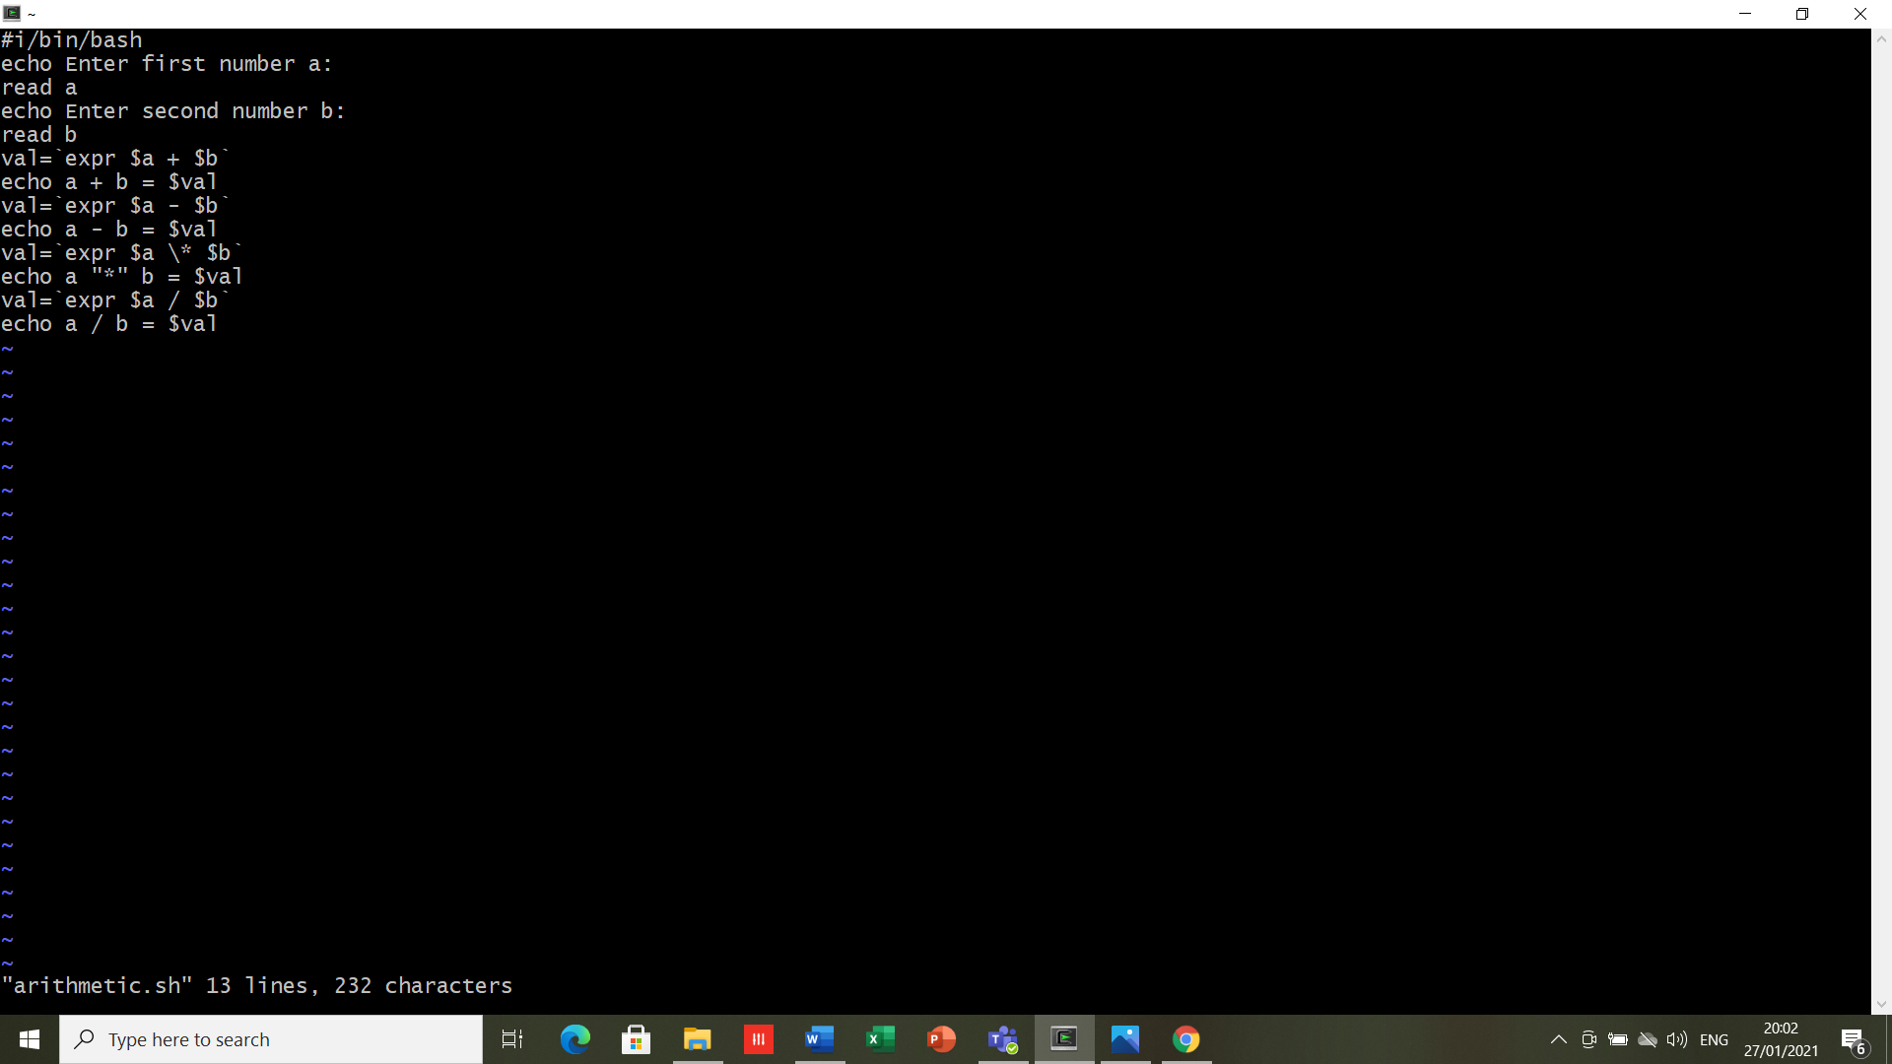

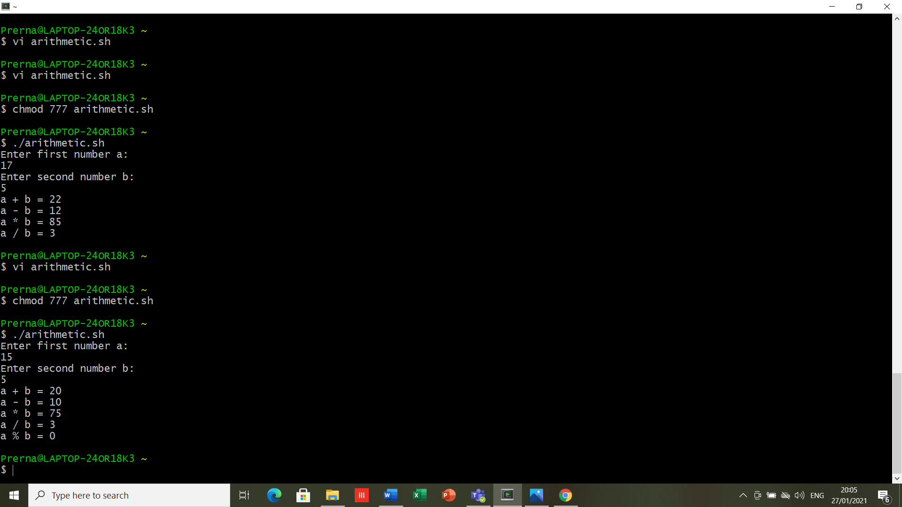

**RESULT-** All the scripts are written and executed successfully.

**EXPERIMENT -6**

**DATE-04/02/2021**

**AIM-** To explore Shell scripting using Vi editor

**SOFTWARE USED-** Cygwin

**THEORY-** Shell is the user interface to the operating system. It accepts human readable commands from user and convert them into something understandable by the kernel. Shell is after all, a real programming language, complete with variables, control structures, and so forth. Shell scripts are needed to avoid repetitive work and automation, System monitoring and adding new functionality to the shell etc. each shell script is saved with the .sh extension.

**Relational Operators**

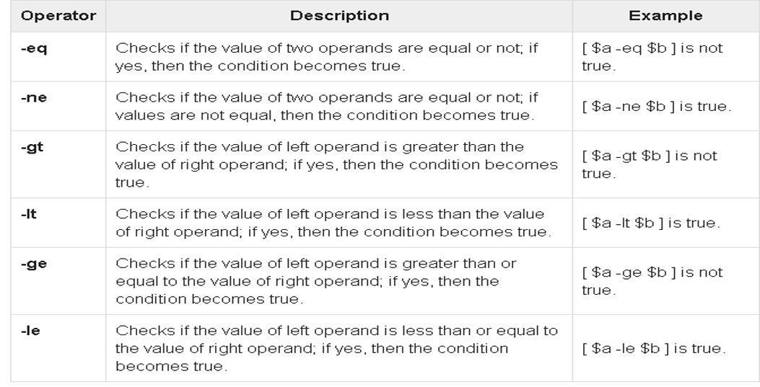

It is very important to understand that all the conditional expressions should be placed inside square braces with spaces around them​.

**Control Structures**

* if [ expression ]​  
  then​  
  command1​  
  else​  
  command2​  
  fi​
* if [ expression ]​  
   then​  
   command1​  
   elif [  expression ]​  
   then​

command2​

    elif [  expression ]​  
    then​

command3​

     else​

       command4​  
   fi​

**Logical Operator​s**

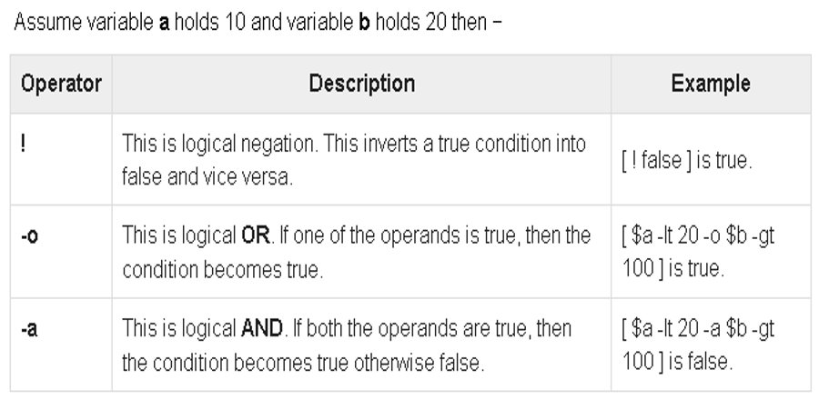

* while [ expression  ]​

do​

  Statement(s) to be executed if expression is true​

done​

* **Nesting Loops​**​All the loops support nesting concept which means you can put one loop inside another similar one or different loops. This nesting can go up to unlimited number of times based on your requirement.​

1. **Write a script to check whether number is +ve, -ve or 0**

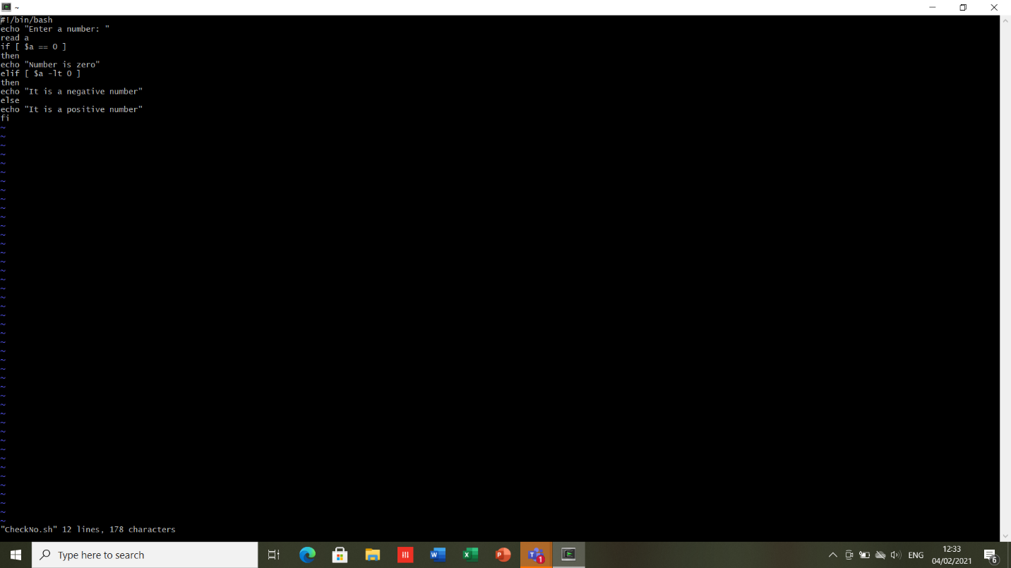

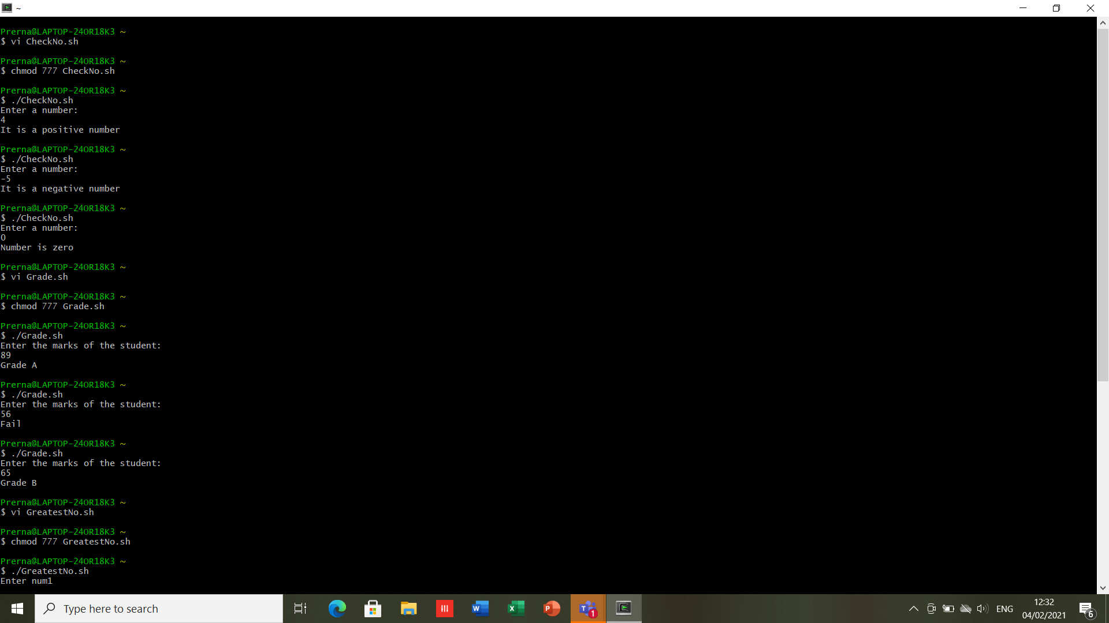

1. **WAS to find greatest number among 3 numbers.**

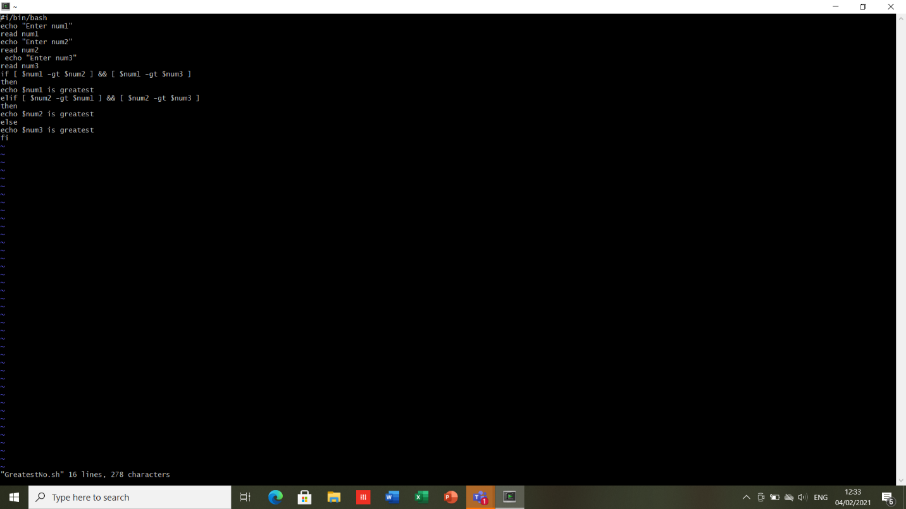

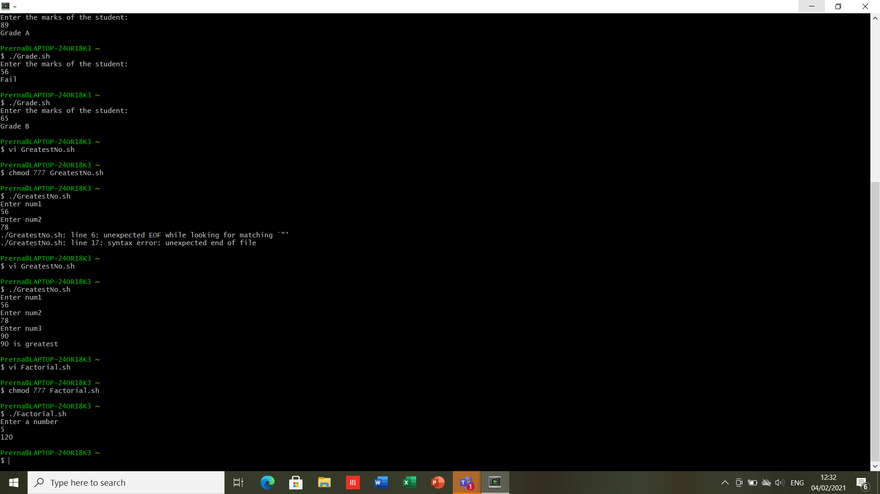

1. **Enter marks of student. if mark is greater than 70 display grade A, if mark is greater than 60 and less than 70 , display grade B else Fail.**

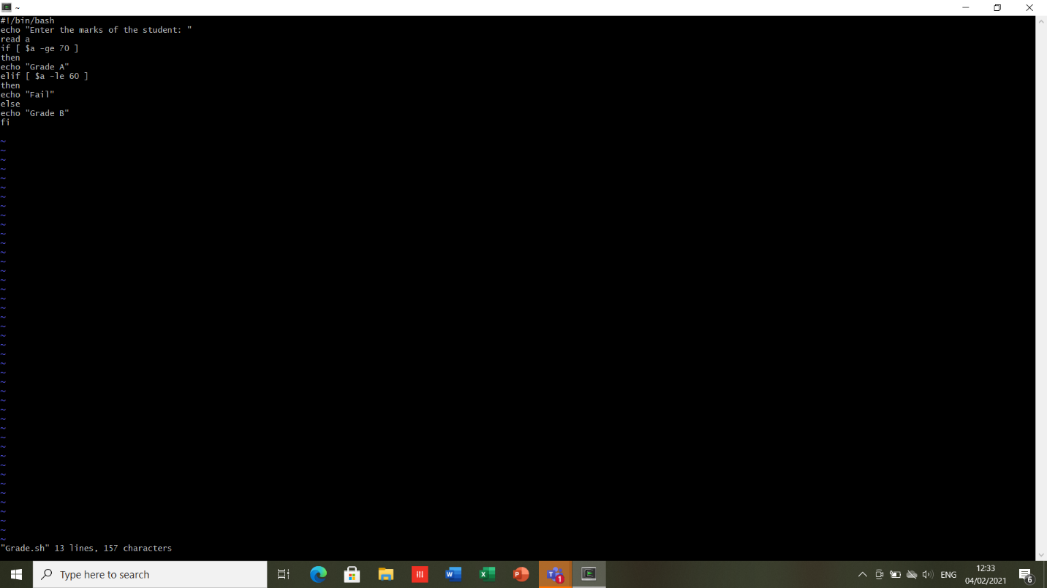



1. **WAS to calculate factorial of number.**

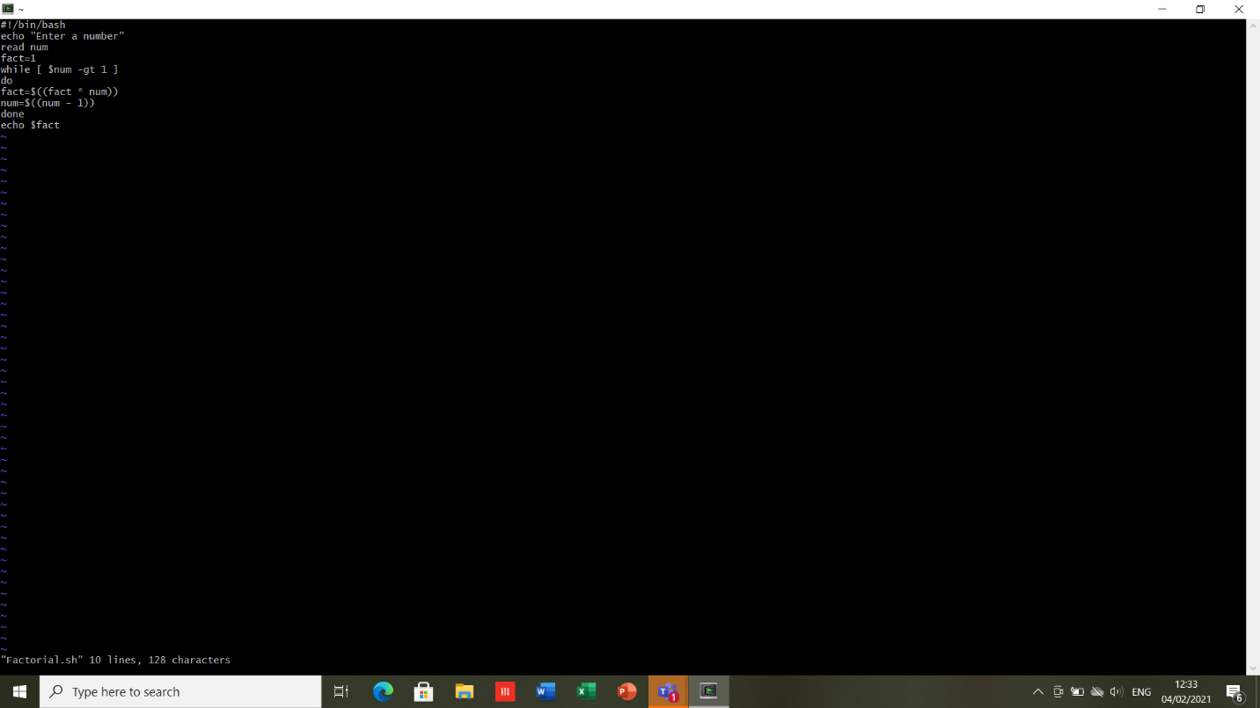



1. **WAS to display whether user is valid or not.**

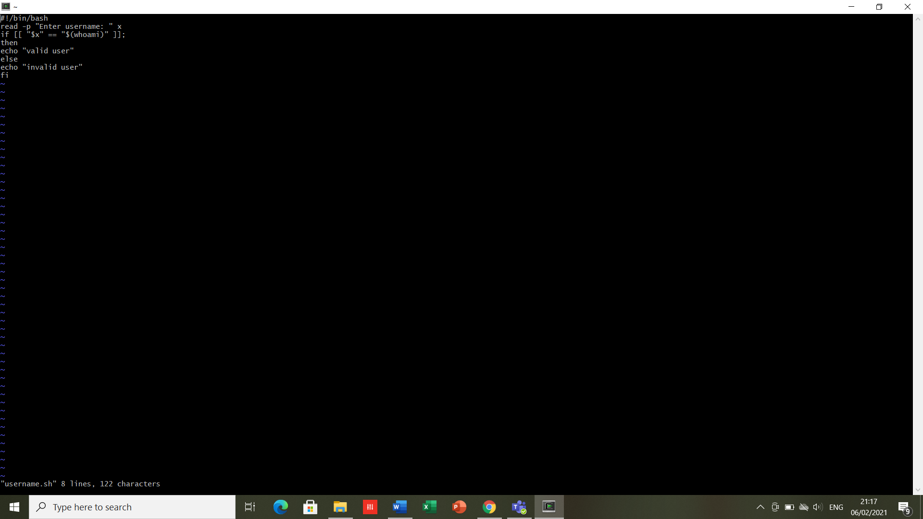

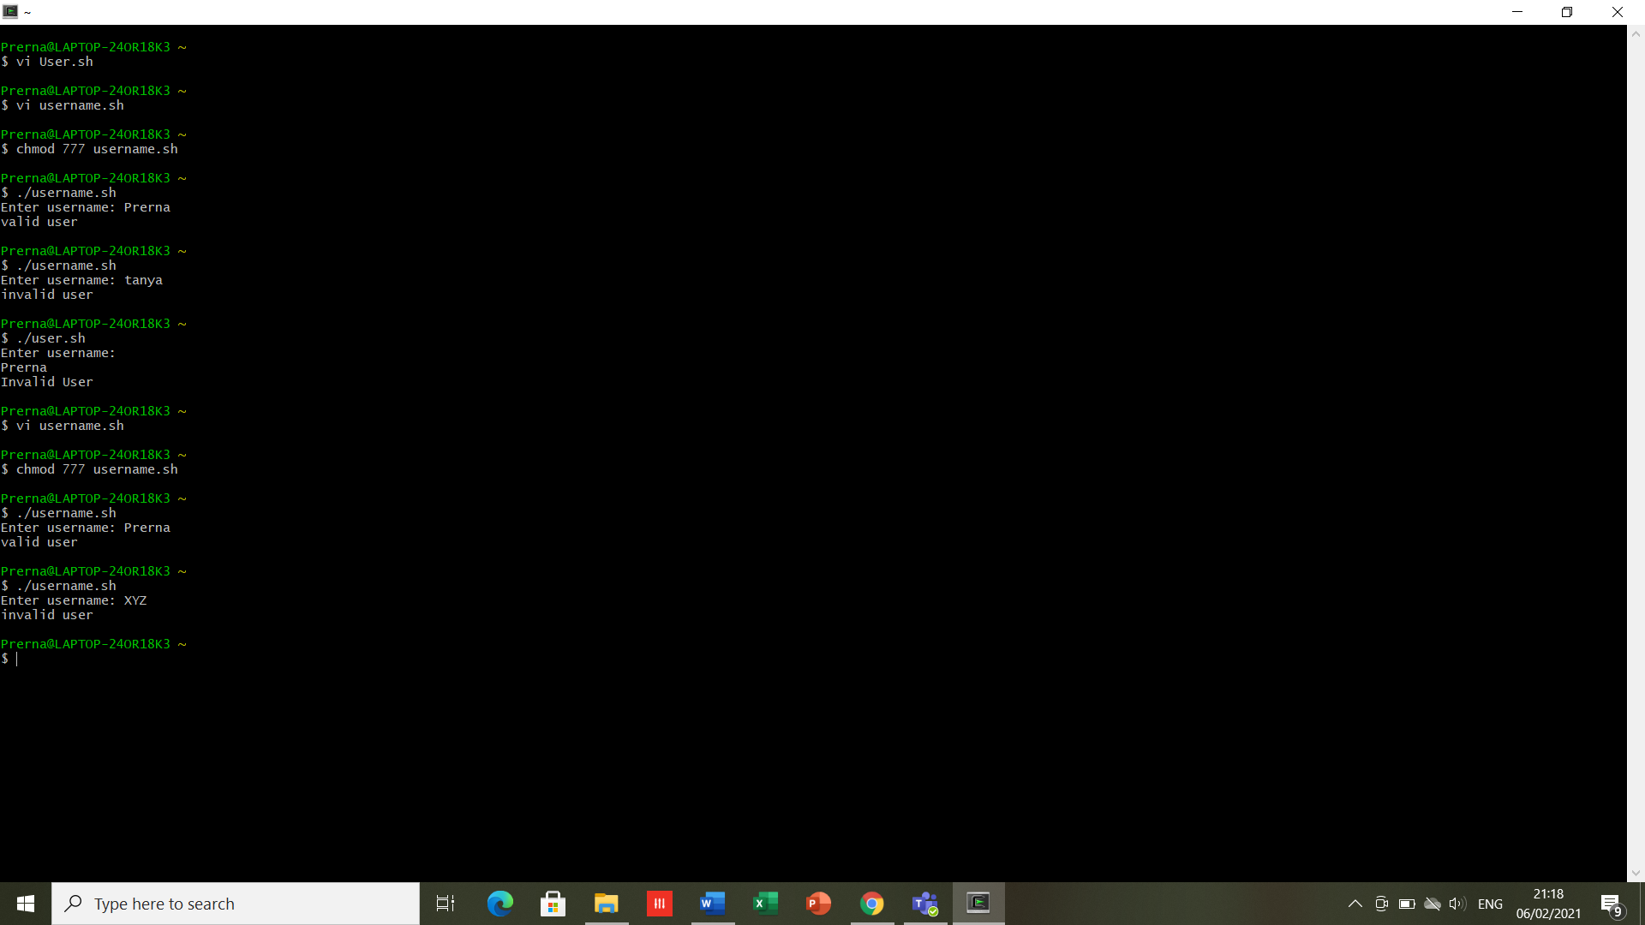

**RESULT-** All the scripts are written and executed successfully.

**EXPERIMENT -7**

**DATE-11/02/2021**

**AIM-** To explore Shell scripting using Vi editor (for loop and switch case).

**SOFTWARE USED-** Cygwin

**THEORY**-

1. **case esac**

case word in

pattern1)

Statement(s) to be executed if pattern1 matches

;;

pattern2)

Statement(s) to be executed if pattern2 matches

;;

pattern3)

Statement(s) to be executed if pattern3 matches

;;

*)

Default condition to be executed

;;

Esac

1. **for loop**

**Method 1**

for var in list ​

do ​

.​

.​

done​

**Method 2 ​**

for((i=0;i<5;i++)​

    do ​

     … ​

   done​

For loops are Typically used with positional parameters or a list of files:​

**Positional parameters​**

A positional parameter is a variable within a shell program.

Its value is set from an argument specified on the command line that invokes the program.

Positional parameters are numbered and are referred to with a preceding ``$'': $1, $2, $3, and so on.

If a shell program is invoked with a command line that appears like this:

Shell.prog pp1 pp2 pp3 pp4 pp5 pp6 pp7 pp8 pp9

Positional parameter $1 within the program is assigned the value pp1, positional parameter $2 within the program is assigned the value pp2, and so on, at the time the shell program is invoked.

sum=0​

for var in "$@"​

do​

sum=`expr $sum + $var`​

done​

echo The sum is $sum​

**List of file**​

for file in *.txt ​

Do​

 echo "We have $file"​  
done​

1. **Script to reverse number passed using positional parameter.**

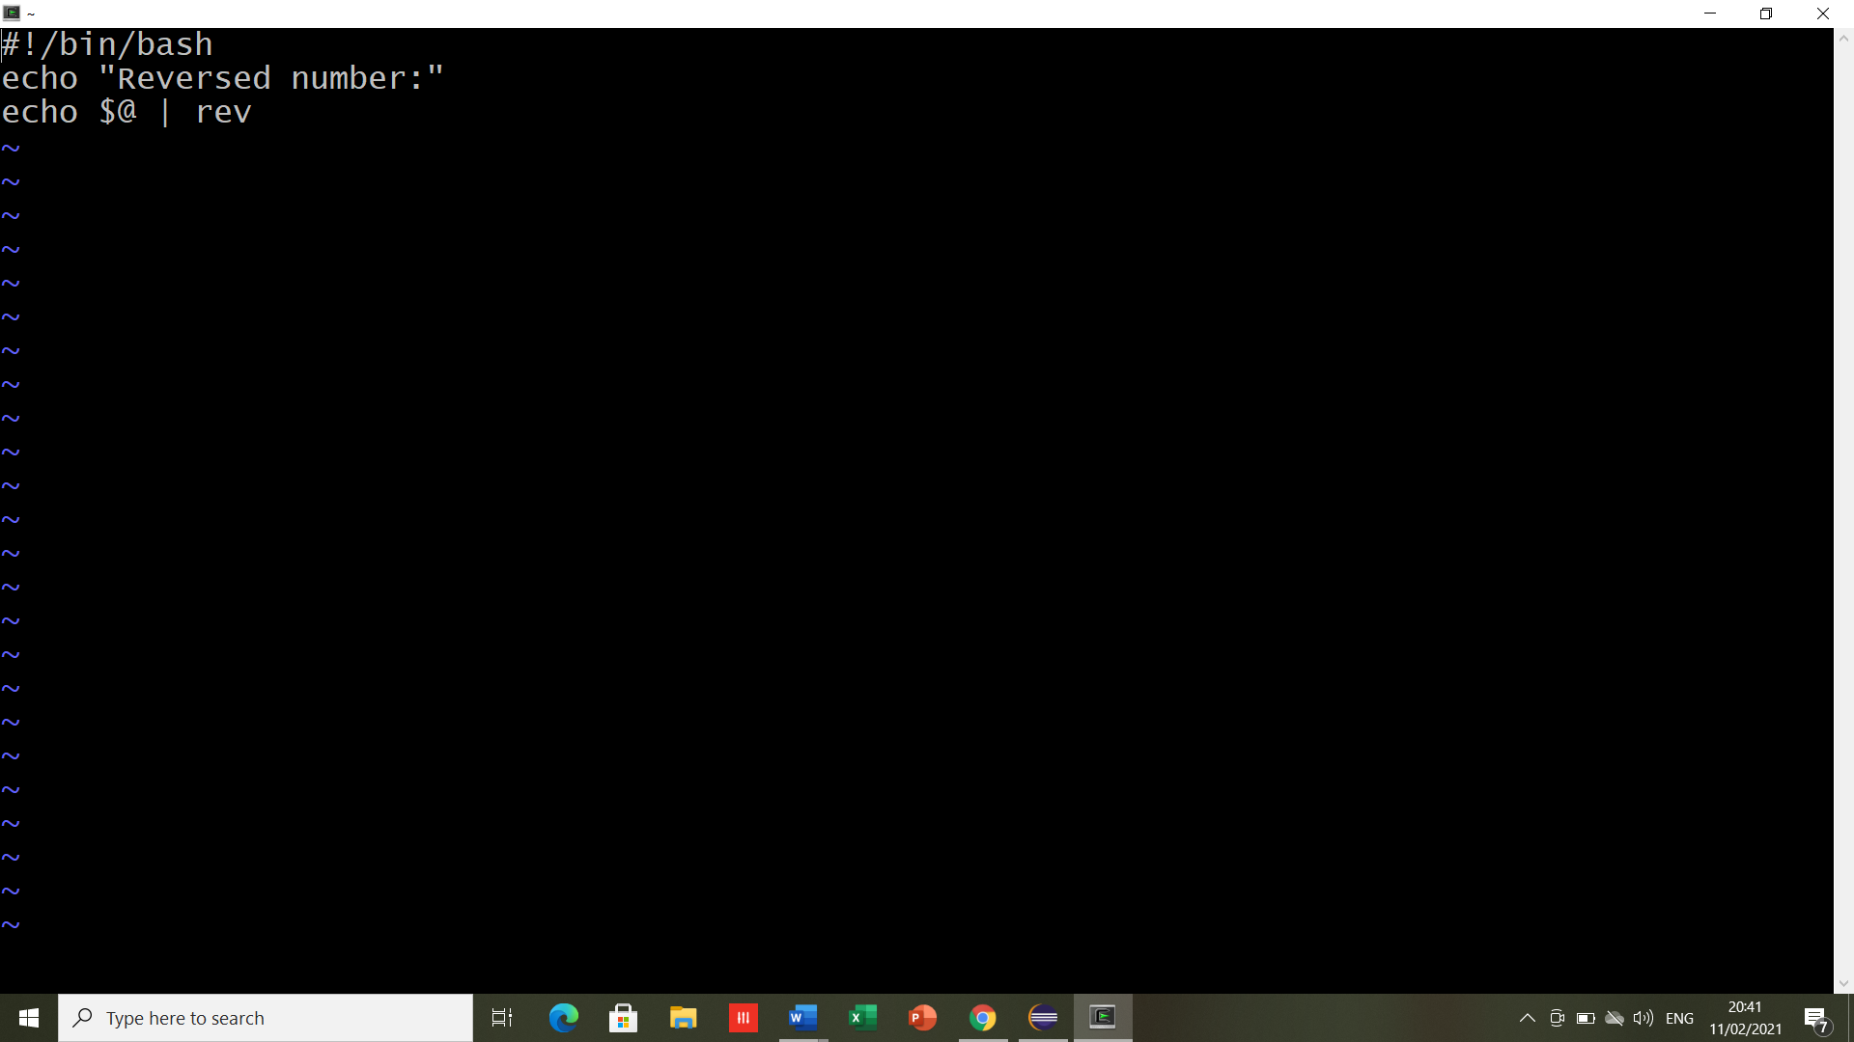

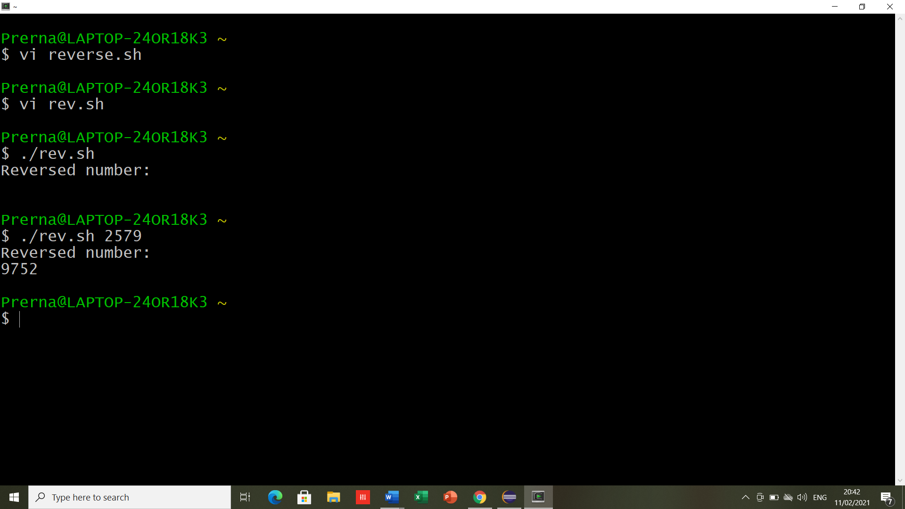

1. **Script to list all files in directory using for loop**

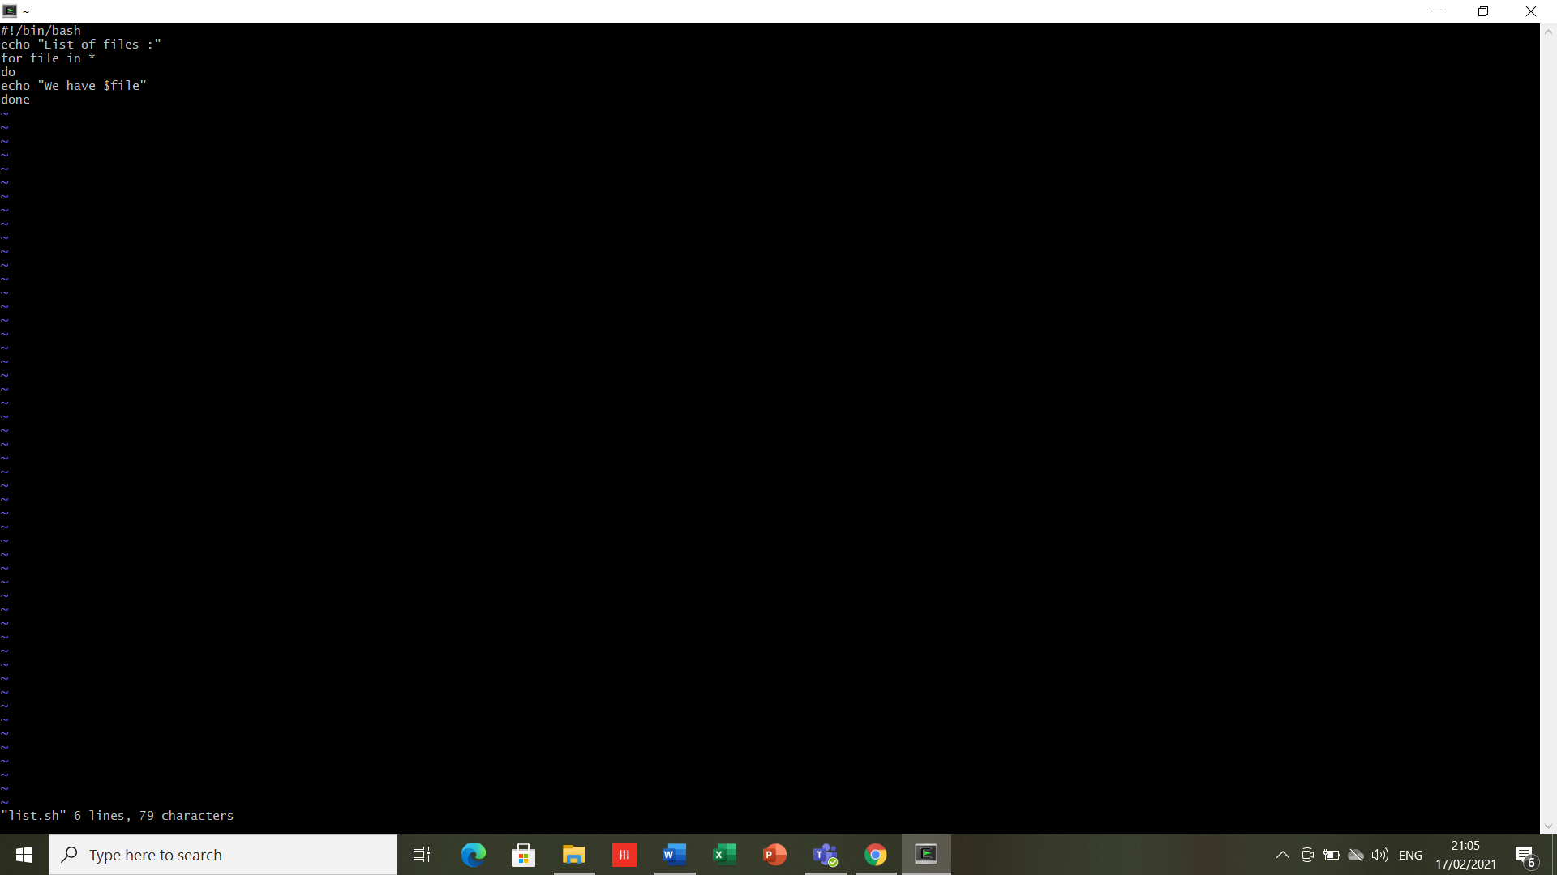

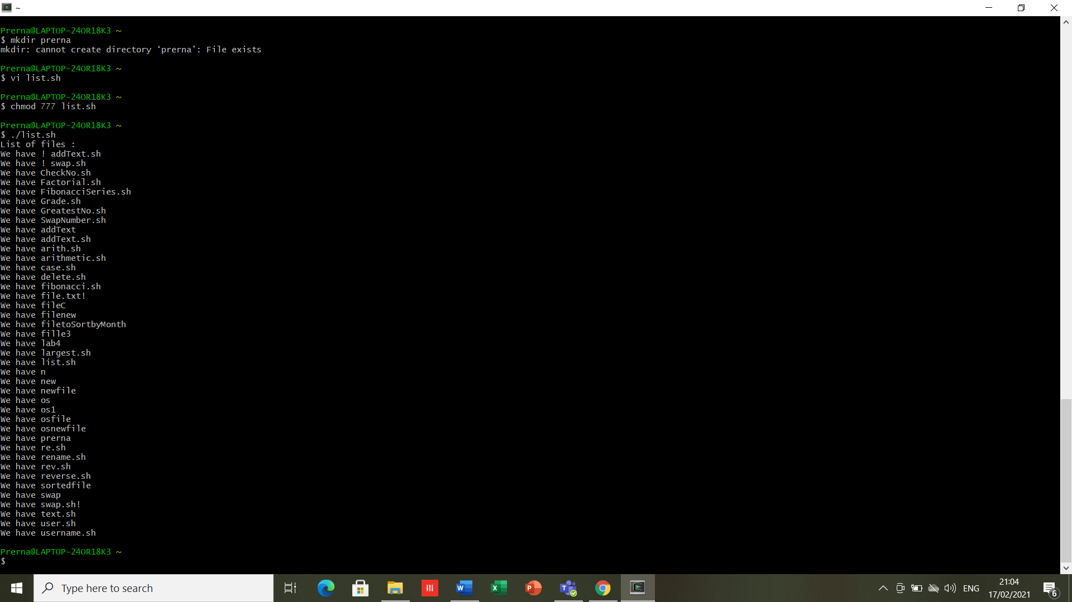

1. **Write a script to search particular file and rename it.**

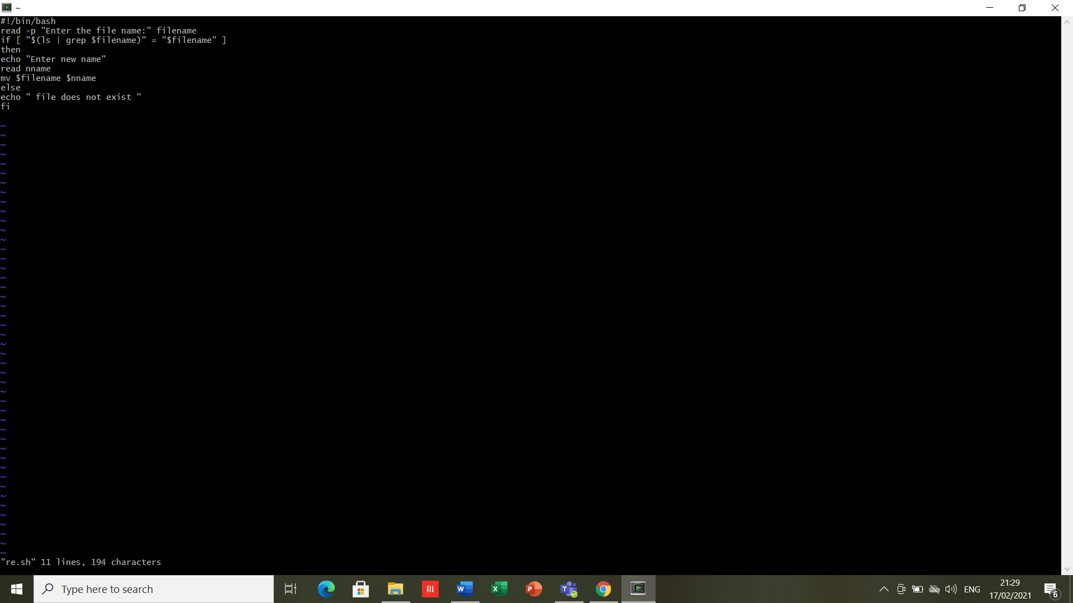

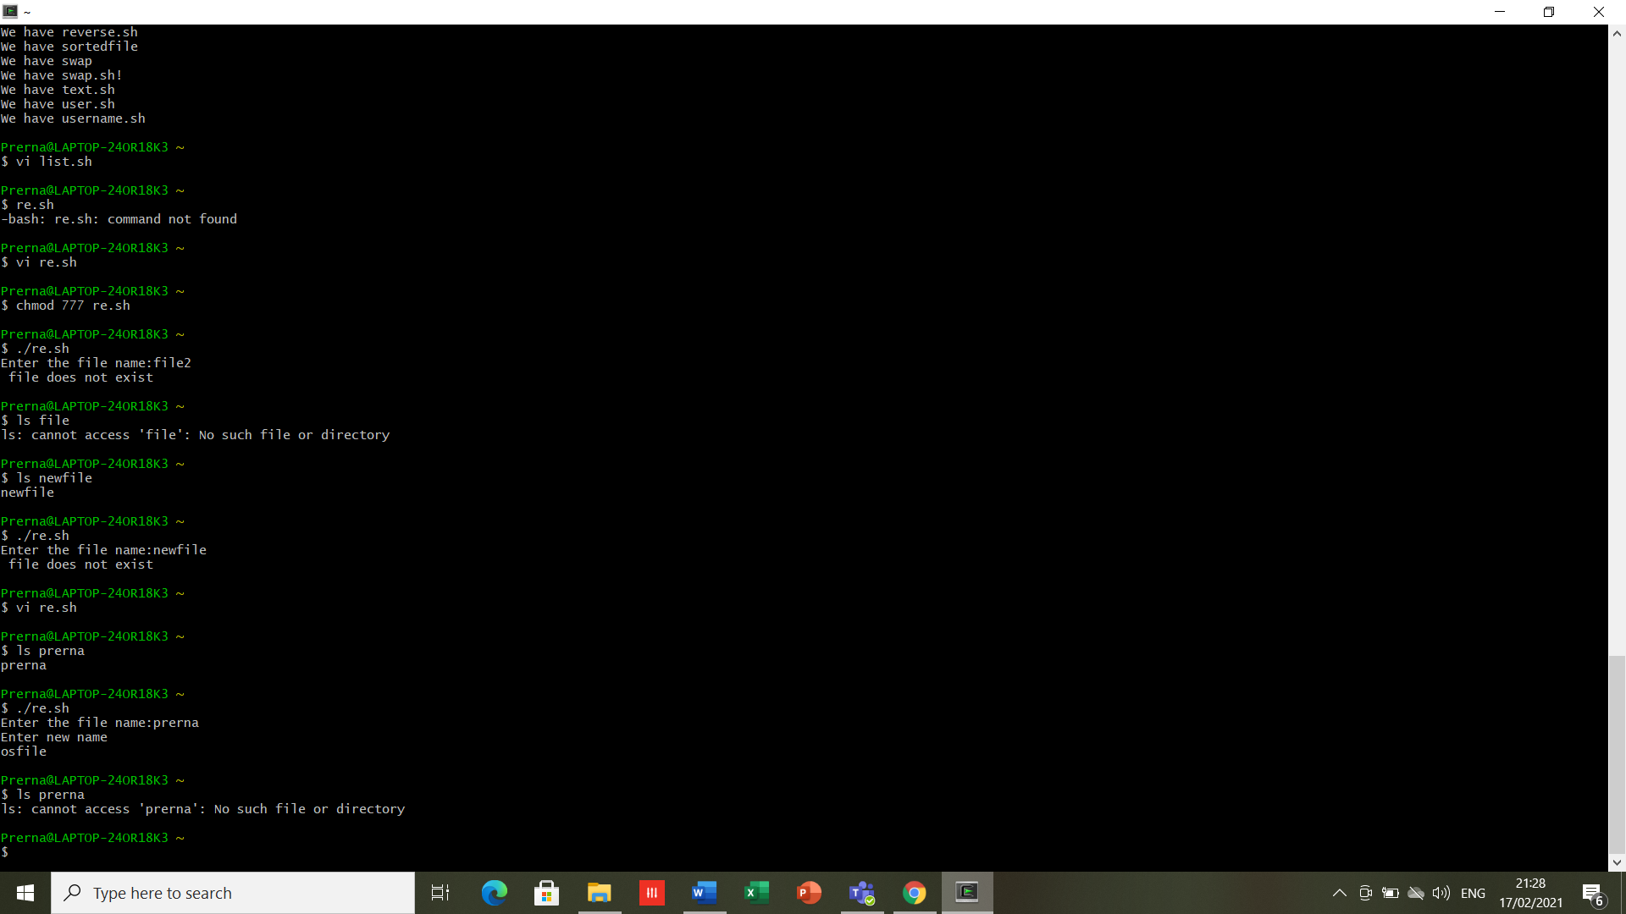

1. **Script to find largest value passed using command line.**

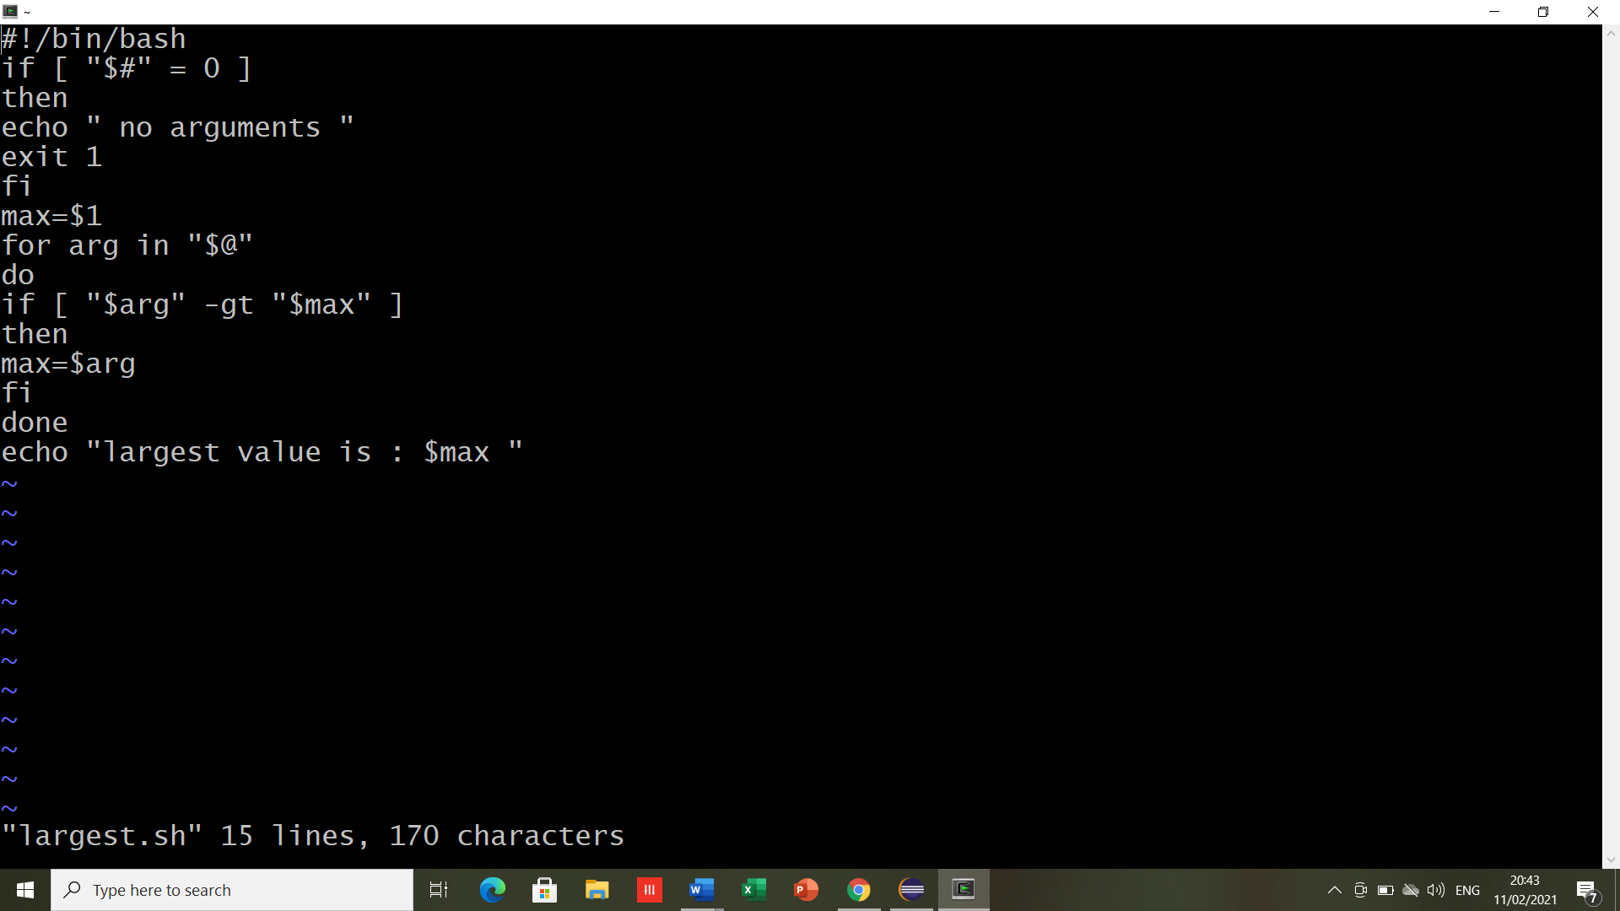

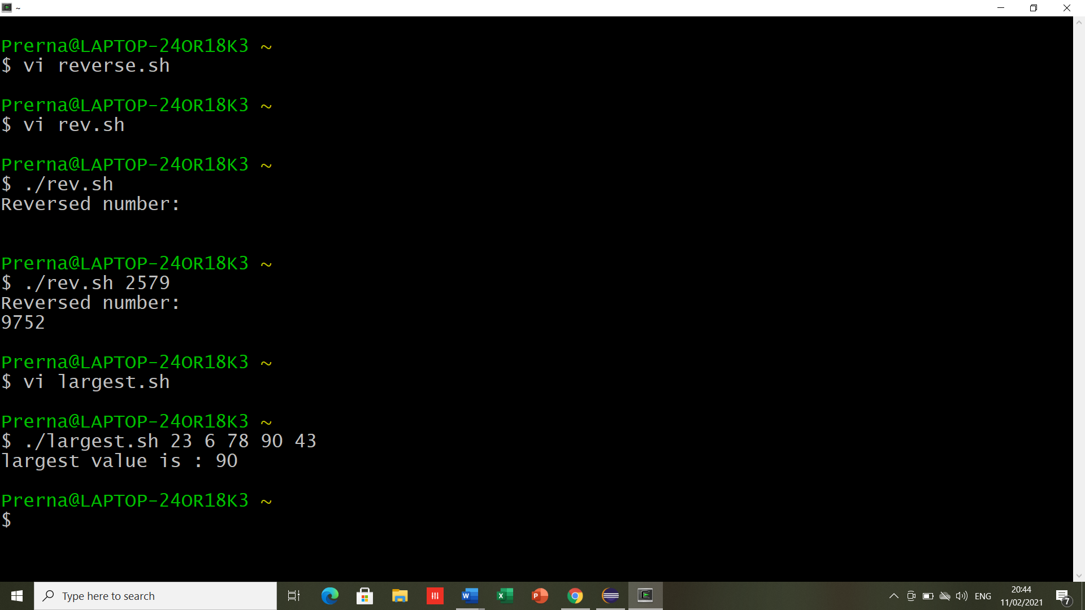

1. **Script to print Fibonacci series.**

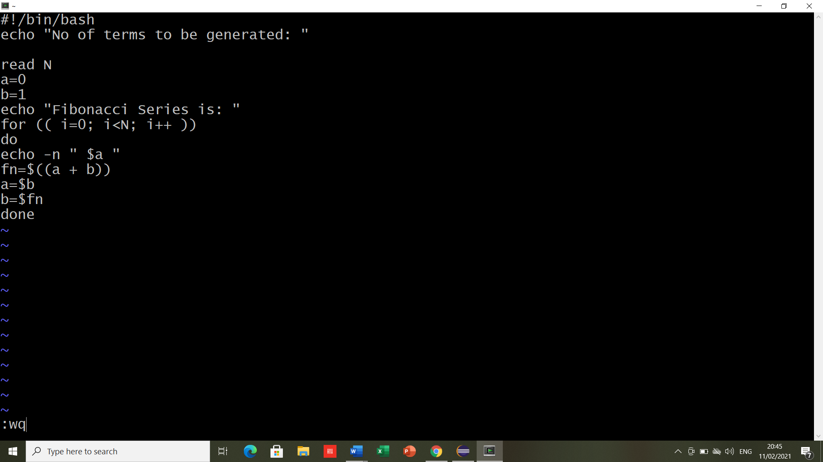

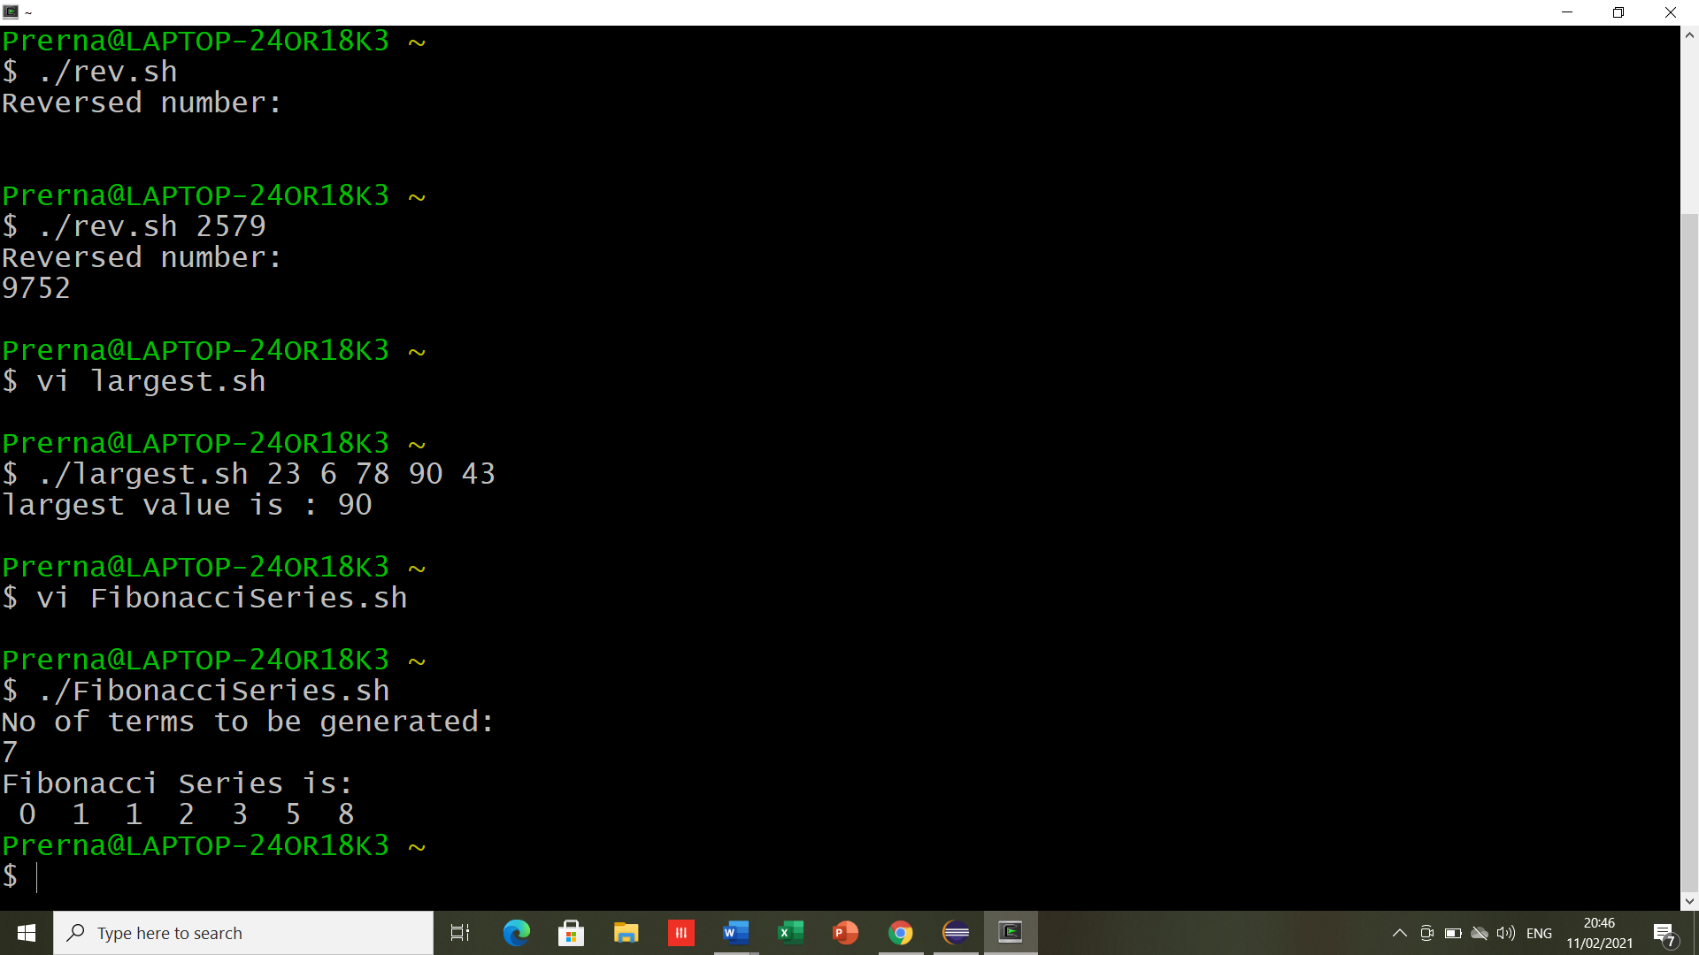

1. **Script using case to create, delete directory**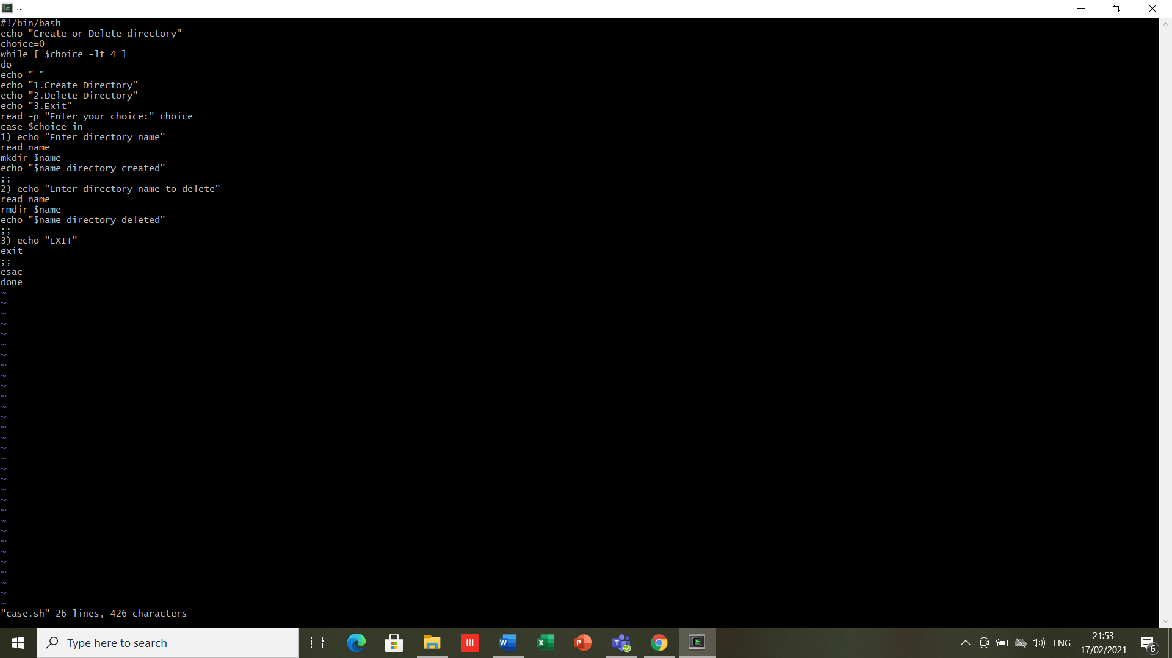

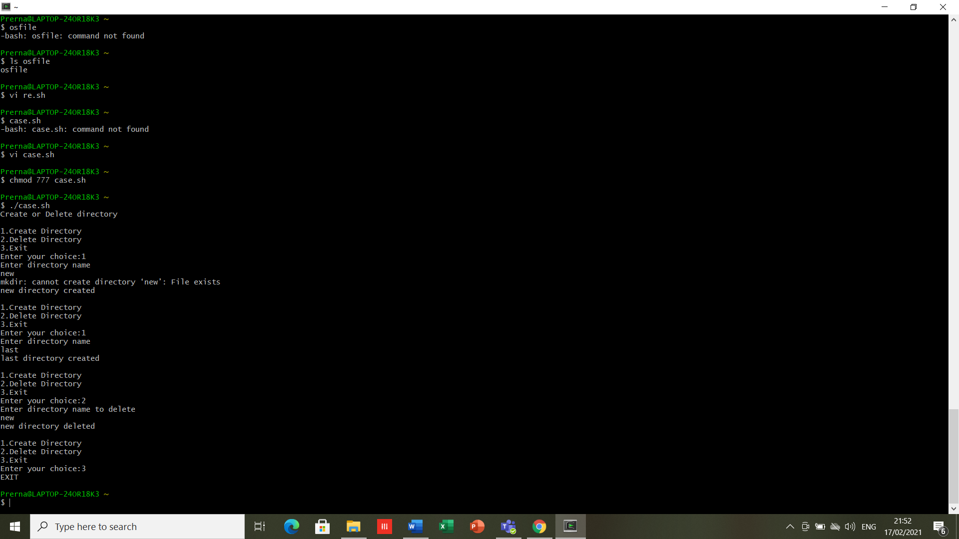

**RESULT-** The scripts are executed successfully.

**EXPERIMENT -8**

**DATE-18/02/2021**

**AIM-** Write a program to simulate FCFS CPU Scheduling algorithm.

**SOFTWARE USED-** Cygwin/ C compiler

**PROGRAM**-

1. **Burst time P1 3, P2 4, P3 5**

|  |  |  |
| --- | --- | --- |
| **Process Id** | **Arrival time** | **Burst time** |
| **P1** | **3** | **4** |
| **P2** | **5** | **3** |
| **P3** | **0** | **2** |
| **P4** | **5** | **1** |
| **P5** | **4** | **3** |

#include<stdio.h>

int main()

{

int at[10],at2[10],bt[100],ex[100],seq[100],re[100],wt[100],tat[100];

int n,i,j,start,pos,max=0,min,idle=0,k=0;

float av1=0,av2=0;

printf("Enter number of process\n");

scanf("%d",&n);

printf("Enter arrival time for processess\n");

for(i=0;i<n;i++)

{

scanf("%d",&at[i]);

at2[i]=at[i];

}

printf("Enter burst time for processess\n");

for(i=0;i<n;i++)

{

scanf("%d",&bt[i]);

}

start=at[0];

for(i=1;i<n;i++)

{

if(start>at[i])

{

start=at[i];

} }

printf("Sequence of execution is\n");

for(i=0;i<n;i++)

{

if(max<at[i])

{

max=at[i];

} }

max=max+1;

for(i=0;i<n;i++,k++)

{ min=max;

for(j=0;j<n;j++){

if(at[j]!=-1)

{

if(at[j]<min)

{

min=at[j];

pos=j;

} } }

printf("[P%d] ",pos);

seq[k]=pos;

if(start<at[pos]){

re[pos]=start;

idle+=at[pos]-start;

start=at[pos];

start+=bt[pos];

at[pos]=-1;

ex[pos]=start;

}

else{

re[pos]=start;

start+=bt[pos];

at[pos]=-1;

ex[pos]=start;

}}

printf("\n");

for(i=0;i<n;i++)

{ tat[i]=ex[i]-at2[i];

wt[i]=tat[i]-bt[i];

}

printf("P AT(s) BT WT(s) TAT(s)\n");

for(i=0;i<n;i++)

{

printf("P%d %d %d %d %d\n",i,at2[i],bt[i],wt[i],tat[i]); }

for(i=0;i<n;i++)

{

av1+=tat[i];

av2+=wt[i];}

printf("Average waiting time(s) %f\nAverage turnaroundtime(s) %f\nCPU idle time(s)%d\n",av2/n,av1/n,idle);}

**OUTPUT-**

1)

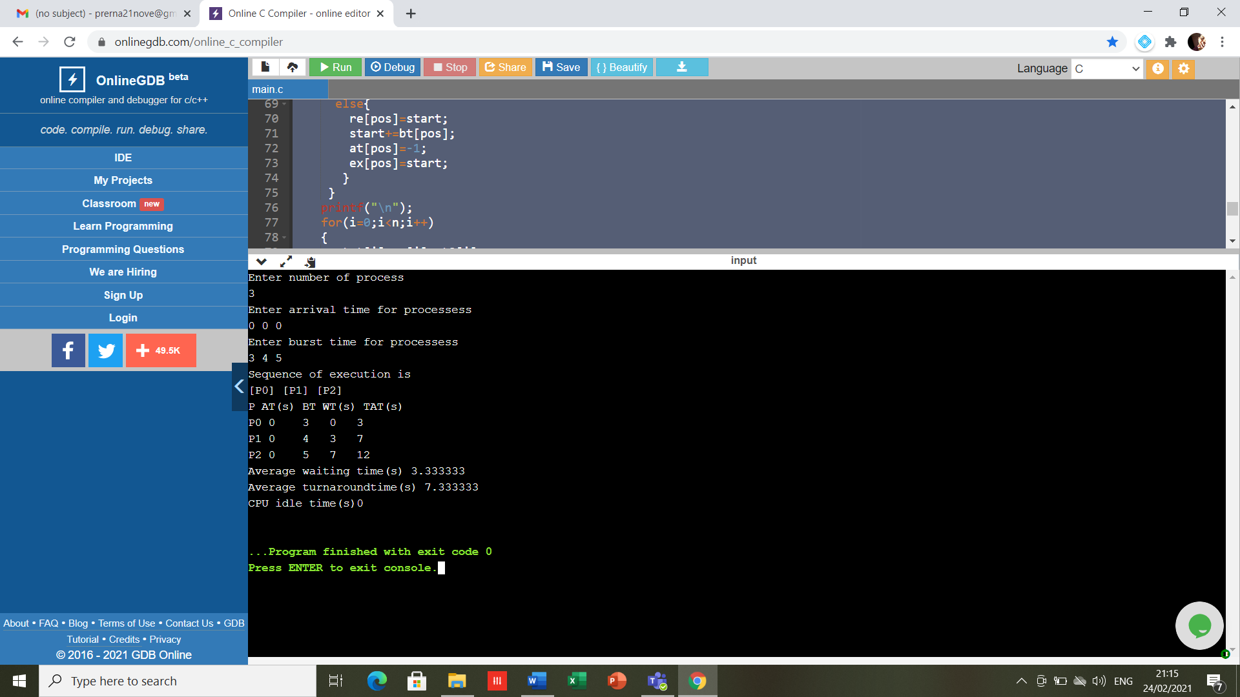

2)

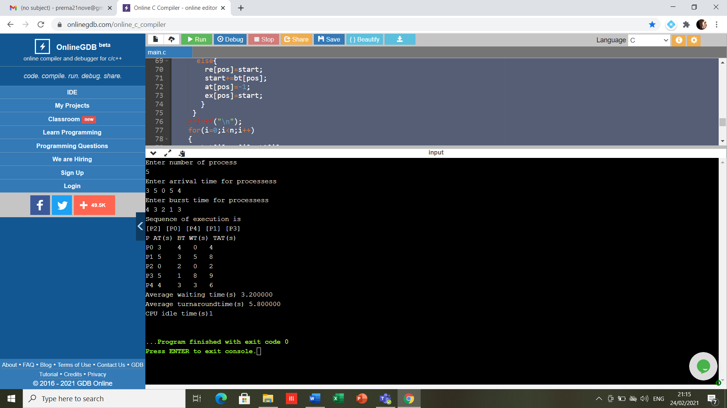

**RESULT-** The program has been executed successfully.

**EXPERIMENT -9**

**DATE-04/03/2021**

**AIM-** Write a program to simulate Non preemptive and Preemptive SJF algorithm.

**SOFTWARE USED-** Cygwin/ C compiler

1. **Write a program to implement Non preemptive and Preemptive SJF**

**Code for Non preemptive -**

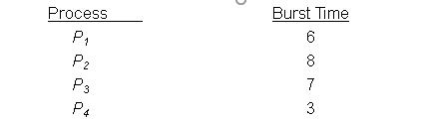

#include<stdio.h>

int main()

{

int bt[20],p[20],wt[20],tat[20],i,j,n,total=0,pos,temp;

float avg_wt,avg_tat;

printf("Enter number of process:");

scanf("%d",&n);

printf("\nEnter Burst Time:\n");

for(i=0;i<n;i++)

{

printf("p%d:",i+1);

scanf("%d",&bt[i]);

p[i]=i+1;

}

//sorting of burst times

for(i=0;i<n;i++)

{

pos=i;

for(j=i+1;j<n;j++)

{

if(bt[j]<bt[pos])

pos=j;

}

temp=bt[i];

bt[i]=bt[pos];

bt[pos]=temp;

temp=p[i];

p[i]=p[pos];

p[pos]=temp;

}

wt[0]=0;

for(i=1;i<n;i++)

{

wt[i]=0;

for(j=0;j<i;j++)

wt[i]+=bt[j];

total+=wt[i];

}

avg_wt=(float)total/n;

total=0;

printf("\nProcess\t Burst Time \tWaiting Time\tTurnaround Time");

for(i=0;i<n;i++)

{

tat[i]=bt[i]+wt[i];

total+=tat[i];

printf("\np%d\t\t %d\t\t %d\t\t\t%d",p[i],bt[i],wt[i],tat[i]);

}

avg_tat=(float)total/n;

printf("\n\nAverage Waiting Time=%f",avg_wt);

printf("\nAverage Turnaround Time=%f\n",avg_tat);

}

**OUTPUT-**

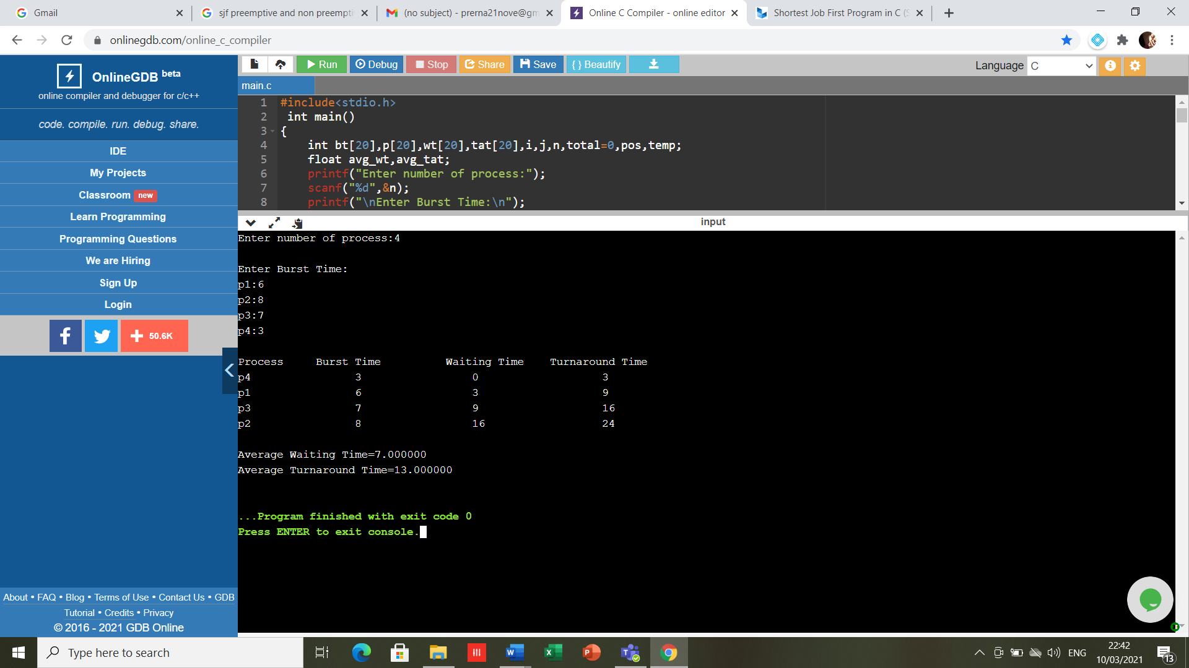

**Code for Preemptive -**

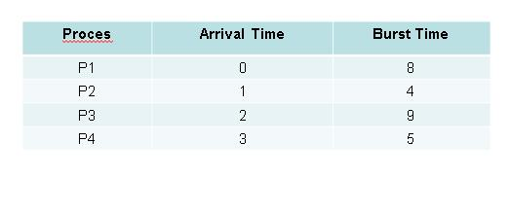

#include <stdio.h>

int main()

{

int arrival_time[10], burst_time[10], temp[10];

int i, smallest, count = 0, time, limit;

double wait_time = 0, turnaround_time = 0, end;

float average_waiting_time, average_turnaround_time;

printf("\nEnter the Total Number of Processes:\t");

scanf("%d", &limit);

printf("\nEnter Details of %d Processesn", limit);

for(i = 0; i < limit; i++)

{

printf("\nEnter Arrival Time:\t");

scanf("%d", &arrival_time[i]);

printf("Enter Burst Time:\t");

scanf("%d", &burst_time[i]);

temp[i] = burst_time[i];

}

burst_time[9] = 9999;

for(time = 0; count != limit; time++)

{

smallest = 9;

for(i = 0; i < limit; i++)

{

if(arrival_time[i] <= time && burst_time[i] < burst_time[smallest] && burst_time[i] > 0)

{

smallest = i;

}

}

burst_time[smallest]--;

if(burst_time[smallest] == 0)

{

count++;

end = time + 1;

wait_time = wait_time + end - arrival_time[smallest] - temp[smallest];

turnaround_time = turnaround_time + end - arrival_time[smallest];

}

}

average_waiting_time = wait_time / limit;

average_turnaround_time = turnaround_time / limit;

printf("\n\nAverage Waiting Time:\t%lf\n", average_waiting_time);

printf("Average Turnaround Time:\t%lf\n", average_turnaround_time);

return 0;

}

**OUTPUT-**

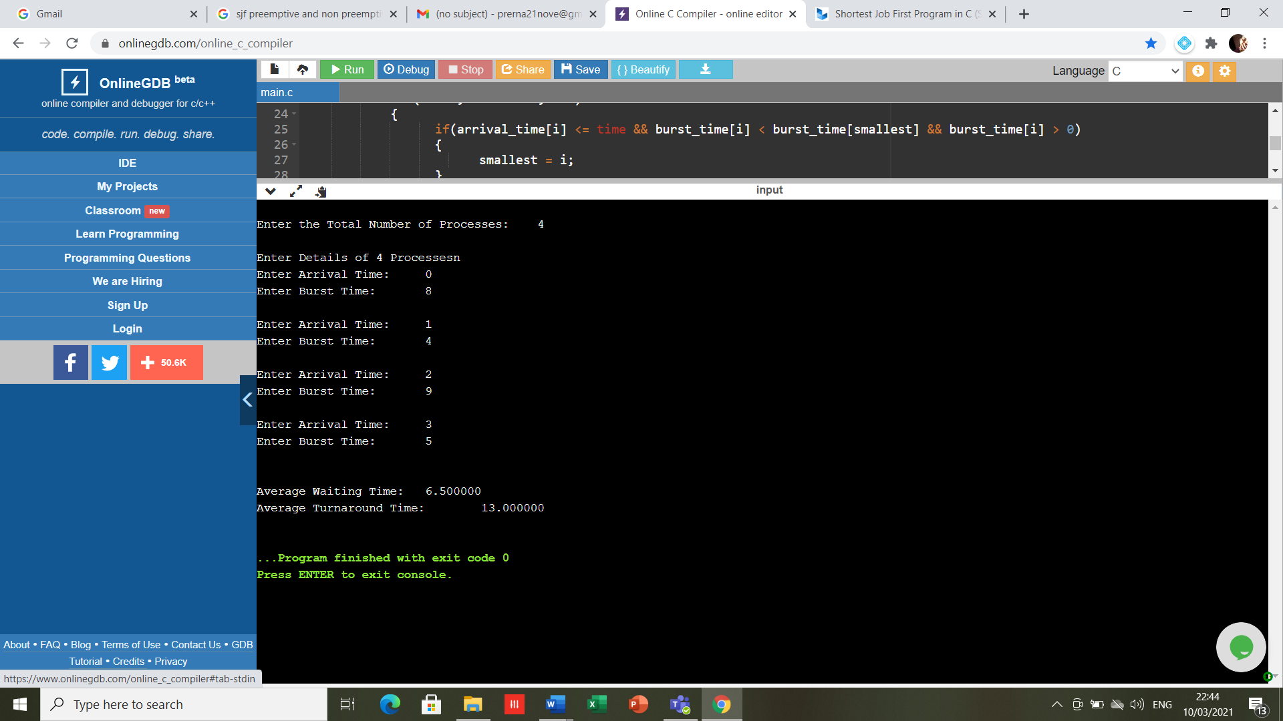

**RESULT-** The program has been executed successfully.

**EXPERIMENT -10**

**DATE-18/03/2021**

**AIM-** Write a program to simulate Round robin.

**SOFTWARE USED-** Cygwin/ C compiler

#include<stdio.h>

#include<conio.h>

void main()

{

int i, NOP, sum=0,count=0, y, quant, wt=0, tat=0, at[10], bt[10], temp[10];

float avg_wt, avg_tat;

printf(" Total number of process in the system: ");

scanf("%d", &NOP);

y = NOP;

for(i=0; i<NOP; i++)

{

printf("\n Enter the Arrival and Burst time of the Process[%d]\n", i+1);

printf(" Arrival time is: \t");

scanf("%d", &at[i]);

printf(" \nBurst time is: \t");

scanf("%d", &bt[i]);

temp[i] = bt[i];

}

printf("Enter the Time Quantum for the process: \t");

scanf("%d", &quant);

printf("\n Process No \t\t Burst Time \t\t TAT \t\t Waiting Time ");

for(sum=0, i = 0; y!=0; )

{

if(temp[i] <= quant && temp[i] > 0)

{ sum = sum + temp[i];

temp[i] = 0;

count=1; }

else if(temp[i] > 0)

{ temp[i] = temp[i] - quant;

sum = sum + quant; }

if(temp[i]==0 && count==1)

{ y--;

printf("\nProcess No[%d] \t\t %d\t\t\t\t %d\t\t\t %d", i+1, bt[i], sum-at[i], sum-at[i]-bt[i]);

wt = wt+sum-at[i]-bt[i];

tat = tat+sum-at[i];

count =0; }

if(i==NOP-1)

{ i=0;

}

else if(at[i+1]<=sum)

{ i++;

}

else

{ i=0;

} } avg_wt = wt * 1.0/NOP;

avg_tat = tat * 1.0/NOP;

printf("\n Average Turn Around Time: \t%f", avg_wt);

printf("\n Average Waiting Time: \t%f", avg_tat);

getch(); }

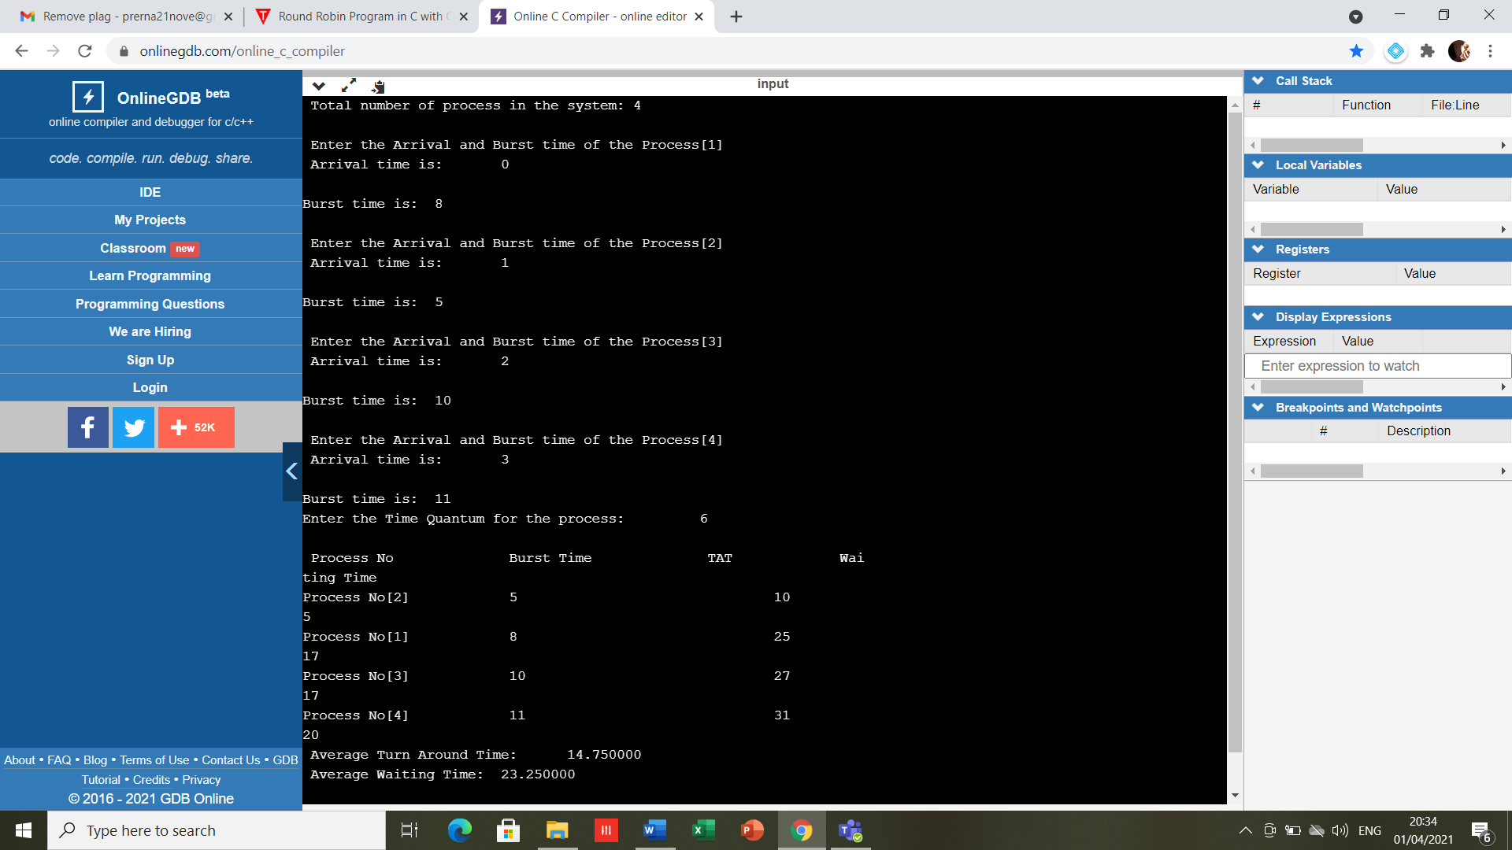

**RESULT-** The program has been executed successfully.

**EXPERIMENT -11**

**DATE-25/03/2021**

**AIM-** Write a program to simulate Banker’s algorithm

**SOFTWARE USED-** Cygwin/ C compiler

#include <stdio.h>

int main()

{

int count = 0, m, n, process, temp, resource;

int allocation_table[5] = {0, 0, 0, 0, 0};

int available[5], current[5][5], maximum_claim[5][5];

int maximum_resources[5], running[5], safe_state = 0;

printf("\nEnter The Total Number Of Processes:\t");

scanf("%d", &process);

for(m = 0; m < process; m++)

{

running[m] = 1;

count++;

}

printf("\nEnter The Total Number Of Resources To Allocate:\t");

scanf("%d", &resource);

printf("\nEnter The Claim Vector:\t");

for(m = 0; m < resource; m++)

{

scanf("%d", &maximum_resources[m]);

}

printf("\nEnter Allocated Resource Table:\n");

for(m = 0; m < process; m++)

{

for(n = 0; n < resource; n++)

{

scanf("%d", &current[m][n]);

}

}

printf("\nEnter The Maximum Claim Table:\n");

for(m = 0; m < process; m++)

{

for(n = 0; n < resource; n++)

{

scanf("%d", &maximum_claim[m][n]);

}

}

printf("\nThe Claim Vector \n");

for(m = 0; m < resource; m++)

{

printf("\t%d ", maximum_resources[m]);

}

printf("\n The Allocated Resource Table\n");

for(m = 0; m < process; m++)

{

for(n = 0; n < resource; n++)

{

printf("\t%d", current[m][n]);

}

printf("\n");

}

printf("\nThe Maximum Claim Table \n");

for(m = 0; m < process; m++)

{

for(n = 0; n < resource; n++)

{

printf("\t%d", maximum_claim[m][n]);

}

printf("\n");

}

for(m = 0; m < process; m++)

{

for(n = 0; n < resource; n++)

{

allocation_table[n] = allocation_table[n] + current[m][n];

}

}

printf("\nAllocated Resources \n");

for(m = 0; m < resource; m++)

{

printf("\t%d", allocation_table[m]);

}

for(m = 0; m < resource; m++)

{

available[m] = maximum_resources[m] - allocation_table[m];

}

printf("\nAvailable Resources:");

for(m = 0; m < resource; m++)

{

printf("\t%d", available[m]);

}

printf("\n");

while(count != 0)

{

safe_state = 0;

for(m = 0; m < process; m++)

{

if(running[m])

{

temp = 1;

for(n = 0; n < resource; n++)

{

if(maximum_claim[m][n] - current[m][n] > available[n])

{

temp = 0;

break;

}

}

if(temp)

{

printf("\nProcess %d Is In Execution \n", m + 1);

running[m] = 0;

count--;

safe_state = 1;

for(n = 0; n < resource; n++)

{

available[n] = available[n] + current[m][n];

}

break;

}

}

}

if(!safe_state)

{

printf("\nThe Processes Are In An Unsafe State \n");

break;

}

else

{

printf("\nThe Process Is In A Safe State \n");

printf("\nAvailable Vector\n");

for(m = 0; m < resource; m++)

{

printf("\t%d", available[m]);

}

printf("\n");

}

}

return 0;

}

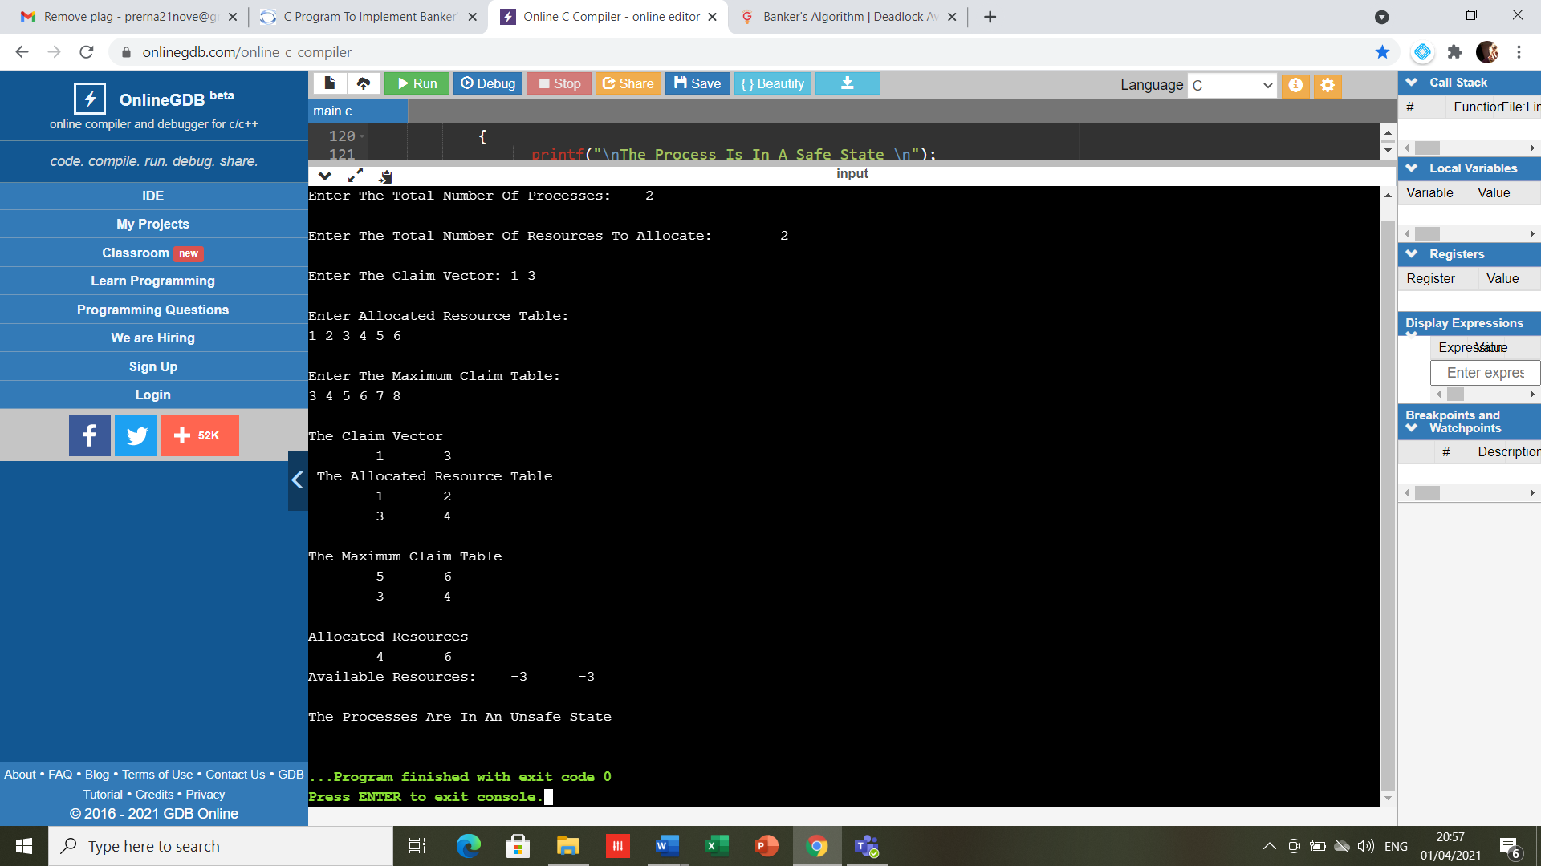

**RESULT-** The program has been executed successfully.

**EXPERIMENT -12**

**DATE-25/03/2021**

**AIM-** Write a program for FCFS disk scheduling

**SOFTWARE USED-** Cygwin/ C compiler

#include<stdio.h>

int main()

{

            int queue[20],n,head,i,j,k,seek=0,max,diff;

            float avg;

            printf("Enter the max range of disk\n");

            scanf("%d",&max);

            printf("Enter the size of queue request\n");

            scanf("%d",&n);

            printf("Enter the queue of disk positions to be read\n");

            for(i=1;i<=n;i++)

            scanf("%d",&queue[i]);

            printf("Enter the initial head position\n");

            scanf("%d",&head);

            queue[0]=head;

            for(j=0;j<=n-1;j++)

            {

                        diff=abs(queue[j+1]-queue[j]);

                        seek+=diff;

                        printf("Disk head moves from %d to %d with seek %d\n",queue[j],queue[j+1],diff);

            }

            printf("Total seek time is %d\n",seek);

            avg=seek/(float)n;

            printf("Average seek time is %f\n",avg);

            return 0;

}

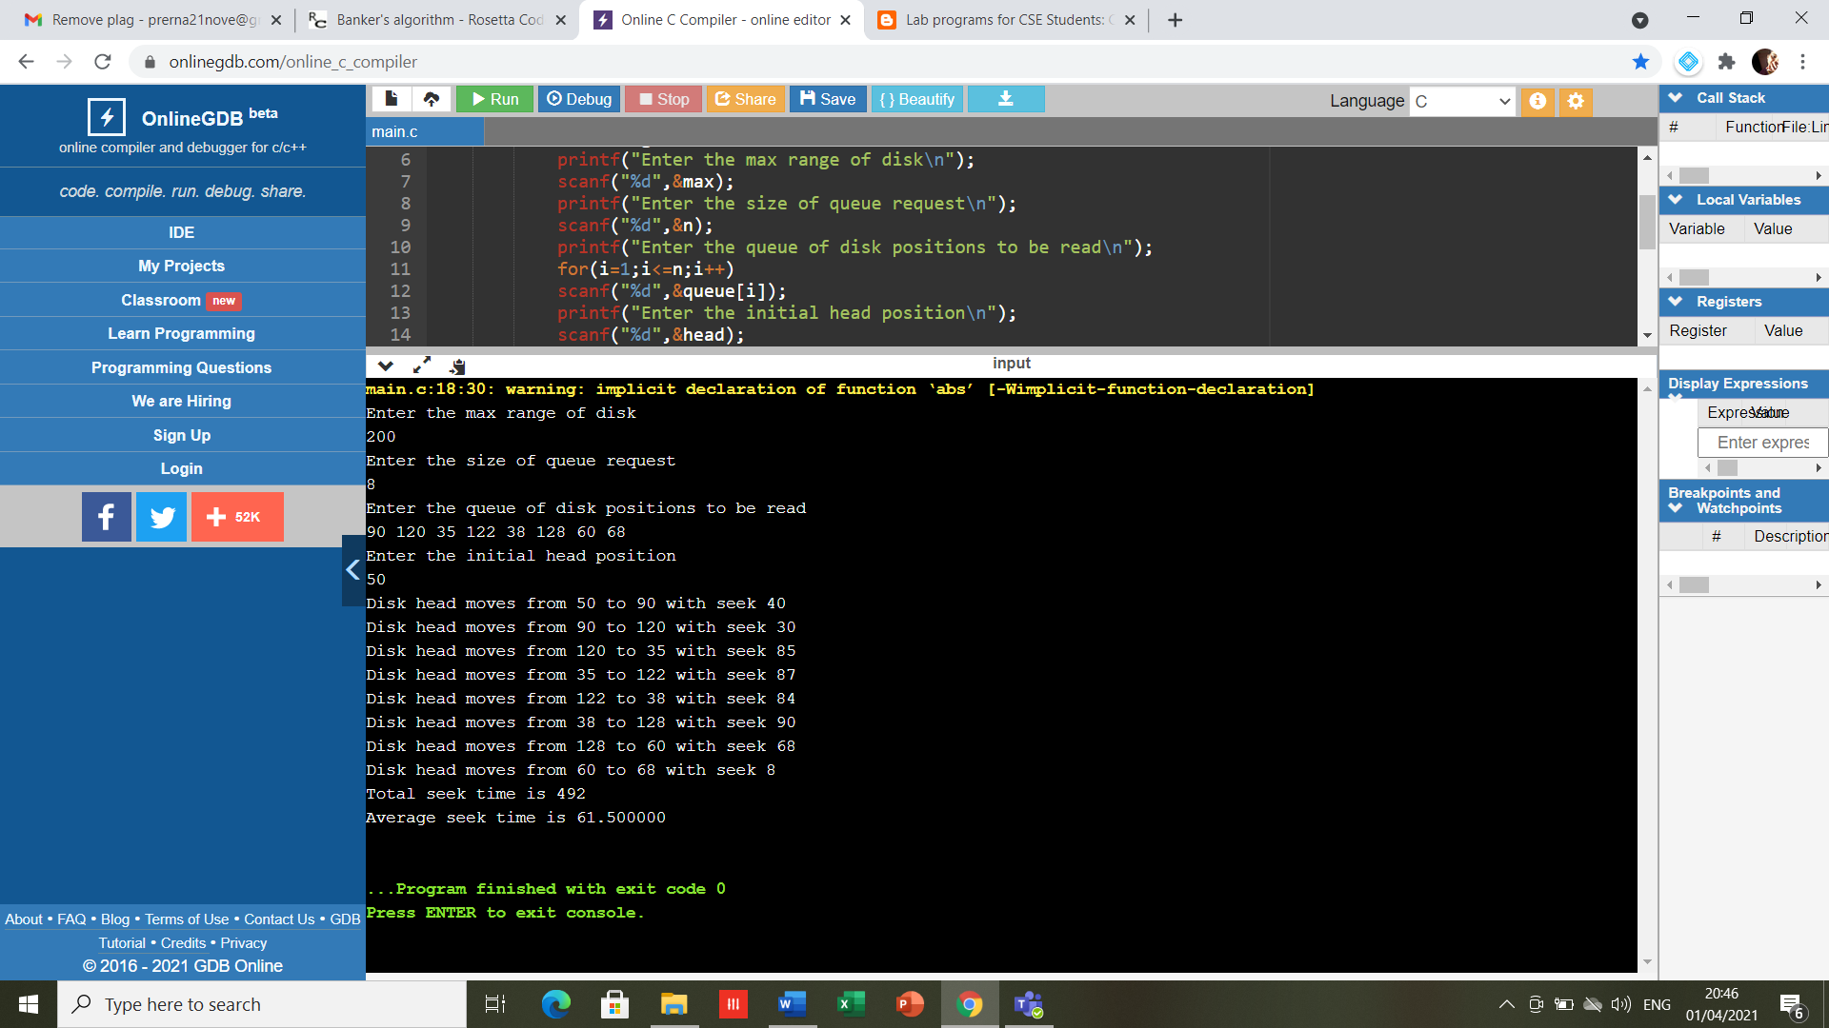

**RESULT-** The program has been executed successfully.